Fractions and Decimals
Grade 4 Mathematics: seeing numbers between whole numbers

Slide 1: Fractions and Decimals
Grade 4 Mathematics: seeing numbers between whole numbers
Sources: Outcome
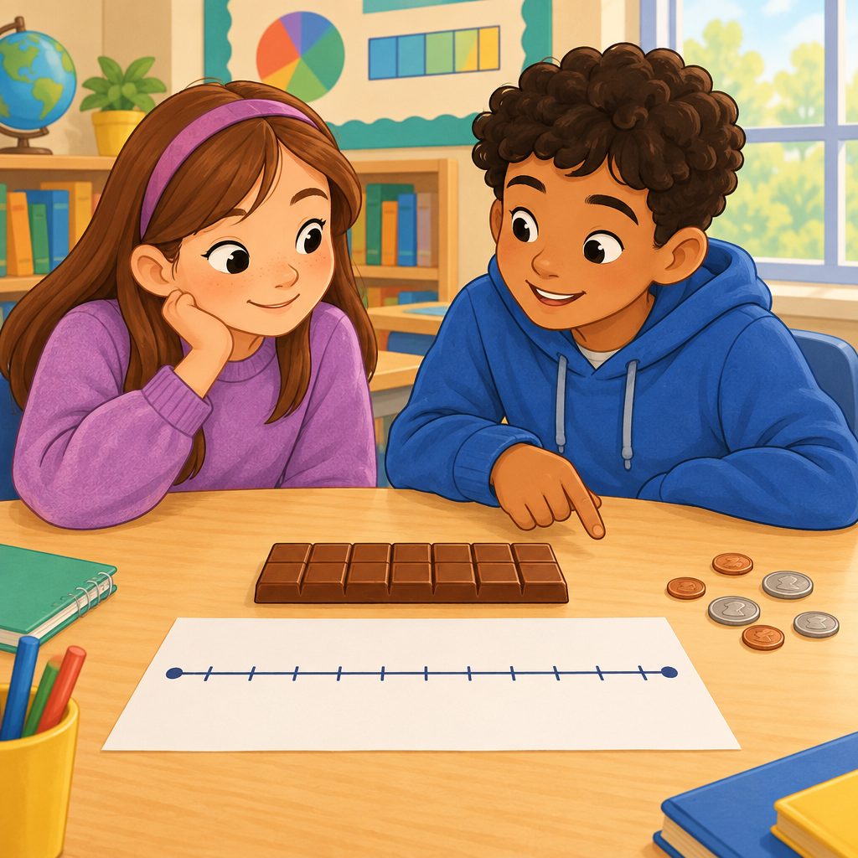
Notes: Welcome students and connect to prior learning from Grade 3 on fractions of a whole (Outcome). Today we build toward decimal place value and fraction equivalence, both Grade 4 outcomes.

Slide 2: What We Already Know About Fractions
- A fraction shows equal parts of one whole shape, length, or group (Details).
- The numerator counts the parts, the denominator tells the total number of equal parts (Details).
- Each fraction has its own spot on the number line (Details).
- We can compare fractions using benchmarks of 0, 1/2, and 1 (Details).
Sources: Details
Notes: Review Grade 3 knowledge before introducing new Grade 4 content. Formative checkpoint: ask students to sketch 3/4 of a pizza and mark it on a number line. Support: use fraction strips for students who need a concrete model. Extension: ask students to compare 3/4 and 5/6 using benchmarks.

Slide 3: Place Value Grows Smaller: Decimals
Whole Numbers
In base ten, each place has one tenth the value of the place to its left (Details). Moving left to right, values shrink by a factor of ten.
Decimal Parts
Decimal numbers are fractions with denominators of 10, 100, and so on (Details). For example, 0.7 means 7 tenths, and 0.25 means 25 hundredths. We use a decimal point to separate wholes from parts (Details).
Sources: Details
Notes: Learning intention: students will explain how place value extends to tenths and hundredths. Success criteria: students can identify the value of a digit in a decimal number and write a monetary amount using decimal notation (Details). Materials: base-ten blocks or grid paper for hundredths. Checkpoint: have students write 3.05 dollars using words. Support: connect cents to dollars as a familiar model. Extension: ask what 0.70 and 0.7 have in common (Details).

Slide 4: Turning a Fraction Into an Equivalent Fraction
- Start with a fraction: For example, 1/2 shown as one shaded part out of two.
- Partition each part the same way: Split every equal part into the same number of smaller pieces (Details).
- Multiply numerator and denominator: This partitioning is the same as multiplying top and bottom by the same number (Details).
- Name the new fraction: 1/2 becomes 2/4, then 4/8, and so on, all on the same point on the number line (Details).
- Simplify if needed: Divide numerator and denominator by a common factor to reach simplest form (Details).
Sources: Details
Notes: Learning intention: students understand that equivalent fractions represent the same point on the number line. Success criteria: students can generate two equivalent fractions for a given fraction and simplify a fraction to lowest terms. Materials: fraction circles or paper strips for folding. Checkpoint: ask students to find an equivalent fraction for 2/3. Support: use physical folding of paper strips. Extension: challenge students to simplify 8/12 to simplest form.

Slide 5: Fractions, Decimals, and Percentages: Same Idea, Different Clothes
- Equivalent Fractions: Equivalent fractions can be created by partitioning each equal part of a fraction in the same way, or by multiplying the numerator and denominator by the same number(Details).
- Decimal to Percentage: Multiply a decimal by 100 to get a percentage (Details).
- Percentage to Decimal: Divide a percentage by 100 to get a decimal (Details).
- One Percent: One percent means one hundredth of a whole (Details).
- Same Point, Same Number: Fractions and their equivalent decimals sit at the same spot on the number line (Details).
- Everyday Percentages: Percentages show up in sales, test scores, and sports statistics (Details).
Sources: Details, Details
Notes: Learning intention: students see fractions, decimals, and percentages as three ways to describe the same part-whole relationship. Success criteria: students can identify and create equivalent fractions, and simplify fractions to simplest form by dividing the numerator and denominator by their greatest common factor. Materials: number lines for locating equivalent fractions. Checkpoint: ask students to identify equivalent fractions and simplify a given fraction to its simplest form. Support: focus only on fraction to decimal for students still building confidence. Extension: ask students to research a percentage they see in daily life and express it three ways.

Slide 6: Bringing Fractions and Decimals Together
Summary: This year we learn that decimal numbers follow patterns in place value, with each place worth one tenth of the place to its left (Details). We also learn that fractions can be renamed as equivalent fractions, which are associated with the same point on the number line and describe the same part-whole relationship(Details, Details).
Question: Can you think of a number you use every day, like a price or a score, that could be written as a fraction, a decimal, and a percentage?
Sources: Details, Details, Details
Notes: Wrap up by revisiting the learning intentions from the lesson sequence. Use the closing question as an exit ticket, either written or discussed in pairs. Look for students who can name at least two of the three forms (fraction, decimal, percentage) for a familiar number as evidence of understanding.

AILI presentation · en · claude-sonnet-5 · 2026-09-17

