Renaissance Worldviews: Origins of Western Thought
Exploring how ideas, trade and art shaped a new view of the world

Slide 1: Renaissance Worldviews: Origins of Western Thought
How the exchange of ideas in Renaissance Europe reshaped the Western world
Sources: Topic
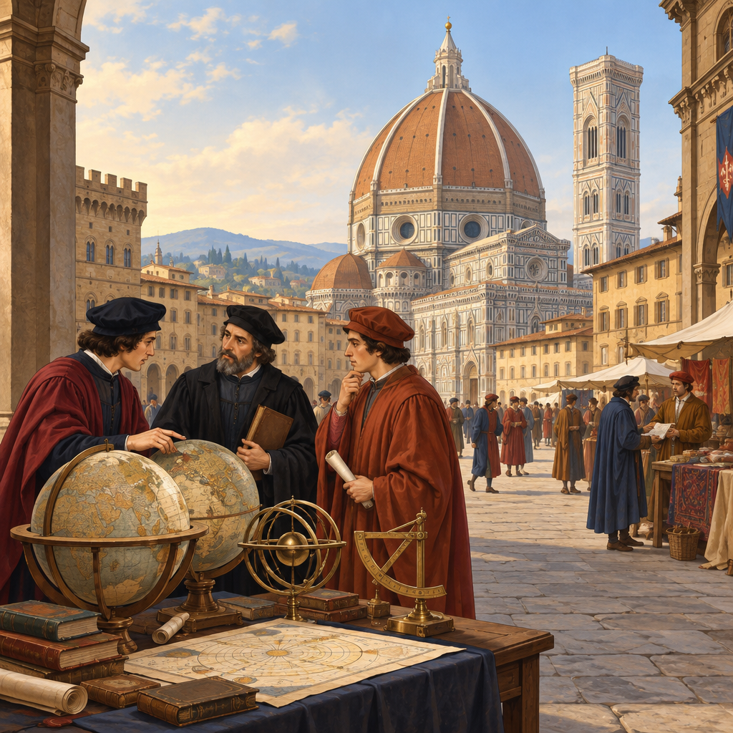
Notes: Introduce unit 8.2. Ask students what they already know about the Renaissance from art class or movies. Set purpose: we are studying how a worldview forms and spreads (Topic).

Slide 2: What Is a Worldview, and Why Study the Renaissance?
- A worldview is the set of beliefs and values a society uses to understand life (Outcome).
- Renaissance Europe formed the basis for the worldview of the Western world (Outcome).
- Beliefs and values are shaped by time period, geographic location and societal context (Outcome).
- Studying this era means practicing an openness to differing beliefs and values (Outcome).
Sources: Outcome, Outcome, Outcome
Notes: Checkpoint: have students give one example of a belief that has changed over time in their own community. Support: provide a worldview definition card. Extension: ask students to compare their own worldview influences to those of Renaissance Europeans.

Slide 3: How the Renaissance Spread Ideas Across Europe
- Trade and Geography: Physical geography shaped trade routes and competition among European countries (Outcome).
- Rise of City-States: Increased trade helped powerful city-states emerge, such as Florence, Venice and Genoa (Outcome).
- Growth of Knowledge: Ideas spread in astronomy, mathematics, science, politics, religion and the arts (Outcome).
- Humanist Thinkers: Philosophers and thinkers shaped a humanist worldview across society (Outcome).
- Age of Discovery: Expansion and imperialism reflected an expansionist worldview (Outcome).
Sources: Outcome
Notes: Walk through each stage as cause and effect, not isolated facts. Formative check: students trace one arrow from geography to city-states in their notes. Extension: research one city-state and its trade goods. Support: provide a partially filled chart.

Slide 4: Art as a Mirror of a New Worldview
Renaissance art did not simply record faces and places. It carried a philosophy. As humanist ideas grew, artists began showing individual people as worthy of careful, realistic attention.
- Art styles change across historical periods as societies change (Topic).
- Renaissance art reflected a new humanism and individualism (Outcome).
- Compare a medieval religious icon with a Renaissance portrait: what changed, and why?
Sources: Topic, Outcome
Notes: Bring in two contrasting images if possible: a flat medieval icon and a realistic Renaissance portrait (e.g., Mona Lisa style). Ask students to identify differences in realism, perspective and subject. Extension: have students sketch a face in each style. Support: give a comparison chart with guiding questions.

Slide 5: Contact, Identity and Citizenship
When European explorers reached new lands during the Age of Discovery, they encountered peoples with different beliefs, values and ways of life. This contact changed how Europeans saw themselves and their place in the world, raising questions about identity and citizenship that still matter today (Outcome). Considering these encounters critically means asking who benefited, who was harmed, and how contact reshaped identity on both sides (Outcome).
Exploration and intercultural contact during the Renaissance
When European explorers reached new lands during the Age of Discovery, they encountered peoples with different beliefs, values and ways of life. This contact changed how Europeans saw themselves and their place in the world, raising questions about identity and citizenship that still matter today (Outcome). Considering these encounters critically means asking who benefited, who was harmed, and how contact reshaped identity on both sides (Outcome).
Sources: Outcome, Outcome
Notes: Discuss both the exchange of knowledge and the harms of imperialism honestly. Formative check: exit ticket asking students to name one way contact changed European identity and one way it affected the peoples they encountered. Extension: research a specific voyage (e.g., Portuguese exploration) and its effects. Support: provide a simple cause-effect sentence frame.

Slide 6: Bringing It Together
Summary: Renaissance Europe's exchange of ideas across trade routes, city-states, humanist thought and exploration built the foundation of the Western worldview (Topic, Outcome). Beliefs and values shift with time, place and context, and studying this era asks us to consider worldviews different from our own (Outcome, Outcome). Renaissance art shows this shift visually, reflecting a new humanism and individualism (Outcome).
Question: If a historian five hundred years from now studied art and ideas from your community today, what would they conclude about our worldview?
Sources: Topic, Outcome, Outcome, Outcome, Outcome
Notes: Use the closing question as a short written reflection or discussion starter. Collect responses as a formative check on whether students grasp that worldview is shaped by time, place and context (Outcome).

AILI presentation · en · claude-sonnet-5 · 2026-09-17

