Enthalpy Changes and Calorimetry
Applying Q = mcΔt and ΔH notation to calorimetry data in Unit A: Thermochemical Changes
Audience: Chemistry 30 students, ages 16 to 18, preparing for diploma-level thermochemistry problems on enthalpy and calorimetry.
Grades: Grade 12
Subjects: Chemistry 30
Time: about 60 minutes
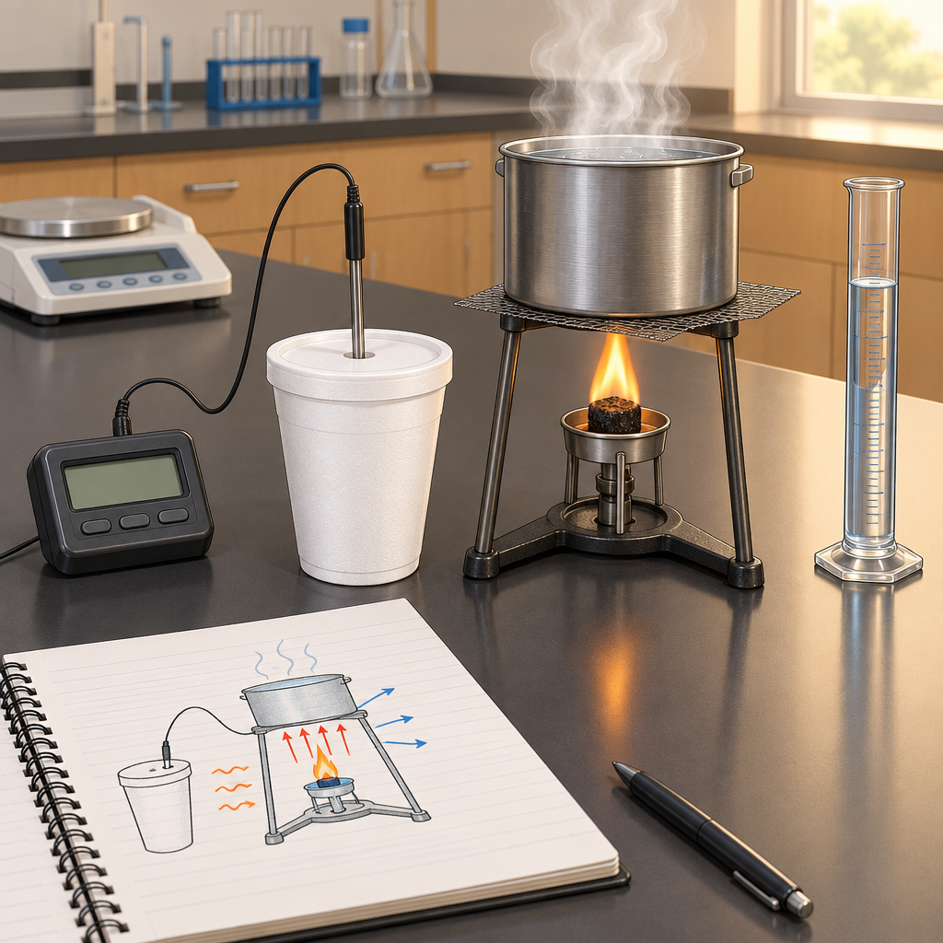

Overview
This lesson introduces Grade 12 Chemistry 30 students to enthalpy, molar enthalpy, and calorimetry as part of Unit A: Thermochemical Changes (Topic). Students review the relationship Q = mcΔt from Chemistry 20, then extend it to calculate molar enthalpy changes from experimental calorimetry data (Outcome, Outcome, Outcome). The lesson builds fluency with ΔH notation and sign conventions for exothermic and endothermic reactions (Outcome), using a worked combustion example modelled on nut-burning and cup-calorimeter investigations (Resource, Resource) before students practice independently in pairs.
The lesson sequences direct instruction, a fully worked numerical example, and paired guided practice, closing with an individual exit slip that checks both conceptual understanding and calculation skill. It prepares students for a subsequent hands-on calorimetry lab and for later work applying Hess's law and standard enthalpies of formation.

Outcomes covered
- Define enthalpy and molar enthalpy for chemical reactions. (Outcome, Outcome)
Students need a precise definition of enthalpy and molar enthalpy before they can interpret calorimetry data or thermochemical equations correctly on the diploma exam.
- Recall the application of Q = mcΔt to the analysis of heat transfer. (Outcome, Outcome)
This formula is the computational foundation for every calorimetry calculation students will perform in this unit and in laboratory investigations.
- Use calorimetry data to determine the enthalpy changes in chemical reactions. (Outcome)
Translating measured temperature and mass data into a molar enthalpy value is the central skill assessed in this unit's laboratory and written work.
- Use and interpret ΔH notation to communicate and calculate energy changes in chemical reactions. (Outcome)
Correct sign conventions and notation allow students to communicate whether a reaction is exothermic or endothermic and to perform further thermochemical calculations such as Hess's law.

Materials
- Whiteboard or projector for worked examples
- Scientific calculators, one per student
- Printed guided practice problem sets (Problems A and B), one per pair
- Printed exit slips, one per student
- Reference card with Q = mcΔt and ΔH = −Q/n formulas and units, for students requiring support
- Optional: photographs or short video clip of a combustion calorimetry setup (Resource) for visual reference during the worked example

Sequence of activities

1. Activation: What does 'enthalpy' actually mean? (8 min, whole class)
- Display the equation Q = mcΔt and ask students to recall each variable from Chemistry 20/30 review (Q in joules, m in grams, c in J/g°C, Δt in °C).
- Pose the question: "When methane burns in a Bunsen burner, where does the released energy go, and how could we measure it?"
- Take two or three verbal responses, steering toward the idea that heat flows from the reacting system into a surrounding medium (usually water) that we can measure.
- Introduce the term enthalpy (H) as the heat content of a system at constant pressure, and ΔH as the enthalpy change of a reaction, distinguishing it from Q, which is the heat absorbed or released by the surroundings (Outcome, Outcome, Outcome).
- State today's learning intentions: define enthalpy and molar enthalpy, apply Q = mcΔt to calorimetry data, and use ΔH notation with correct sign conventions.
Confirm students recall specific heat capacity (c) and the units of each term before moving on. If review is shaky, write the formula with units labelled directly beneath each variable. Emphasize that Q describes energy transferred to or from the surroundings (measured), while ΔH describes the energy change of the reaction system (calculated or looked up), a distinction many students blur.
Sources: Outcome, Outcome, Outcome, Outcome

2. Direct instruction: Enthalpy, molar enthalpy, and ΔH notation (12 min, whole class)
- Define enthalpy (H) as the total heat content of a system at constant pressure, and enthalpy change (ΔH) as the difference between the enthalpy of products and reactants: ΔH = H(products) − H(reactants) (Outcome).
- Define molar enthalpy (ΔHmolar) as the enthalpy change per mole of a specified substance in a reaction, with units kJ/mol (Outcome).
- Present sign convention: ΔH is negative for exothermic reactions (heat released to surroundings) and positive for endothermic reactions (heat absorbed from surroundings). Write ΔH = −Q(surroundings) as the link between the measured heat and the reaction's enthalpy change (Outcome).
- Work through a sample thermochemical equation on the board:
CH4(g) + 2O2(g) → CO2(g) + 2H2O(l) ΔH = −890 kJ/mol
Ask: is this reaction exothermic or endothermic? How much heat is released when 2 mol of CH4 burns? (Answer: exothermic; 1780 kJ released.)
- Show the calorimetry relationship: heat gained by water (Q = mcΔt) is used to calculate ΔH for the reaction, then divided by moles of reactant consumed to find molar enthalpy (Outcome, Outcome).
- Check understanding with a quick verbal question: "If burning 0.500 g of a fuel raises the temperature of 200 g of water by 12.0°C, is more or less heat released per gram compared to a fuel that raises the same water by only 6.0°C?" (Answer: more heat per gram for the first fuel.)
Write the two formulas side by side on the board: Q = mcΔt (heat transferred to surroundings) and ΔH = −Q/n (molar enthalpy of reaction). Students commonly forget the negative sign linking Q and ΔH for exothermic reactions; flag this explicitly. The specific heat capacity of water, c = 4.19 J/g°C, should be posted for reference during the worked example and later practice.
Sources: Outcome, Outcome, Outcome, Outcome, Outcome

3. Worked example: Calculating molar enthalpy from calorimetry data (15 min, whole class)
- Present the scenario, modelled on a combustion calorimetry investigation: a 0.850 g sample of ethanol (C2H5OH, molar mass 46.07 g/mol) is burned under a calorimeter containing 150.0 g of water. The water temperature rises from 21.5°C to 45.8°C (Outcome, Resource).
- Step 1: Calculate Q, the heat absorbed by the water.
Q = mcΔt = (150.0 g)(4.19 J/g°C)(45.8°C − 21.5°C)
Q = (150.0)(4.19)(24.3) = 15,272 J ≈ 15.3 kJ (Outcome, Outcome).
- Step 2: Relate Q to ΔH for the combustion reaction. Since the water gained heat, the reaction released it, so ΔH(reaction) = −15.3 kJ for the 0.850 g sample burned (Outcome).
- Step 3: Convert mass of ethanol burned to moles.
n = 0.850 g ÷ 46.07 g/mol = 0.01845 mol.
- Step 4: Calculate molar enthalpy of combustion.
ΔHmolar = ΔH ÷ n = −15.3 kJ ÷ 0.01845 mol = −829 kJ/mol (Outcome, Outcome, Outcome).
- Compare the calculated value (−829 kJ/mol) to the accepted literature value for ethanol combustion (approximately −1367 kJ/mol) and ask students to suggest sources of experimental error, such as heat loss to the surroundings or incomplete combustion (Resource).
- Ask students to record the four-step method (find Q, assign sign to get ΔH, convert mass to moles, divide to get ΔHmolar) in their notes as a reusable procedure.
This worked example mirrors an open-cup combustion calorimetry setup similar to Resource, where a burning sample heats a container of water. The large discrepancy between the calculated and literature values is intentional and sets up the discussion of experimental error and calorimeter efficiency, which connects to Resource on testing calorimeter precision. Consider asking students why an open calorimeter loses more heat than a sealed bomb calorimeter (convection and radiation losses to the room).
Sources: Outcome, Outcome, Outcome, Outcome, Outcome, Outcome, Resource, Resource

4. Guided practice: Calorimetry problem set in pairs (18 min, pairs)
- Distribute two calorimetry problems to each pair. Problem A: A student dissolves 5.00 g of NaOH(s) in 100.0 g of water in a coffee-cup calorimeter. The temperature rises from 22.0°C to 31.4°C. Calculate Q and the molar enthalpy of dissolution (molar mass NaOH = 40.00 g/mol).
- Problem B: In a nut-combustion calorimetry lab similar to a classroom investigation, burning a 1.20 g sample of a snack food under 250.0 g of water raises the temperature from 20.0°C to 62.5°C. Calculate the molar enthalpy of combustion per gram of food, and per mole if the sample is assumed to be mostly a fat with molar mass 890 g/mol (Resource).
- Circulate as pairs work, prompting with questions such as "What is gaining heat here, and what is losing it?" and "What sign should ΔH have if the mixture felt warm?"
- After 12 minutes, select two pairs to present their solution for Problem A and Problem B on the board, showing all four steps from the worked example.
- As a class, verify Problem A: Q = (100.0)(4.19)(9.4) = 3939 J; n = 5.00/40.00 = 0.125 mol; ΔHmolar = −3939 J ÷ 0.125 mol = −31,512 J/mol ≈ −31.5 kJ/mol.
- Verify Problem B: Q = (250.0)(4.19)(42.5) = 44,519 J ≈ 44.5 kJ; ΔH per gram = −44.5 kJ ÷ 1.20 g = −37.1 kJ/g; per mole = −37.1 kJ/g × 890 g/mol ≈ −33,000 kJ/mol.
Problem B is modelled on the nut-burning calorimetry investigation in Resource and works well as a bridge to a future hands-on lab. Watch for students forgetting to convert the sign of Q to ΔH, and for arithmetic slips when computing Δt. Pairs finishing early can be directed to the extension task of estimating percent error against a published food-energy value.
Sources: Outcome, Outcome, Outcome, Outcome, Resource

5. Consolidation and exit check (7 min, individual)
- Distribute an exit slip with one definition question and one calculation question.
- Definition question: "In your own words, distinguish between Q, ΔH, and molar enthalpy." (Outcome, Outcome, Outcome).
- Calculation question: "Burning 0.400 g of a candle wax under 100.0 g of water raises the temperature by 15.0°C. Calculate Q and state whether the sign of ΔH for this reaction is positive or negative." Expected answer: Q = (100.0)(4.19)(15.0) = 6285 J ≈ 6.29 kJ; ΔH is negative because combustion is exothermic and the water gained heat (Outcome, Outcome, Outcome).
- Collect exit slips on the way out as a formative check of individual understanding before the next class introduces hands-on calorimetry lab work (Resource).
Scan exit slips for two common errors: mixing up which object's mass and temperature change belong in Q = mcΔt, and forgetting to assign a negative sign to ΔH for an exothermic process. Use results to decide whether the next class needs a re-teach before students carry out the calorimeter-construction lab in Resource.
Sources: Outcome, Outcome, Outcome, Outcome, Outcome, Resource

Differentiation
Extension
- Challenge students to calculate the percent error between their calculated molar enthalpy in the worked example and a published literature value, then propose two specific design changes to reduce heat loss in the calorimeter.
- Ask students to research the difference between a coffee-cup calorimeter and a bomb calorimeter and explain why bomb calorimetry gives values closer to literature enthalpies, connecting to the calorimeter precision investigation in Resource.
Support
- Provide a reference card listing Q = mcΔt and ΔH = −Q/n with each variable and unit labelled, for use during guided practice and the exit slip.
- Reduce the guided practice task to Problem A only, with the numeric values already substituted into the Q = mcΔt formula so students focus on arithmetic and sign conventions.
- Pair students with a stronger peer for the guided practice segment and allow use of a calculator with stored formula steps.
Inclusive supports
- Post the worked example steps as a numbered anchor chart on the board throughout the lesson so students can refer back to the procedure without relying on memory.
- Offer both a written and a verbal option for the exit slip definition question for students who benefit from speaking their answer to the teacher or an educational assistant.
- Use consistent, uncluttered notation (Q, m, c, Δt, ΔH) throughout all board work and handouts to reduce cognitive load for students with processing difficulties.

Assessment
Formative. Verbal questioning during the direct instruction and worked example segments, checking whether students can distinguish Q from ΔH and correctly assign the sign of an enthalpy change for an exothermic reaction.
Look for: Students respond correctly when asked to identify a reaction as exothermic or endothermic from a stated ΔH value, and can explain the negative sign relating Q(surroundings) to ΔH(reaction). (Outcome, Outcome)
Formative. Circulation and coaching during the paired calorimetry problem set, observing whether pairs correctly apply Q = mcΔt and convert to molar enthalpy.
Look for: Pairs set up Q = mcΔt with correct values for mass, specific heat capacity of water, and temperature change, then correctly convert grams of reactant to moles before dividing to find molar enthalpy. (Outcome, Outcome, Outcome)
Formative. Exit slip with one definition question and one calculation question, collected at the end of class.
Look for: Written responses show correct use of ΔH notation with an appropriate sign, and an accurate Q calculation with correct units (joules or kilojoules). (Outcome, Outcome, Outcome, Outcome, Outcome)

Vocabulary
- Enthalpy (H): The total heat content of a system at constant pressure. Enthalpy itself cannot be measured directly; only the change in enthalpy (ΔH) during a reaction is measured or calculated (Outcome, Outcome).
- Molar enthalpy (ΔHmolar): The enthalpy change associated with one mole of a specified substance in a chemical reaction, expressed in kilojoules per mole (kJ/mol) (Outcome, Outcome).
- ΔH notation: A way of writing the enthalpy change of a reaction alongside its balanced equation, with a negative sign indicating an exothermic reaction and a positive sign indicating an endothermic reaction (Outcome).
- Q (heat transferred): The quantity of heat energy absorbed or released by the surroundings, such as water in a calorimeter, calculated using Q = mcΔt where m is mass, c is specific heat capacity, and Δt is the temperature change (Outcome, Outcome).
- Specific heat capacity (c): The quantity of heat required to raise the temperature of one gram of a substance by one degree Celsius, expressed in J/g°C. For water, c = 4.19 J/g°C (Outcome, Outcome).
- Calorimetry: The experimental technique of measuring the heat absorbed or released during a physical or chemical process, typically by tracking the temperature change of a known mass of water or another surrounding medium (Outcome, Resource, Resource).

Sources
- Outcome: "30-A1.3k define enthalpy and molar enthalpy for chemical reactions"
- Outcome: "30-A1.1k recall the application of Q = mcΔt to the analysis of heat transfer"
- Outcome: "30-A1.8k use calorimetry data to determine the enthalpy changes in chemical reactions"
- Outcome: "perform calorimetry experiments to determine the molar enthalpy change of chemical reactions"
- Outcome: "30-A1.1k recall the application of Q = mcΔt to the analysis of heat transfer"
- Outcome: "30-A1.3k define enthalpy and molar enthalpy for chemical reactions"
- Outcome: "30-A1.5k use and interpret ΔH notation to communicate and calculate energy changes in chemical reactions"
- Topic: "Students will determine and interpret energy changes in chemical reactions."
- Outcome: "compare energy changes associated with a variety of chemical reactions through the analysis of data and energy diagrams"
- Resource: "This lab presents a multimedia investigation of calorimetry by examining how burning a nut transfers thermal energy to water."
- Resource: "This lab presents a guided investigation of building a polystyrene-cup calorimeter and evaluating the calorimeter's performance by measuring temperature changes during mixing."

All content, examples, and the cover image depict standard classroom chemistry apparatus and calculations appropriate for supervised Grade 12 laboratory contexts, with no unsafe procedures described or depicted.

AILI detailed pack · en · claude-sonnet-5 · 2026-09-17

