Movement Skills and Healthy Relationships
Grade 6 Physical Education and Wellness

Slide 1: Movement Skills and Healthy Relationships
Grade 6 Physical Education and Wellness: building skilled movers and strong teammates
Sources: Outcome, Outcome
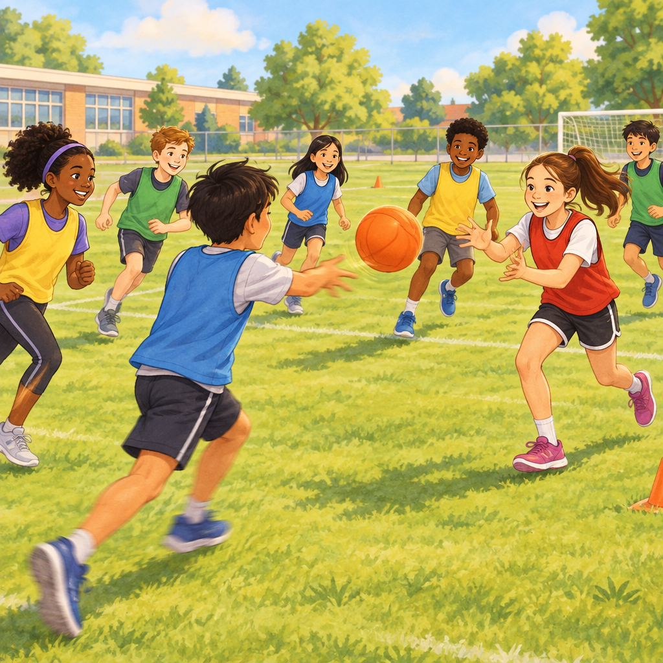
Notes: Introduce the unit: two big ideas connect this term, movement patterns and conflict resolution. Explain both work together because sport and games need skilled bodies and skilled teammates.

Slide 2: What Are Movement Patterns?
- A pattern is a way the body moves in response to a stimulus, like a whistle, a ball, or music.
- Similar patterns show up across many different activities, such as throwing in baseball and throwing in team handball.
- Practising a pattern helps you get better at it in every sport that uses it.
- First Nations, Métis, and Inuit games use unique movement patterns that build skill in creative ways.
- Adding objects, tempo, or rhythm can make movement patterns more creative and challenging.
Sources: Knowledge, Understanding, Knowledge
Notes: Checkpoint: ask students to name one movement pattern (running, jumping, throwing) and list two sports where it appears. Support: provide a picture chart of common patterns. Extension: challenge students to find a pattern used in three or more sports.

Slide 3: Controlled vs. Dynamic Activities
Controlled
Controlled activities are structured and can be done alone or with a partner. They let you repeat a movement skill again and again until it feels natural, like practising a free throw or a dribble drill.
Dynamic
Dynamic activities are less structured, fluid, and always changing. They need quick decisions and fast adjustments to your movement, like reacting to a defender in soccer or a teammate's pass in basketball.
Sources: Knowledge, Skills, Understanding
Notes: Learning intention: students will distinguish controlled from dynamic practice and adapt patterns for accuracy, speed, and proficiency. Materials: cones, balls, a whistle. Timing: 10 minutes demonstration, 15 minutes station rotation. Formative check: exit ticket naming one controlled and one dynamic activity from class today.

Slide 4: Five Steps to Resolve Conflict on a Team
- Acknowledge emotions: Notice how you and others feel before reacting.
- Clarify facts: Check what actually happened, not just assumptions.
- Listen to understand: Let each person explain their side fully.
- Discuss outcomes: Talk through what could happen with different choices.
- Propose a solution: Agree on a fair way to move forward together.
Sources: Knowledge, Skills
Notes: Team success can be affected by how conflict is handled. Role-play a disagreement over a foul call or a turn-taking dispute, then have students practise these five steps in pairs. Formative check: observe pairs and listen for use of at least two steps. Support: give sentence starters for each step. Extension: ask students to write a script showing all five steps used in order.

Slide 5: Cooperation and Competition Change Conflict
- Cooperative games: Everyone works toward one shared goal, so conflict often centres on sharing roles or ideas.
- Competitive games: Teams or players work against each other, so conflict can involve rules, fairness, or winning.
- Adjusting thinking: Group members may need to change their thinking or actions to resolve a disagreement.
- Team collaboration: Working out a resolution together, not alone, builds a stronger team.
Sources: Understanding, Knowledge, Skills, Understanding
Notes: Discuss how the same disagreement, like disagreeing on a rule, feels different in a friendly gym game versus a tournament. Formative check: exit slip asking students to describe one difference between resolving conflict in a cooperative game and a competitive game. Support: use two contrasting video clips. Extension: have students design a class rule that helps resolve conflict in competitive games.

Slide 6: Putting It All Together
Summary: This unit connects two skills that make physical activity work well: adapting movement patterns for controlled and dynamic situations and using conflict resolution to keep teams strong. Skilled movers who can also solve disagreements fairly help every game run smoothly, whether it is cooperative or competitive.
Question: Think of a game you played recently. What movement pattern did you use, and did your team need to resolve any conflict during it?
Sources: Outcome, Outcome, Skills, Understanding
Notes: Wrap-up discussion: invite a few students to share their answers aloud. Use this as an informal formative assessment of understanding across both learning outcomes before moving into skill-testing activities next class.

AILI presentation · en · claude-sonnet-5 · 2026-09-17

