Communities in Alberta
Being a good citizen where we live

Slide 1: Communities in Alberta
Being a good citizen where we live
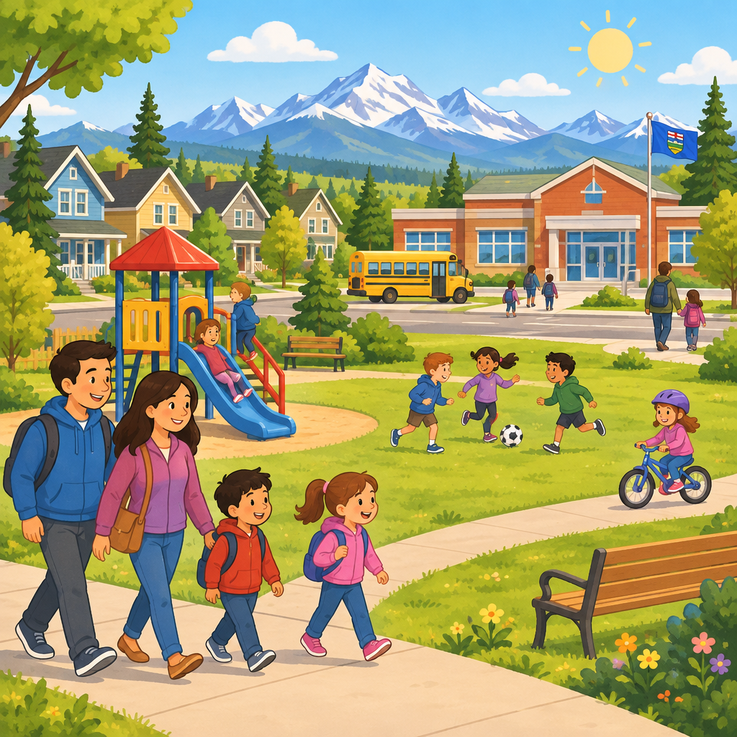
Notes: Welcome students. Explain that today we will learn what it means to be a good citizen in our community. Activate prior knowledge by asking: what is a community you belong to?

Slide 2: What is Citizenship?
- A citizen is a member of a community (Outcome).
- Citizens in Canada have rights, like being treated fairly (Details).
- Citizens also have jobs to do, called responsibilities (Details).
- One responsibility is helping our community (Details).
Sources: Guiding question, Outcome, Details
Notes: Learning outcome: students investigate rights and responsibilities in Canada (Outcome). Guiding question: What is responsible citizenship? (Guiding question). Discuss the word 'right' as something everyone should have, and 'responsibility' as a job we do. Formative checkpoint: thumbs up if you can name one right and one responsibility.

Slide 3: Rights and Responsibilities
My Rights
I have the right to be treated the same as everyone else (Details). This is true no matter how I look or where I come from (Details).
My Responsibilities
I help my community (Details). I respect other people's rights (Details). One day I will vote (Details).
Sources: Details
Notes: Understanding: rights come with responsibilities (Details). Have students draw one right and one responsibility side by side. Support: give sentence starters. Extension: ask students to explain why rights need responsibilities.

Slide 4: How Can I Take Action?
- Notice a problem: See something that needs help in your community (Details).
- Ask questions: Learn from many sources, not just one (Details).
- Listen to others: Think about how other people feel (Details).
- Take action: Share ideas, give donations, or volunteer (Details).
Sources: Guiding question, Outcome, Details
Notes: Guiding question: How can citizens become active and informed? (Guiding question). Learning outcome: students investigate ways to learn about the world and take action for change (Outcome). The study of historical issues and events, such as those in ancient civilizations and empires, can provide insight into contemporary issues and events. Support: use pictures for each step. Extension: ask for a real example from their own community.

Slide 5: Ways to Help Our Community
- Share information: Tell people something important you learned (Details).
- Collect donations: Gather items like food or clothes to give (Details).
- Volunteer: Give your time to help others (Details).
- Plan a project: Pick an issue, then make small steps to fix it (Details).
Sources: Details, Details
Notes: Connects grade 5 action ideas (Details) with grade 6 project planning steps (Details), simplified for grade 3 as an introduction to civic participation. Have students identify an action they could take in response to an issue or event, such as sharing information, collecting donations, volunteering, or changing personal behaviours. Extension: ask students to sequence a mini project plan for a classroom problem.

Slide 6: Being Part of a Community
Summary: Being a citizen means having rights and responsibilities (Outcome). We can be informed by asking questions and listening to others (Outcome). We can take action to help our community grow strong (Details).
Question: What is one small action you can do this week to help your community?
Sources: Outcome, Outcome, Details
Notes: Success criteria: students can name one right, one responsibility, and one action for community helping. Wrap up with sharing circle. Support: sentence frame 'I can help my community by ___.' Extension: write a plan with three steps.

AILI presentation · en · claude-sonnet-5 · 2026-09-17

