Comprehension of Texts: Grade 6
Central concept: Text Comprehension

Connections
- Text Comprehension (uses) -> Comprehension Strategies
- Text Comprehension (requires) -> Self-Monitoring Skills
- Text Comprehension (includes) -> Analyzing Texts
- Text Comprehension (uses) -> Comprehension Strategies
- Text Comprehension (supports) -> Interpretation of Texts
- Comprehension Strategies (includes) -> Making Connections
- Comprehension Strategies (includes) -> Summarizing and Synthesizing
- Analyzing Texts (examines) -> Explicit and Implicit Ideas
- Analyzing Texts (uses) -> Context Clues
- Making Connections (supports) -> Drawing Conclusions
- Comprehension Strategies (include) -> Evaluating
- Self-Monitoring Skills (support) -> Comprehension and Interpretation

Notes
- Text Comprehension: Understanding texts through strategies and critical thinking Outcome, Understanding
- Comprehension Strategies: Predicting, inferring, connecting, summarizing, synthesizing, evaluating Knowledge
- Self-Monitoring Skills: Checking understanding while reading independently Knowledge, Skills
- Analyzing Texts: Reading closely to examine ideas and information separately and together Knowledge, Understanding
- Making Connections: Text to self, text to text, text to world connections Knowledge, Skills
- Explicit and Implicit Ideas: Stated information and ideas that must be inferred Knowledge, Understanding
- Context Clues: Words, phrases, punctuation, dialogue, pictures, diagrams, charts, graphs Knowledge
- Perspectives and Bias: How authors share viewpoints; bias favours one thing unfairly Knowledge, Skills
- Historical and Social Context: Time, place, beliefs that influence how texts are understood Knowledge, Understanding
- Summarizing and Synthesizing: Combining main ideas and expanding understanding Skills, Understanding
- Drawing Conclusions: Judgements based on stated or inferred information Knowledge, Skills
- Text Influence: How authors deliberately shape audience beliefs and perspectives Knowledge, Skills
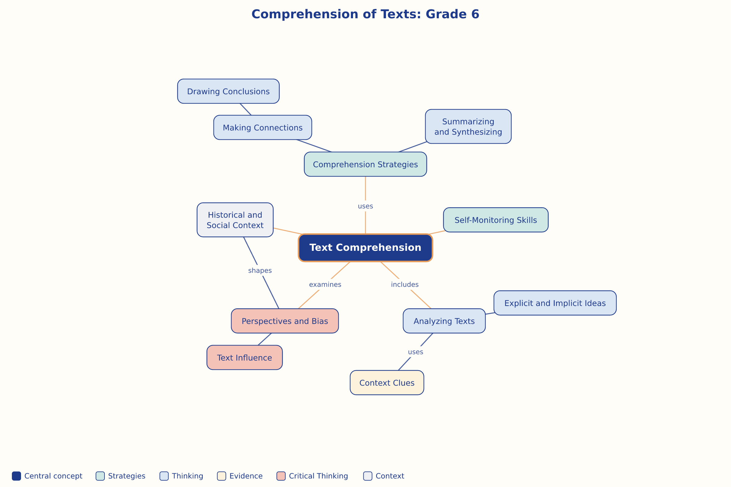

AILI word map · en · claude-haiku-4-5-20251001 · 2026-09-17

