Living Systems: How Plants and Animals Interact
Food chains, carnivores, herbivores, omnivores, senses, and protecting local environments
Audience: Grade 3 science students learning about living systems in local and Canadian environments
Grades: Grade 3
Subjects: Science
Time: about 60 minutes
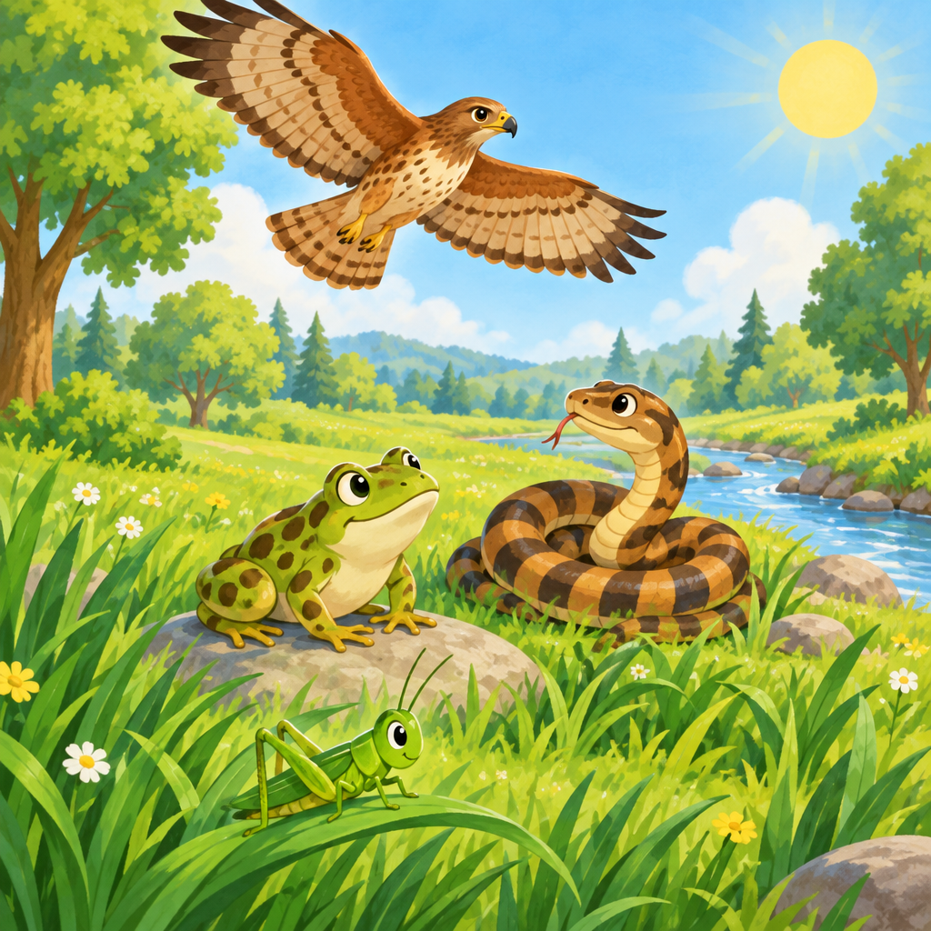

Overview
This lesson explores the big question: how do plants and animals interact? (Guiding question). Students build hands-on food chains, sort animals by diet, act out responses to stimuli, and reflect on how to protect plants and animals in their own environment.
Students work with the understanding that plants and animals interact with each other in ways that can be represented with food chains (Understanding, Understanding), that animals can be classified by what they eat (Understanding), that living things sense and respond to stimuli to survive (Understanding), and that awareness of these interactions helps humans protect plants and animals (Understanding). The lesson also introduces First Nations, Métis, and Inuit knowledge of animal behaviour, migration, and seasonal patterns (Knowledge, Skills).

Outcomes covered
- Students analyze and describe how plants and animals interact with each other and within environments. (Outcome)
This is the big learning goal for the whole lesson. Everything students do today, from ordering food chain cards to acting out senses, builds toward being able to explain these interactions.
- Represent various food chains in local and other Canadian environments. (Skills)
Building a physical food chain with cards helps students see and explain the order of eating in a real way they can touch and rearrange.
- Classify animals in a food chain as carnivores, herbivores, or omnivores. (Skills)
Sorting animals by diet helps students understand the different roles animals play in a food chain and why some eat plants and others eat meat.
- Investigate and discuss how plants and animals respond to stimuli in their environments in order to survive. (Skills)
Acting out responses to stimuli like light, cold, and danger helps students connect senses to survival in a memorable, physical way.
- Reflect on and share actions that can be taken to protect plants and animals in local environments. (Skills)
Students leave the lesson with a concrete action they can take, connecting classroom learning to real responsibility in their own community.

Materials
- Picture cards showing grass, grasshopper, frog, snake, and hawk (one set per small group)
- Picture cards showing wolf, deer, bear, rabbit, owl, squirrel, and raccoon (one set per pair)
- Chart paper or whiteboard with three columns labeled Carnivore, Herbivore, Omnivore
- Markers or crayons
- Exit ticket worksheet (blank space for drawing plus two lines for writing)
- A large picture of a meadow scene with grass, a rabbit, a fox, and a bush for the opening discussion

Sequence of activities

1. Circle Talk: How Do Plants and Animals Need Each Other? (10 min, whole class)
- Show a picture of a sunny meadow with grass, a rabbit, a fox, and a small bush.
- Ask: "What do you see in this picture?" Let students name each thing.
- Ask: "Does the rabbit need the grass? Why?" Guide toward: rabbit eats grass for food.
- Ask: "Does the fox need the rabbit? Why?" Guide toward: fox eats rabbit for food.
- Explain: this order of eating is called a food chain. A food chain shows who eats whom (Knowledge).
- Tell students a food chain can also be drawn, told as a story, or written in words (Knowledge).
- Write today's learning intention on the board: "We are learning how plants and animals depend on each other for food, and how they sense and protect their world."
Accept any reasonable answer that shows understanding of eating order. If students say "the fox eats the rabbit and the rabbit eats grass," praise this as a food chain in words already. Keep this short and lively; it is meant to activate prior knowledge, not teach everything.
Sources: Knowledge, Understanding

2. Build a Food Chain (Grass, Grasshopper, Frog, Snake, Hawk) (15 min, small group)
- Put students into groups of three or four.
- Give each group five picture cards: grass, grasshopper, frog, snake, hawk.
- Say: "Put these in order. Who eats whom? Start with what makes its own food."
- Groups arrange cards in a line: grass to grasshopper to frog to snake to hawk.
- Each group draws an arrow between cards. Explain the arrow means "is eaten by" or "energy moves to."
- Ask each group to tell their food chain out loud as a short sentence chain, for example: "Grass is eaten by the grasshopper. The grasshopper is eaten by the frog."
- Ask: "Could this food chain happen in Alberta?" Discuss that food chains exist in local and other Canadian environments (Skills).
- Circulate and check that groups place producers (plants) first and understand the direction of the arrows.
Correct order: grass, grasshopper, frog, snake, hawk. If a group reverses the arrows, ask "which one has to eat to survive, the grass or the grasshopper?" to guide correction. This activity directly practices representing food chains (Skills) built on the understanding that interactions can be shown this way (Understanding).
Sources: Knowledge, Skills, Understanding

3. Sort the Eaters: Carnivore, Herbivore, Omnivore (12 min, pairs)
- Give each pair a set of animal picture cards: wolf, deer, bear, rabbit, owl, squirrel, raccoon.
- Draw three columns on the board labeled: Carnivore, Herbivore, Omnivore.
- Remind students: carnivores eat mostly meat, herbivores eat only plants, omnivores eat both meat and plants (Knowledge).
- Pairs sort their cards into the three groups by talking together.
- Ask two or three pairs to place one card on the board and explain their reason.
- Check answers together: wolf and owl are carnivores; deer and rabbit are herbivores; bear, raccoon, and squirrel are omnivores.
- Ask: "Where would these animals fit in a food chain?" Connect back to the food chain built earlier.
This activity meets the specific outcome of classifying animals as carnivore, herbivore, or omnivore (Skills), built on the understanding that diet determines this classification (Understanding). If a pair struggles, ask "does it have big flat teeth for chewing plants, or sharp teeth for meat?" as a memory prompt.
Sources: Knowledge, Skills, Understanding

4. Senses for Survival: Act It Out (10 min, whole class)
- Explain: plants and animals sense things around them, like water, food, temperature, and light, and respond to survive (Knowledge, Understanding).
- Give examples: a plant grows toward sunlight; a deer's ears turn toward a sound; a rabbit freezes when it smells a fox nearby.
- Call out a stimulus and have students act out a response. Say "Bright light!" Students pretend to be a plant leaning toward the sun.
- Say "A predator is near!" Students freeze like a rabbit that just sensed danger.
- Say "It is very cold!" Students act out an animal curling up to stay warm.
- Ask: "Why do animals need to sense a predator?" Discuss that animals use senses to detect food, predators, or other living things (Knowledge).
- Ask: "What might happen if an animal could not sense danger?" Let a few students share ideas.
This meets the specific outcome of investigating and discussing how plants and animals respond to stimuli to survive (Skills). Keep movements simple and inclusive; students who cannot stand can act with hands or facial expressions.
Sources: Knowledge, Skills, Understanding

5. Protecting Our Local Plants and Animals (13 min, whole class)
- Ask: "We learned plants and animals depend on each other. How can we help protect them?"
- Share examples: watching animals quietly instead of chasing them, staying on paths so plants are not stepped on, watching for animal crossing signs, and following rules about fishing and hunting seasons (Knowledge).
- Explain that First Nations, Métis, and Inuit peoples hold knowledge about animal behaviour, food sources, migration, and seasonal patterns built over a long time (Knowledge, Skills).
- Share one example: some Indigenous communities track animal migration patterns, like the movement of caribou, to know when and where to hunt respectfully and sustainably.
- Ask: "Why is it important to know when animals migrate or when plants grow?" Discuss connections to survival and respect (Understanding).
- Have students turn to a partner and share one action they can take this week to protect a plant or animal near their home or school.
- Invite two or three pairs to share their idea with the whole class.
- Close by restating the big question: how do plants and animals interact? Ask students to answer in one sentence using today's new words.
This activity covers reflecting on protective actions (Skills), understanding why protection matters (Understanding), and discussing Indigenous knowledge and connection to environments (Knowledge, Skills). Be respectful and factual; avoid generalizing all Indigenous peoples as the same, and note that knowledge varies by nation and community.
Sources: Knowledge, Skills, Understanding

Differentiation
Extension
- Ask early finishers to add a second food chain using different local Alberta plants and animals, such as clover, mouse, and owl.
- Challenge students to research one more Canadian animal and decide if it is a carnivore, herbivore, or omnivore, then justify their answer in writing.
- Invite students to write a short story from the point of view of an animal responding to a stimulus, such as a fox smelling a rabbit.
Support
- Give pre-made sentence starters such as "The ___ eats the ___" for students building food chain sentences.
- Use picture cards with both images and simple labels for the carnivore/herbivore/omnivore sort.
- Pair students who need support with a strong reader during the food chain and sorting activities.
- Allow students to point to or place cards instead of speaking aloud during group sharing.
Inclusive supports
- Offer verbal, written, and drawn options for sharing food chain sentences.
- Use large-print picture cards for students who need visual supports.
- Allow movement breaks during the Senses activity for students who benefit from physical regulation.
- Provide a quiet corner with the same cards for a student who prefers working alone before joining a pair.

Assessment
Formative. During the food chain card activity, observe whether each group correctly represents the order in which plants and animals depend on each other for food.
Look for: Groups place grass first and hawk last, with arrows pointing from grass toward the next eater each time. (Knowledge, Skills, Understanding)
Formative. During the carnivore, herbivore, omnivore sort, listen for correct reasoning when pairs explain their card placement.
Look for: Students correctly state that an animal is a carnivore because it eats meat, a herbivore because it eats only plants, or an omnivore because it eats both. (Knowledge, Skills, Understanding)
Formative. During the Senses for Survival activity, watch student actions to check they connect the correct response to each stimulus called out.
Look for: Students act out a fitting response, such as freezing for a predator stimulus or leaning toward light for a plant stimulus. (Knowledge, Skills, Understanding)
Summative. Exit ticket: students draw or write one food chain with at least three living things, label one animal as carnivore, herbivore, or omnivore, and write one sentence about how humans can protect part of that food chain.
Look for: The food chain shows a logical eating order, the animal label matches its real diet, and the protection sentence names a specific respectful action. (Skills, Skills, Skills)

Vocabulary
- food chain: A food chain shows the order in which plants and animals depend on each other for food. It can be drawn, told as a story, or written in words.
- carnivore: A carnivore is an animal that eats mostly meat.
- herbivore: A herbivore is an animal that eats only plants.
- omnivore: An omnivore is an animal that eats both meat and plants.
- stimulus: A stimulus is something in the environment, like light, water, food, or temperature, that a plant or animal senses and responds to.

For families
- Take a walk together outside and ask your child to name one plant and one animal they see, then guess what the animal might eat.
- At mealtime, ask your child whether the food on their plate came from a plant, an animal, or both, and connect it to what they learned about carnivores, herbivores, and omnivores.
- Ask your child to tell you a food chain story using three things from your own backyard or a local park.
- Talk with your child about one simple way your family can protect local plants and animals, such as staying on trails during a hike.

Sources
- Guiding question: "How do plants and animals interact?"
- Outcome: "Students analyze and describe how plants and animals interact with each other and within environments."
- Knowledge: "A food chain shows the order in which plants and animals depend on each other for food."
- Skills: "Represent various food chains in local and other Canadian environments."
- Understanding: "Plants and animals interact with each other in various environments in ways that can be represented with food chains."
- Knowledge: "Carnivores eat mostly meat. Herbivores eat only plants. Omnivores eat both meat and plants."
- Skills: "Classify animals in a food chain as carnivores, herbivores, or omnivores."
- Understanding: "Animals can be classified as carnivores, herbivores, or omnivores based on what they eat."
- Knowledge: "Plants and animals use their senses to respond to sensory stimuli, including water, food, temperature, light."
- Skills: "Investigate and discuss how plants and animals respond to stimuli in their environments in order to survive."
- Understanding: "Plants and animals sense and respond to stimuli in order to survive."
- Knowledge: "First Nations, Métis, and Inuit knowledge of plants and animals within environments includes animal behaviour, sources of food, migration patterns, seasonal patterns"
- Skills: "Reflect on and share actions that can be taken to protect plants and animals in local environments."
- Understanding: "Awareness and consideration of the interactions of plants and animals in local environments helps humans protect them."
- Understanding: "Plants and animals interact with each other in various environments in ways that can be represented with food chains."

All activities use age-appropriate content, respectful references to First Nations, Métis, and Inuit knowledge, and no unsafe materials or actions.

AILI detailed pack · en · claude-sonnet-5 · 2026-09-17

