Enthalpy Changes and Calorimetry
Central concept: Enthalpy & Calorimetry

Connections
- Enthalpy & Calorimetry (defines) -> Enthalpy
- Enthalpy (expressed as) -> Molar Enthalpy
- Enthalpy & Calorimetry (uses) -> ΔH Notation
- ΔH Notation (indicates) -> Exothermic (−ΔH)
- ΔH Notation (indicates) -> Endothermic (+ΔH)
- Enthalpy & Calorimetry (applies) -> Q = mcΔt
- Q = mcΔt (analyzes) -> Heat Transfer
- Enthalpy & Calorimetry (relies on) -> Calorimetry Data
- Calorimetry Data (measures) -> Heat Transfer
- Enthalpy & Calorimetry (investigated by) -> Calorimeter Design
- Enthalpy & Calorimetry (investigated by) -> Combustion Lab
- Calorimeter Design (evaluates) -> Experimental Error
- Combustion Lab (produces) -> Calorimetry Data

Notes
- Enthalpy & Calorimetry: Determining and interpreting energy changes in chemical reactions (Topic). Topic
- Enthalpy: Defined as heat content of a system; molar enthalpy expresses this per mole of substance reacting (Outcome, Outcome). Outcome, Outcome
- Molar Enthalpy: Enthalpy change expressed per mole of a reactant or product (Outcome, Outcome). Outcome, Outcome
- ΔH Notation: Used to communicate and calculate energy changes in reactions (Outcome). Outcome
- Exothermic (−ΔH): Reaction releases energy, shown by negative ΔH notation (Outcome). Outcome
- Endothermic (+ΔH): Reaction absorbs energy, shown by positive ΔH notation (Outcome). Outcome
- Q = mcΔt: Equation applied to analyze heat transfer between substances (Outcome, Outcome). Outcome, Outcome
- Heat Transfer: Movement of thermal energy analyzed using Q = mcΔt (Outcome, Outcome). Outcome, Outcome
- Calorimetry Data: Temperature and mass data used to determine enthalpy changes in reactions (Outcome). Outcome
- Calorimeter Design: Building and testing a polystyrene-cup calorimeter to evaluate precision (Resource). Resource
- Combustion Lab: Measures heat released when burning a substance to transfer energy to water (Resource). Resource
- Experimental Error: Evaluated through repeated trials and data collection in calorimeter testing (Resource). Resource
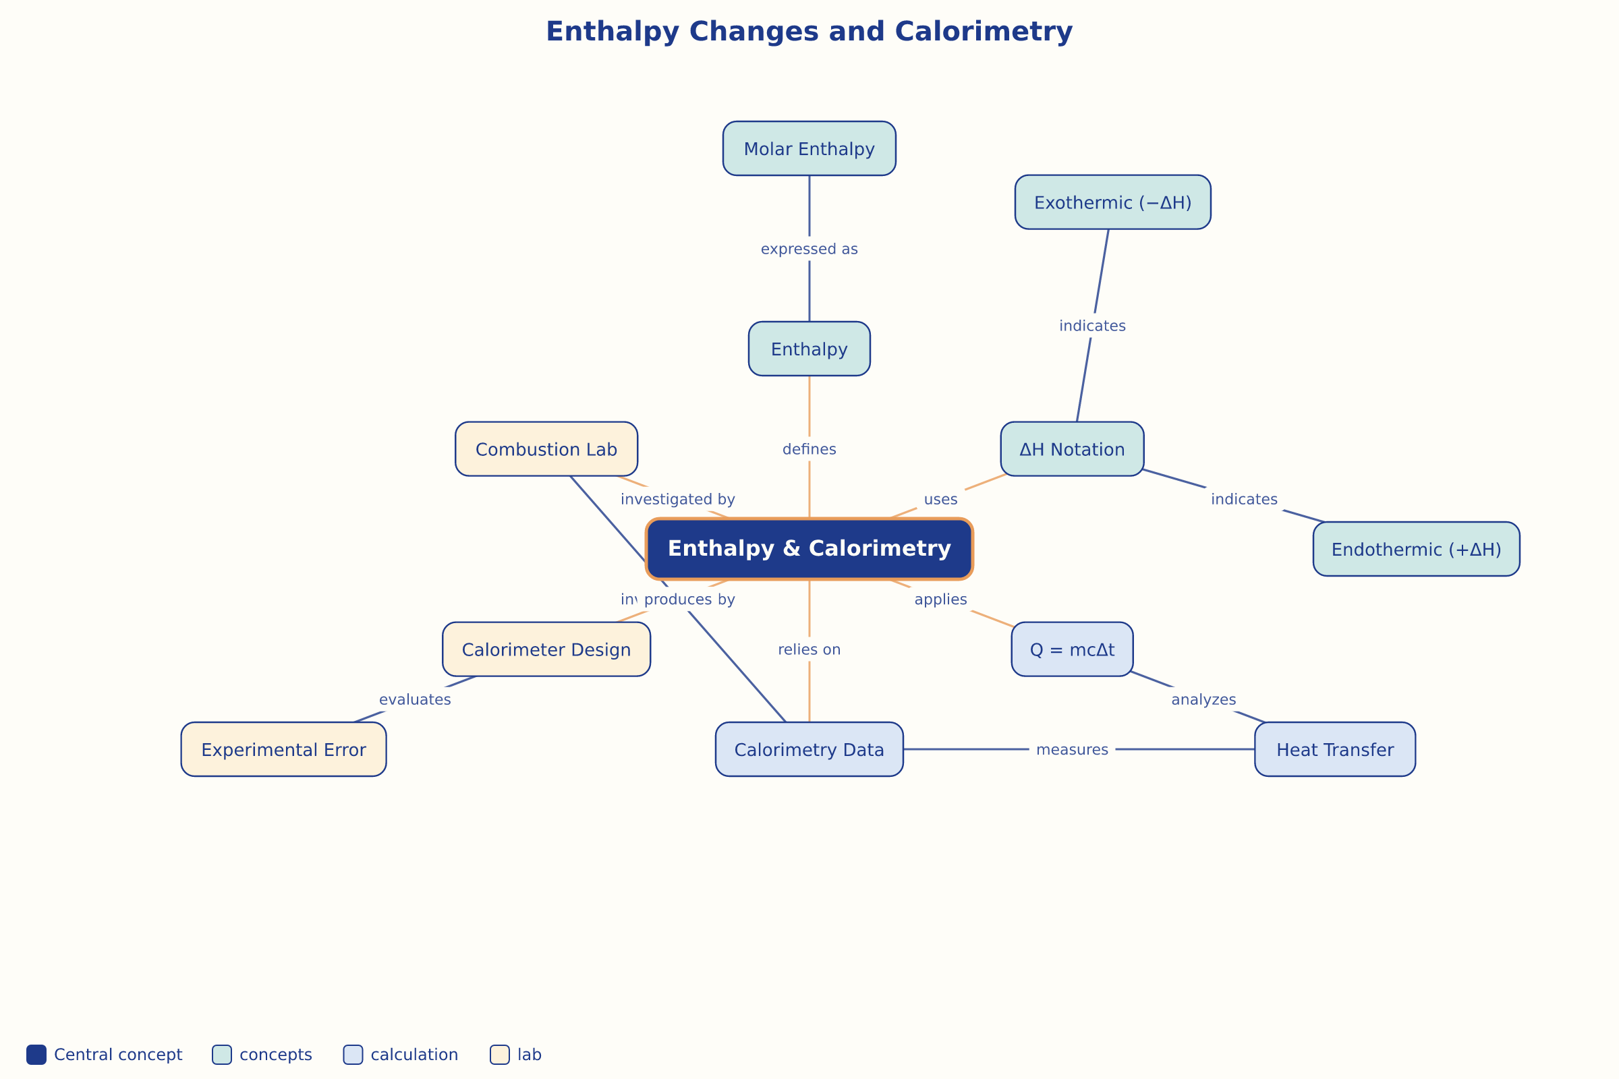

AILI word map · en · claude-sonnet-5 · 2026-09-17

