The Phonics Detective Puzzle
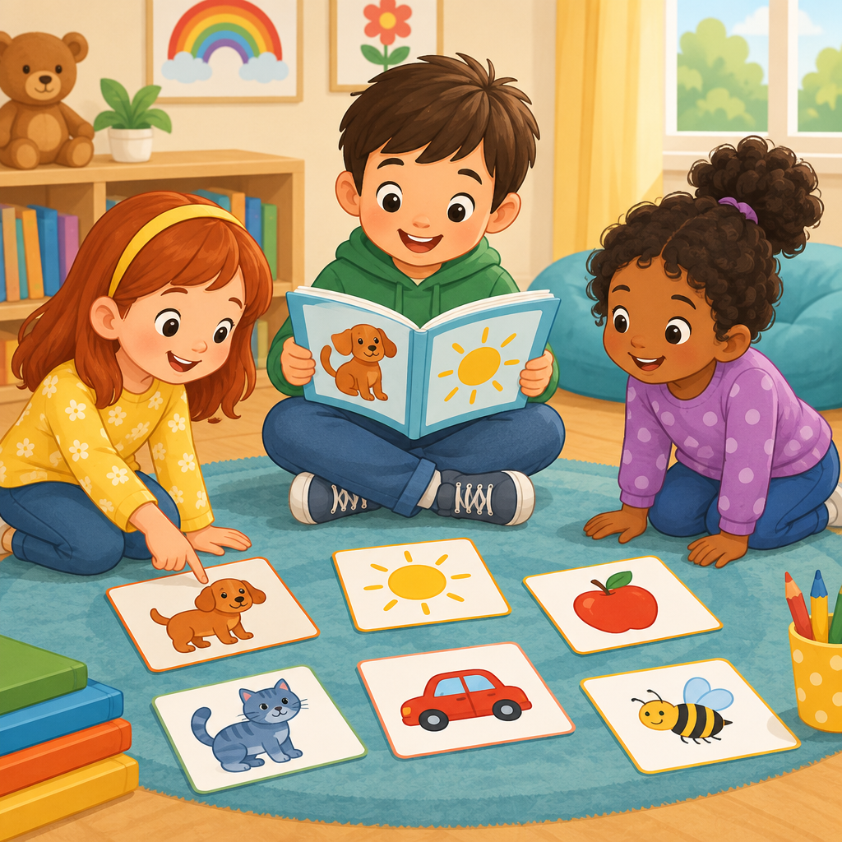
This brain teaser uses letters and sounds. Grade 1 students practice this when they connect graphemes (written letters) to phonemes (letter sounds) and blend sounds into words (Outcome, Details). Solving it means thinking carefully about clues. Readers sound out tricky words one step at a time (Guiding question).

How to play
- There are 3 students. Each one has one thing, and no two have the same thing.
- Read the 2 clues. Every clue is true.
- Write what you know in the grid. The answer key shows who has what.

The puzzle
Three Grade 1 students are practicing reading words during phonics time. Each student reads one word aloud to the class.
Maya, Owen and Priya each have one item from every category below, and no two of them share an item.
- Word each student reads: the word turn, the word bird, the word tiger
Use the clues to work out who has what. Mark in the grid what each clue rules out.
Name | Word each student reads
Maya
Owen
Priya

- Priya has the word turn.
- Maya does not have the word tiger.

Hints
- Start with clue 1. Mark in the grid what it rules out before you read on.
- Clues 1 and 2 together show that Maya has the word bird.
- Maya has the word bird.

Answer key
Name | Word each student reads
Maya | the word bird
Owen | the word tiger
Priya | the word turn

Reasoning
- Clue 1: Priya has the word turn. So Priya has the word turn.
- Clue 2: Maya does not have the word tiger. So Maya has the word bird and Owen has the word tiger.

AILI game · en · claude-sonnet-5 · 2026-09-17

