Displacement, Velocity and Acceleration: Definitions and Relationships
Understand how displacement, velocity and acceleration are defined and related through motion analysis.
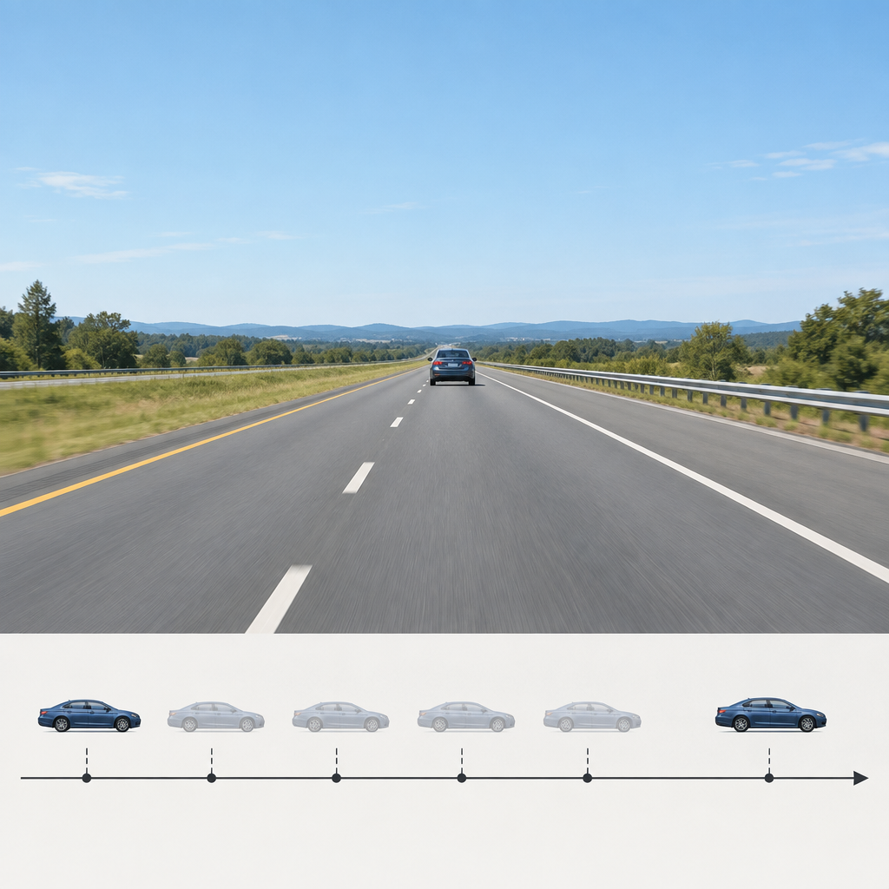

Learning intentions
We are learning to define displacement, velocity and acceleration both qualitatively and quantitatively, and to distinguish between scalar and vector quantities in the context of motion.

Success criteria
I can:
- Define displacement, velocity and acceleration with reference to position, time and direction.
- Distinguish between scalar and vector quantities and give examples of each.
- Calculate displacement, average velocity and acceleration from given data.
- Explain the relationship between displacement, velocity and acceleration in uniform and uniformly accelerated motion.

Curriculum alignment
Aligns to Topic, Outcome, Outcome, Outcome.

Materials
- Whiteboard and markers
- Meter tape or measuring wheel
- Stopwatch or timer (one per pair)
- Straight hallway or outdoor path at least 20 m long
- Handout: "Scalar and Vector Quantities" (one per student)
- Handout: "Motion Calculations" (one per student)
- Graph paper (one sheet per student)

Lesson sequence
1. Hook: Observing motion in the hallway (5 minutes)
Take the class to a hallway or outdoor space. Mark two points 20 m apart with tape or chalk. Ask a student volunteer to walk from the first point to the second at a steady pace while the class times the walk. Record the time.
Ask the class: "What did we just measure?" Collect responses. Guide them toward the idea that we measured how far the student moved and how long it took. Write on the board: "Position changed. Time passed."
Ask: "If the student had taken a different path, say, walking to the end of the hallway and back, would the distance walked be the same? Would the change in position be the same?" Take responses. Clarify that distance and displacement are different ideas, even though we often use the words loosely.
Return to the classroom.
2. Direct instruction: Defining displacement, velocity and acceleration (12 minutes)
Write the following on the board:
Displacement is the change in position from start to finish. It has both size and direction. We write it as Δx (read as "delta x"). Displacement = final position − initial position.
Ask: "In our hallway walk, what was the displacement?" (20 m in the direction we walked, or simply 20 m if we define one direction as positive.)
Velocity is the rate of change of displacement. It also has size and direction. Average velocity is displacement divided by the time taken.
Write: Average velocity = Δx / Δt
Ask: "What was the average velocity of our volunteer?" (If the walk took 20 seconds, average velocity = 20 m ÷ 20 s = 1 m/s in the direction of motion.)
Acceleration is the rate of change of velocity. It also has size and direction.
Write: Average acceleration = Δv / Δt = (final velocity − initial velocity) / time
Ask: "If our volunteer started from rest and reached 1 m/s after 5 seconds, what was the acceleration?" (Δv = 1 m/s − 0 m/s = 1 m/s; Δt = 5 s; acceleration = 1 m/s ÷ 5 s = 0.2 m/s².)
Now introduce scalar and vector quantities. Write on the board:
Scalar quantities have size (magnitude) only. Examples: distance (20 m), speed (1 m/s), time (20 s), mass (75 kg).
Vector quantities have both size and direction. Examples: displacement (20 m east), velocity (1 m/s east), acceleration (0.2 m/s² in the direction of motion).
Emphasize: "Displacement is not the same as distance. Velocity is not the same as speed. Displacement and velocity are vectors. Distance and speed are scalars."
Distribute the "Scalar and Vector Quantities" handout. Work through two examples together:
Example 1: A runner completes a 400 m lap on a track and returns to the starting line. The run takes 60 seconds.
- Distance travelled: 400 m (scalar).
- Displacement: 0 m (the runner returns to the start; vector).
- Average speed: 400 m ÷ 60 s ≈ 6.67 m/s (scalar).
- Average velocity: 0 m ÷ 60 s = 0 m/s (vector).
Example 2: A car accelerates from rest to 20 m/s in 8 seconds on a straight road.
- Change in velocity: Δv = 20 m/s − 0 m/s = 20 m/s.
- Average acceleration: 20 m/s ÷ 8 s = 2.5 m/s².
3. Guided practice: Calculations and motion scenarios (15 minutes)
Distribute the "Motion Calculations" handout. Work through the first three problems as a class. For each, ask students to identify what is given, what is asked, which formula to use, and what the answer tells us.
Problem 1: A cyclist travels 15 km east in 45 minutes. Calculate the average velocity.
Walk through: Given: displacement = 15 km east, time = 45 min = 0.75 h. Find: average velocity. Formula: v = Δx / Δt. Answer: v = 15 km ÷ 0.75 h = 20 km/h east.
Problem 2: A car's velocity changes from 10 m/s to 25 m/s over 6 seconds. Calculate the average acceleration.
Walk through: Given: initial velocity = 10 m/s, final velocity = 25 m/s, time = 6 s. Find: average acceleration. Formula: a = Δv / Δt. Answer: a = (25 − 10) m/s ÷ 6 s ≈ 2.5 m/s².
Problem 3: A ball is thrown upward and returns to the thrower's hand after 4 seconds. Is the displacement zero? Is the average velocity zero?
Walk through: Yes, the displacement is zero (the ball returns to its starting point). Yes, the average velocity is zero (displacement ÷ time = 0 ÷ 4 = 0). This is true even though the ball was moving the whole time.
Now ask students to work in pairs on Problems 4 and 5 from the handout. Circulate and check for correct identification of vectors vs. scalars and correct formula use.
Problem 4: A train travels 120 km north in 2 hours, then 80 km south in 1.5 hours. Calculate the total distance, total displacement, average speed and average velocity for the entire journey.
Expected answers: Distance = 200 km; Displacement = 40 km north; Average speed = 200 km ÷ 3.5 h ≈ 57 km/h; Average velocity = 40 km north ÷ 3.5 h ≈ 11.4 km/h north.
Problem 5: A runner accelerates from 4 m/s to 8 m/s over 3 seconds. What is the average acceleration?
Expected answer: a = (8 − 4) m/s ÷ 3 s ≈ 1.33 m/s².
4. Independent practice: Motion analysis and graphing (6 minutes)
Provide each student with a graph paper sheet and a simple motion scenario:
"A car starts from rest and accelerates uniformly at 2 m/s² for 10 seconds. Then it travels at constant velocity for 5 seconds."
Ask students to:
- Calculate the velocity at the end of the acceleration phase. (v = 0 + 2 m/s² × 10 s = 20 m/s.)
- Sketch a velocity-time graph showing both phases of motion.
- Write one sentence explaining what the slope of the line means in the acceleration phase.
Circulate and observe. Look for correct calculation of final velocity and correct interpretation of the graph.
5. Consolidation: Reflection and summary (2 minutes)
Gather the class. Ask: "What is the key difference between displacement and distance?" (Displacement includes direction and is the straight-line change in position; distance is the total path length.)
Ask: "Why does a runner who completes a lap have zero velocity but non-zero speed?" (Because velocity depends on displacement, which is zero; speed depends on distance, which is not zero.)
Collect the independent practice sheets. These will be reviewed for formative assessment.

Differentiation
Extension
Ask students to solve a two-step problem: "A car travels 50 m east at 10 m/s, then 30 m west at 6 m/s. Calculate the total displacement, total time, average velocity and average speed." (Displacement = 20 m east; time = 5 + 5 = 10 s; average velocity = 2 m/s east; average speed = 8 m/s.) Have them explain why average velocity and average speed are different.
Introduce instantaneous velocity as the limit of average velocity over a very short time interval. Ask: "How would you measure the instantaneous velocity of a car?" (Use a radar gun, or calculate the slope of a position-time graph at a single point.)
Support
Provide a worked example sheet with the formulas clearly labelled and step-by-step solutions to two problems. Pair the student with a peer during guided practice. Use a simplified scenario: "A student walks 10 m in 5 seconds. What is the average velocity?" Ensure they can identify given information, select the correct formula and substitute values before moving to multi-step problems.

Assessment
Formative checkpoint: Independent practice sheet
Collect the velocity-time graph and calculations from the motion scenario at the end of guided practice.
What to look for:
- Correct calculation of final velocity (20 m/s) using v = u + at.
- A velocity-time graph with two distinct phases: a sloped line (acceleration) from 0 to 20 m/s over 10 seconds, then a horizontal line at 20 m/s for the next 5 seconds.
- A written statement that correctly interprets slope as acceleration (e.g., "The slope of the line is 2 m/s², which is the acceleration").
Students who calculate velocity correctly but struggle with the graph can be supported with a template showing axes and scale. Students who complete the task early can be asked to calculate the total displacement during both phases and to sketch a position-time graph for the same scenario.

AILI rapid lesson · en · claude-haiku-4-5-20251001 · 2026-09-17

