The Comprehension Detectives: A Logic Puzzle
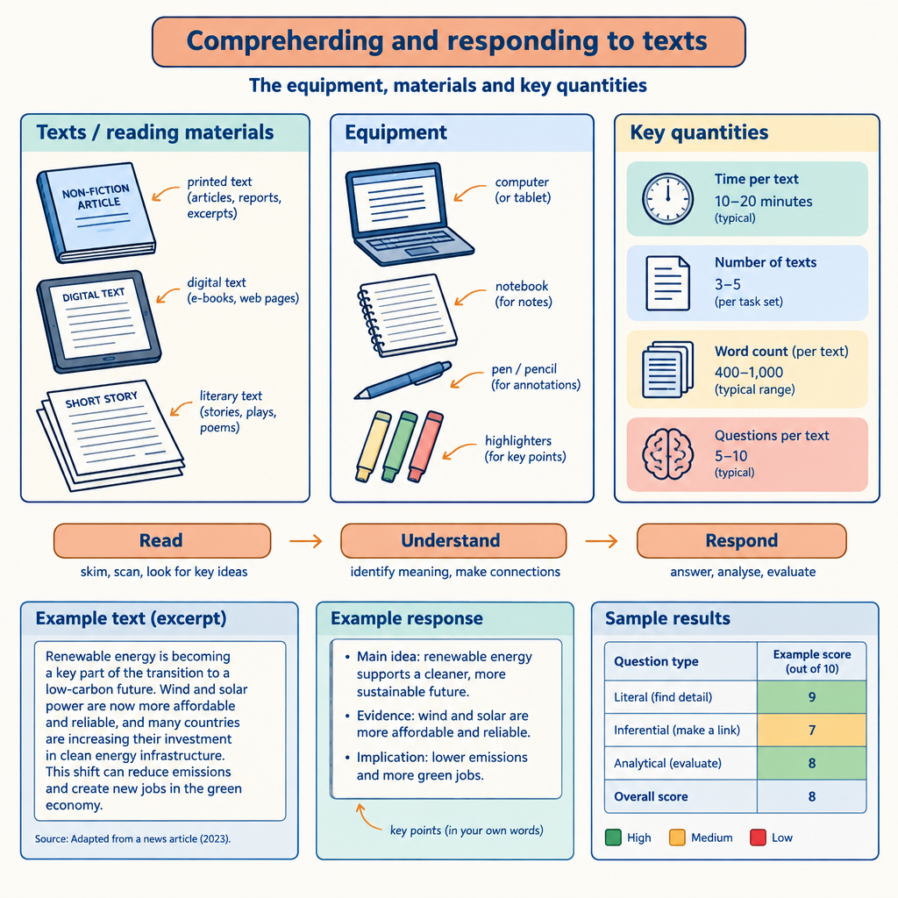
This puzzle challenges you to apply the same critical-thinking moves that underpin text comprehension: making inferences, drawing on context clues, and eliminating possibilities using stated and implied information. The reasoning skills required to solve it mirror those used to interpret texts, including synthesizing information, evaluating strategies, and analyzing evidence to reach a supported conclusion (Outcome, Details). Just as a reader distinguishes between what a text states outright and what it implies, you will need to separate the clues that are direct from those that require inference to solve the grid (Details).

How to play
- The puzzle is about 4 students and 3 categories. Each one has exactly one value in each category, and each value is used once.
- Read the 10 clues. Every clue is true. Use the grid to mark what is certain and cross out what is impossible.
- Exactly one arrangement fits every clue; the server has checked it. The hints go from gentle to direct, and the answer key shows the solution with the reasoning.

The puzzle
Four grade 12 students each apply a different comprehension strategy while analyzing a novel for their English Language Arts 30-1 seminar. Each student sits at a different table and finishes writing up findings on a different day of the week.
Priya, Declan, Farah and Marcus each have one item from every category below, and no two of them share an item.
- Comprehension strategy applied: making connections, evaluating bias, drawing conclusions from context clues, analyzing shifting perspectives
- Seminar table: table one, table two, table three, table four
- The order of finishing the write-up (in order, from first to fourth): first, second, third, fourth
Use the clues to work out who has what. Mark in the grid what each clue rules out.
Name | Comprehension strategy applied | Seminar table | The order of finishing the write-up
Priya
Declan
Farah
Marcus

- Declan has table two.
- The student with analyzing shifting perspectives also has third.
- The student with table four also has first.
- The student with table three also has fourth.
- Declan does not have second.
- The student with evaluating bias also has first.
- The student with drawing conclusions from context clues does not have fourth.
- Priya does not have second.
- Priya does not have first.
- Farah does not have table four.

Hints
- Start with clue 1. Mark in the grid what it rules out before you read on.
- Clues 1 to 5 together show that Declan has analyzing shifting perspectives.
- Declan has analyzing shifting perspectives, table two and third.

Answer key
Name | Comprehension strategy applied | Seminar table | The order of finishing the write-up
Priya | making connections | table three | fourth
Declan | analyzing shifting perspectives | table two | third
Farah | drawing conclusions from context clues | table one | second
Marcus | evaluating bias | table four | first

Reasoning
- Clue 1: Declan has table two. This fixes Declan has table two; 3456 arrangements remain.
- Clue 2: The student with analyzing shifting perspectives also has third. Nothing is fixed yet; 864 arrangements remain.
- Clue 3: The student with table four also has first. Nothing is fixed yet; 216 arrangements remain.
- Clue 4: The student with table three also has fourth. Nothing is fixed yet; 72 arrangements remain.
- Clue 5: Declan does not have second. This fixes Declan has analyzing shifting perspectives and Declan has third; 36 arrangements remain.
- Clue 6: The student with evaluating bias also has first. Nothing is fixed yet; 12 arrangements remain.
- Clue 7: The student with drawing conclusions from context clues does not have fourth. Nothing is fixed yet; 6 arrangements remain.
- Clue 8: Priya does not have second. Nothing is fixed yet; 4 arrangements remain.
- Clue 9: Priya does not have first. This fixes Priya has making connections, Priya has table three and Priya has fourth; 2 arrangements remain.
- Clue 10: Farah does not have table four. This fixes Farah has drawing conclusions from context clues, Marcus has evaluating bias, Farah has table one, Marcus has table four, Farah has second and Marcus has first, and only one arrangement remains.

AILI game · en · claude-sonnet-5 · 2026-09-17

