Vertex Form and Key Features of Quadratic Functions
Analyze parabolas in vertex form to identify transformations and graph characteristics.
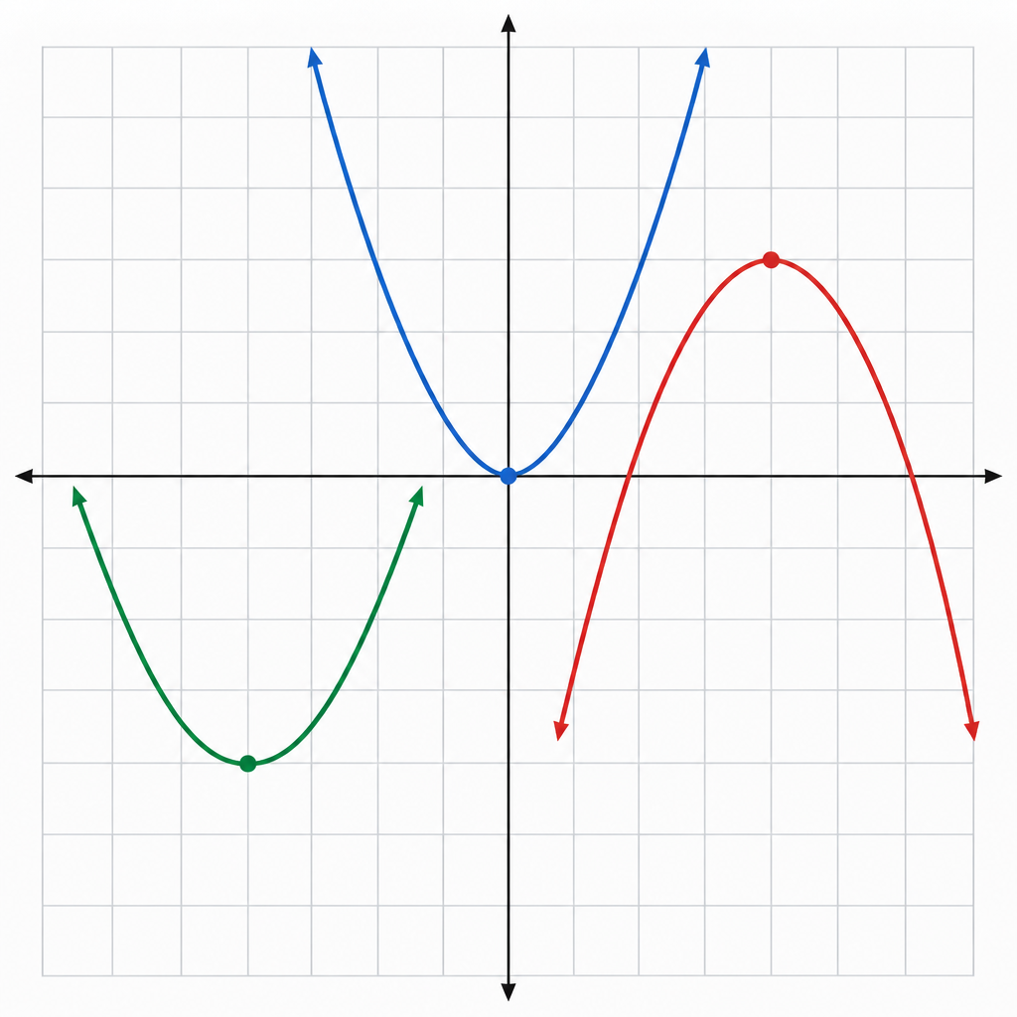

Learning intentions
We are learning to identify and interpret the vertex, axis of symmetry, domain, range, and direction of opening for quadratic functions written in vertex form y = a(x − p)² + q.

Success criteria
I can determine the vertex of a quadratic function in vertex form.
I can state the axis of symmetry from the equation.
I can identify the direction of opening and describe the effect of the parameter a.
I can find the domain and range of a quadratic function.
I can sketch the graph of a quadratic function using vertex form information.

Curriculum alignment
Analyze quadratic functions of the form y = a(x − p)² + q and determine the vertex, domain and range, direction of opening, axis of symmetry, and x- and y-intercepts (Outcome).
Graph and analyze absolute value functions limited to linear and quadratic functions to solve problems (Outcome).

Materials
Graphing technology (graphing calculator or software such as Desmos)
Printed or projected coordinate planes (at least 4 per student)
Ruler
Function cards with equations in vertex form (prepared in advance)
Student worksheet with 6 quadratic equations in vertex form

Lesson sequence
1. Hook (5 minutes)
Display three parabolas on screen or board without equations. Ask students: "What do all three of these curves have in common? What is different?" Take responses. Guide toward the idea that each has a highest or lowest point (the vertex) and opens either up or down.
Say: "Today we are going to learn how to read all of that information directly from an equation, without having to plot points or use a calculator. The equation form we use is called vertex form, and it tells us almost everything we need to know."
2. Direct instruction (12 minutes)
Write on the board: y = a(x − p)² + q
Say: "This is vertex form. Each letter tells us something specific about the graph."
Point to the vertex (p, q). Say: "The vertex is the point (p, q). That is the lowest point if the parabola opens up, or the highest point if it opens down. Notice that p appears as a subtraction inside the bracket. If the equation says (x − 3)², the p-value is 3, not −3. If it says (x + 2)², we rewrite it as (x − (−2))², so p = −2."
Write three examples on the board:
y = (x − 2)² + 3. Vertex is (2, 3).
y = (x + 1)² − 5. Rewrite as (x − (−1))² − 5. Vertex is (−1, −5).
y = 2(x − 0)² + 0, or y = 2x². Vertex is (0, 0).
Ask students to state the vertex for each. Correct any sign errors.
Point to the parameter a. Say: "The number in front, a, tells us two things. First, if a is positive, the parabola opens upward. If a is negative, it opens downward. Second, the size of a tells us how wide or narrow the parabola is. If |a| > 1, the parabola is narrower. If 0 < |a| < 1, it is wider."
Write: y = 3(x − 1)² + 2 and y = (1/4)(x − 1)² + 2
Say: "Both have the same vertex (1, 2), but the first is narrow and the second is wide."
Point to the axis of symmetry. Say: "The axis of symmetry is a vertical line through the vertex. Its equation is x = p. For y = (x − 2)² + 3, the axis of symmetry is x = 2."
State domain and range. Say: "The domain of any quadratic function is all real numbers. We write that as (−∞, ∞) or in set notation. The range depends on which way the parabola opens. If it opens upward with vertex at (p, q), the range is [q, ∞). If it opens downward, the range is (−∞, q]."
Write an example: y = −2(x + 3)² + 5
Vertex: (−3, 5). Opens downward. Domain: all real numbers. Range: (−∞, 5].
3. Guided practice (10 minutes)
Distribute the student worksheet. Work through the first two equations together as a class.
Equation 1: y = (x − 4)² − 1
Ask: "What is the vertex?" (4, −1). "Which way does it open?" Upward (a = 1 > 0). "What is the axis of symmetry?" x = 4. "What is the range?" [−1, ∞).
Equation 2: y = −(1/2)(x + 2)² + 6
Ask: "Rewrite this so p is clear." y = −(1/2)(x − (−2))² + 6. "Vertex?" (−2, 6). "Direction?" Downward. "Axis of symmetry?" x = −2. "Range?" (−∞, 6].
Students analyze quadratic functions to determine characteristics including vertex, domain and range, direction of opening, axis of symmetry, and x- and y-intercepts. Circulate and listen for correct identification of p and q, and correct interpretation of the sign of a. Ask: "How do you know which way it opens?" and "What does the number in front tell you?"
4. Independent practice (10 minutes)
Students analyze quadratic functions of the form y=ax²+bx+c to identify characteristics of the corresponding graph. Provide a summary box on the worksheet:
Vertex form: y = a(x − p)² + q
Vertex: (p, q)
Axis of symmetry: x = p
Direction of opening: upward if a > 0; downward if a < 0
Domain: all real numbers
Range: [q, ∞) if a > 0; (−∞, q] if a < 0
Circulate. Ask individual students: "How did you find p?" and "What does the negative sign in front tell you about the graph?"
5. Consolidation (3 minutes)
Ask: "If I tell you the equation y = 2(x − 5)² − 3, what three things can you tell me right away without graphing?" Take responses: vertex (5, −3), opens upward, axis of symmetry x = 5.
Say: "Next lesson we will find the x- and y-intercepts by solving, and we will see how to convert between vertex form and standard form. For now, you know how to read the shape and position of any parabola from its vertex form equation."

Differentiation
Support
Provide a completed example card that students can reference while working. Use equations with integer values of p and q only (no fractions or decimals). Pair students with a peer mentor during independent practice. Students analyze quadratic functions to determine vertex, domain and range, direction of opening, axis of symmetry, and x- and y-intercepts.
Extension
Ask students to sketch the graph of y = a(x − p)² + q by hand, using only the vertex and axis of symmetry, and by testing the direction of opening. Then compare to a graphing calculator.
Provide equations with fractional or negative values of a and ask students to explain how the parabola differs from the parent function y = x².
Ask: "If I shift the parabola y = (x − 2)² + 3 left by 1 unit and down by 2 units, what is the new equation?" (Answer: y = (x − 1)² + 1.)

Assessment
Assessment of student understanding of quadratic function analysis.
Collect or observe student responses to equations 5 and 6 on the worksheet.
Look for:
Correct identification of p (including correct handling of the sign inside the bracket).
Correct identification of q.
Correct statement of the axis of symmetry as x = p.
Correct identification of the direction of opening based on the sign of a.
Correct range notation using interval notation or set notation, with the correct inequality direction and endpoint.
If a student has made an error, ask: "Show me where p is in the equation" or "How do you know if it opens up or down?" to identify whether the error is in reading the form or in understanding the meaning of a.

AILI rapid lesson · en · claude-haiku-4-5-20251001 · 2026-09-17

