Variation Within Species: Why Organisms in the Same Species Look Different
Discover how individuals in a single species can have wildly different traits, and why that variation matters for survival.
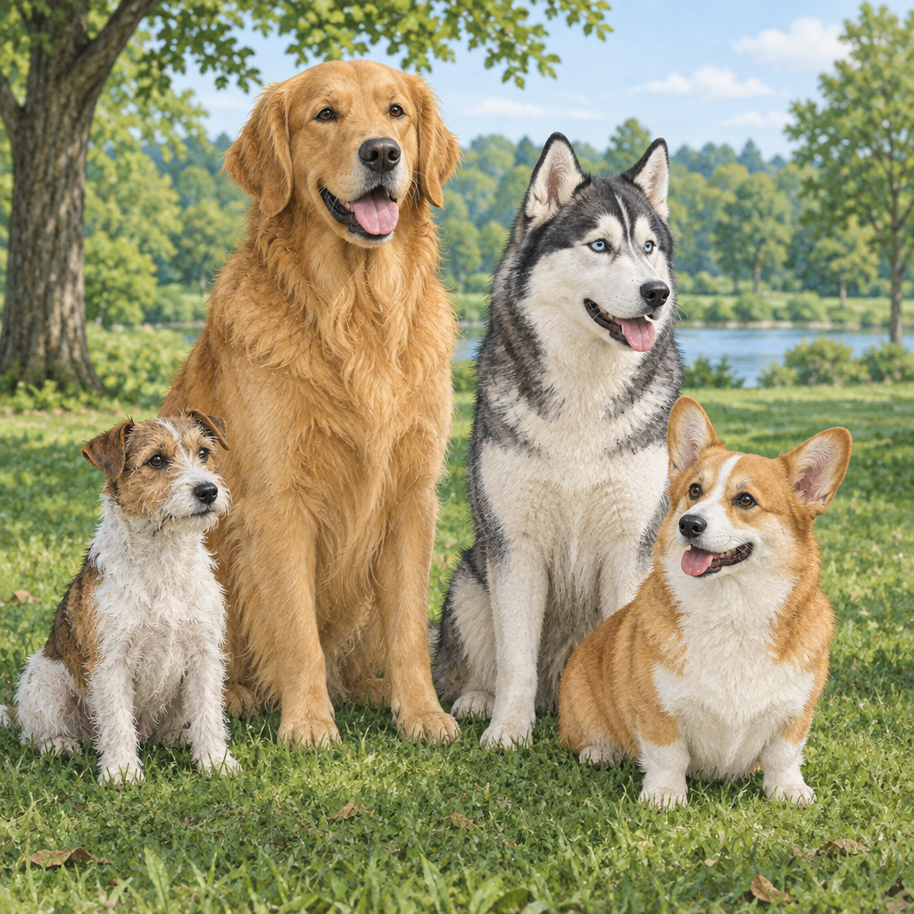

Learning intentions
We are learning to observe and describe variation within a species, distinguish between heritable and non-heritable traits, and explain why variation affects an organism's chances of survival.

Success criteria
I can identify examples of discrete and continuous variation within a species.
I can distinguish between heritable characteristics and those shaped by the environment.
I can explain how variation in a population helps species survive when conditions change.

Curriculum alignment
Describes examples of variation within a species and identifies discrete and continuous variation (Outcome, Outcome).
Distinguishes heritable characteristics from those that are not, and identifies characteristics influenced by both heredity and environment (Outcome, Outcome).
Identifies the role of variation in species survival under changing environmental conditions (Outcome, Outcome).

Materials
Rulers (one per student or pair)
Handout: "Trait Observation Sheet" (printed or digital)
Images of five dog breeds (provided or sourced)
Chart paper and markers
Optional: images of peppered moths (light and dark variants)

Lesson sequence
Stage 1: Hook (5 minutes)
Display the image of diverse dog breeds on screen or as a printed poster. Ask students: "These are all dogs. The same species. So why do they look so different?"
Take two minutes of responses. Guide students toward noticing size, ear shape, coat colour, leg length. Write their observations on the board without organizing them yet.
Ask: "If I bred two golden retrievers together, would their puppies always look exactly like their parents?" Pause for quick answers. Tell them: "That's what we're investigating today. Variation exists even within a species, and it matters more than you might think."
Stage 2: Direct instruction (10 minutes)
Explain the two main types of variation using real examples (Outcome):
Discrete variation: traits that fall into distinct categories with no in-between. Hand clasping preference is a classic example. Ask students to clasp their hands naturally. Most will put either the left or right thumb on top. There is no middle ground. Ask: "Who has their left thumb on top?" Count. "Right thumb?" Count. Show that the class splits into two clear groups.
Continuous variation: traits that exist on a spectrum. Human hand length varies on a continuum. Some people have very small hands, some very large, and most fall somewhere in the middle. You cannot sort people into "small" and "large" without drawing an arbitrary line.
Now introduce heritable versus non-heritable traits (Outcome, Outcome):
Heritable traits are passed from parents to offspring through genes. Eye colour is heritable. If both your parents have brown eyes, you are very likely to have brown eyes too.
Non-heritable traits are shaped by the environment or by what happens to an organism during its life. A scar is not heritable. Your parent's scar will not appear on your skin. A language you speak is not heritable; you learn it from your environment.
Some traits are influenced by both heredity and environment. Height is largely determined by genes, but diet also plays a role. A person with genes for tall height may be shorter if they are malnourished. Muscle strength is partly genetic but also depends on exercise and training.
Show the peppered moth example if available (or describe it): in industrial areas with dark soot on trees, dark moths survived better because they were harder to spot. Variation in characteristics exists within populations. Characteristics can show variation within a species, with some traits being discrete and others continuous.
Stage 3: Guided practice (12 minutes)
Distribute the "Trait Observation Sheet" (see template below). Work through the first example together as a class.
Trait Observation Sheet
For each trait, decide: Is it discrete or continuous? Is it heritable, non-heritable, or both? Explain your reasoning.
- Hair colour in humans
- Discrete or continuous?
- Heritable, non-heritable, or both?
- Why?
- Ability to roll your tongue
- Discrete or continuous?
- Heritable, non-heritable, or both?
- Why?
- Height in humans
- Discrete or continuous?
- Heritable, non-heritable, or both?
- Why?
- Scars on skin
- Discrete or continuous?
- Heritable, non-heritable, or both?
- Why?
- Fingerprint patterns
- Discrete or continuous?
- Heritable, non-heritable, or both?
- Why?
Work through trait 1 (hair colour) aloud. Ask: "Does hair colour come in distinct types, or does it exist on a spectrum?" Guide students to see that hair colour ranges from very light to very dark, with many shades in between. It is continuous. Ask: "Is it heritable?" Yes, children's hair colour is strongly influenced by their parents' hair colour. Ask: "Can the environment change it?" Yes, sun exposure can lighten hair, and dyes change colour, but those changes are not passed to offspring. So hair colour is heritable, though the environment can modify it during a person's lifetime.
Students investigate the transmission of characteristics from parents to offspring. Circulate and prompt with questions: "Can you think of examples from your own family?" "Does this trait run in families?" "Can you change it yourself, and would that change pass to your kids?"
Bring the class together after 8 minutes. Ask pairs to share their answers for one trait each. Record answers on chart paper.
Stage 4: Independent practice (10 minutes)
Hand out rulers. Ask students to measure the length of their hand from wrist to the tip of their middle finger, in centimetres. Record the measurement on a sticky note with their initials (no full names to preserve privacy).
Collect all sticky notes. Create a human bar graph on the board or on chart paper, arranging measurements from smallest to largest. Students identify examples of characteristics in offspring that are the same as both parents, the same as one parent, or intermediate between parent characteristics.
Ask: "Is hand length discrete or continuous?" Students should see a range, a spectrum. "Why might people have different hand lengths?" Prompt them to consider genetics (parents' hand sizes), nutrition during childhood, and age (older students typically have larger hands than younger ones).
Ask: "If hand length is partly genetic, what would happen if we measured the hands of your parents? Would they be similar to yours?" Discuss how children's hand lengths often fall between their parents' measurements, or resemble one parent more closely.
Ask: "Why does this variation matter?" Guide them toward the idea that variation in a population means the population can adapt. If the environment changes, some individuals in the population are already suited to the new conditions.
Stage 5: Consolidation (3 minutes)
Ask: "Why would a species with lots of variation have a better chance of surviving if the environment changed suddenly?"
Take one or two responses. Reinforce: "If a disease spreads, some individuals in a population might naturally be resistant. If the climate gets colder, some individuals might have traits that help them survive cold. Variation is like a toolkit. The more tools you have, the more problems you can solve."
Close with: "Next lesson, we'll look at how these traits get passed down and why some traits show up in children even when their parents don't have them."

Differentiation
Extension
Ask students to research a real example of variation within a species and present a one-paragraph explanation of whether the variation is discrete or continuous, heritable or non-heritable, and how it might affect survival. Examples: beak size in Darwin's finches, coat colour in wild rabbits, shell patterns in snails.
Introduce the concept of dominant and recessive traits (Outcome). Ask: "If eye colour is controlled by genes, and brown is dominant over blue, what eye colours could two brown-eyed parents have in their children?" Work through a simple Punnett square.
Support
Provide a partially completed trait observation sheet with some answers filled in. Ask students to complete the remaining rows using the same reasoning pattern.
Use only three traits instead of five on the observation sheet: hair colour, ability to roll tongue, and height.
Pair students with a stronger reader or provide audio versions of trait descriptions.
During the hand-length activity, allow students to work in a small group with direct teacher guidance. Ask simpler questions: "Is this measurement bigger or smaller than your hand? Bigger or smaller than your friend's hand?"

Assessment
Formative checkpoint (during Stage 3)
Listen to students' explanations as they work through the trait observation sheet in pairs. Look for:
Can they identify whether a trait is discrete (distinct categories) or continuous (spectrum)?
Do they use reasoning based on inheritance ("My parents have this trait too") or environment ("I got a scar, but my parents don't have it")?
Can they name at least one example of a trait influenced by both heredity and environment?
If a pair struggles, ask a follow-up question: "Does this trait run in families?" or "Can the environment change this trait?" to scaffold their thinking. Note which students need additional practice with the heredity-versus-environment distinction and plan a brief check-in before the next lesson.

AILI rapid lesson · en · claude-haiku-4-5-20251001 · 2026-09-17

