Enthalpy Changes and Calorimetry
Central concept: Enthalpy & Calorimetry

Connections
- Enthalpy & Calorimetry (defines) -> Enthalpy
- Enthalpy (expressed as) -> Molar Enthalpy
- Enthalpy & Calorimetry (uses) -> Q = mcΔt
- Q = mcΔt (models) -> Heat Transfer
- Enthalpy & Calorimetry (generates) -> Calorimetry Data
- Calorimetry Data (determines) -> Enthalpy
- Enthalpy & Calorimetry (conducted via) -> Calorimetry Experiments
- Calorimetry Experiments (example) -> Polystyrene Calorimeter
- Calorimetry Experiments (example) -> Combustion Calorimetry
- Calorimetry Experiments (uses) -> Computer-Based Lab
- Enthalpy & Calorimetry (requires) -> Data Analysis
- Data Analysis (produces) -> Energy Diagrams

Notes
- Enthalpy & Calorimetry: Unit A: Thermochemical Changes, Chemistry 30 General Outcome 1 Resource
- Enthalpy: Heat content of a system; molar enthalpy defined per mole of reaction (Outcome, Outcome) Outcome, Outcome
- Molar Enthalpy: Enthalpy change expressed per mole of substance reacted (Outcome, Outcome) Outcome, Outcome
- Q = mcΔt: Equation used to analyze heat transfer between substances (Outcome, Outcome) Outcome, Outcome
- Heat Transfer: Energy moves from a system to surroundings, or vice versa, measured via Q = mcΔt (Outcome) Outcome
- Calorimetry Data: Experimental measurements used to determine enthalpy changes of reactions (Outcome) Outcome
- Calorimetry Experiments: Investigations to determine molar enthalpy change using thermometers or temperature probes (Outcome) Outcome
- Calorimetry: Methods for measuring enthalpy changes in chemical reactions
- Enthalpy and Molar Enthalpy: Defining enthalpy and molar enthalpy for chemical reactions
- Computer-Based Lab: Compiles and organizes calorimetry data to demonstrate molar enthalpy change (Outcome) Outcome
- Data Analysis: Analyzing data and energy diagrams to compare energy changes across reactions (Outcome) Outcome
- Energy Diagrams: Visual models comparing energy changes among different chemical reactions (Outcome) Outcome
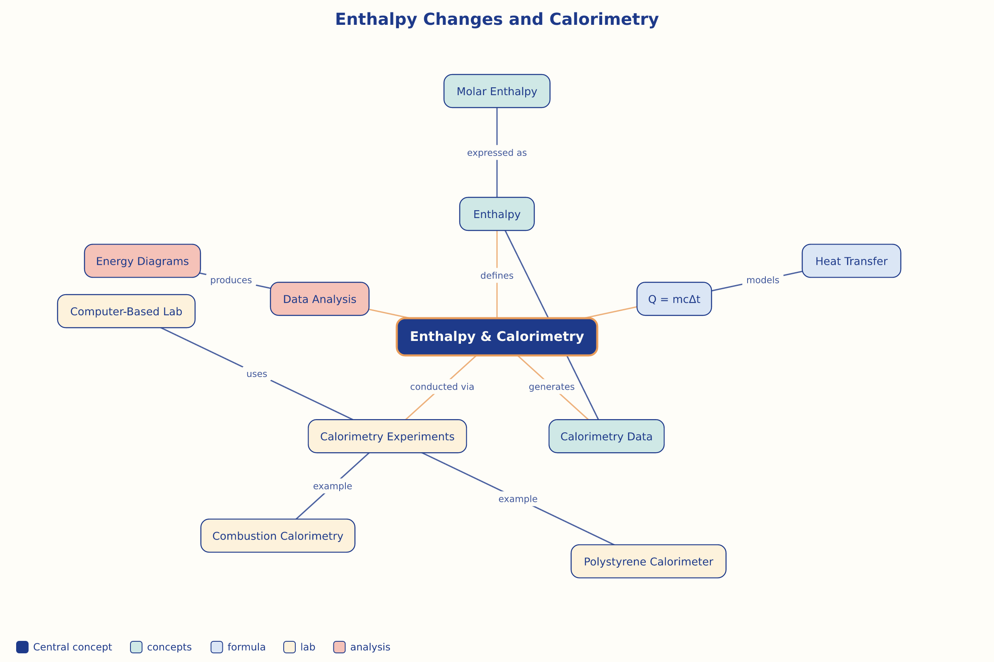

AILI word map · en · claude-sonnet-5 · 2026-09-17

