Mystery of the Three States
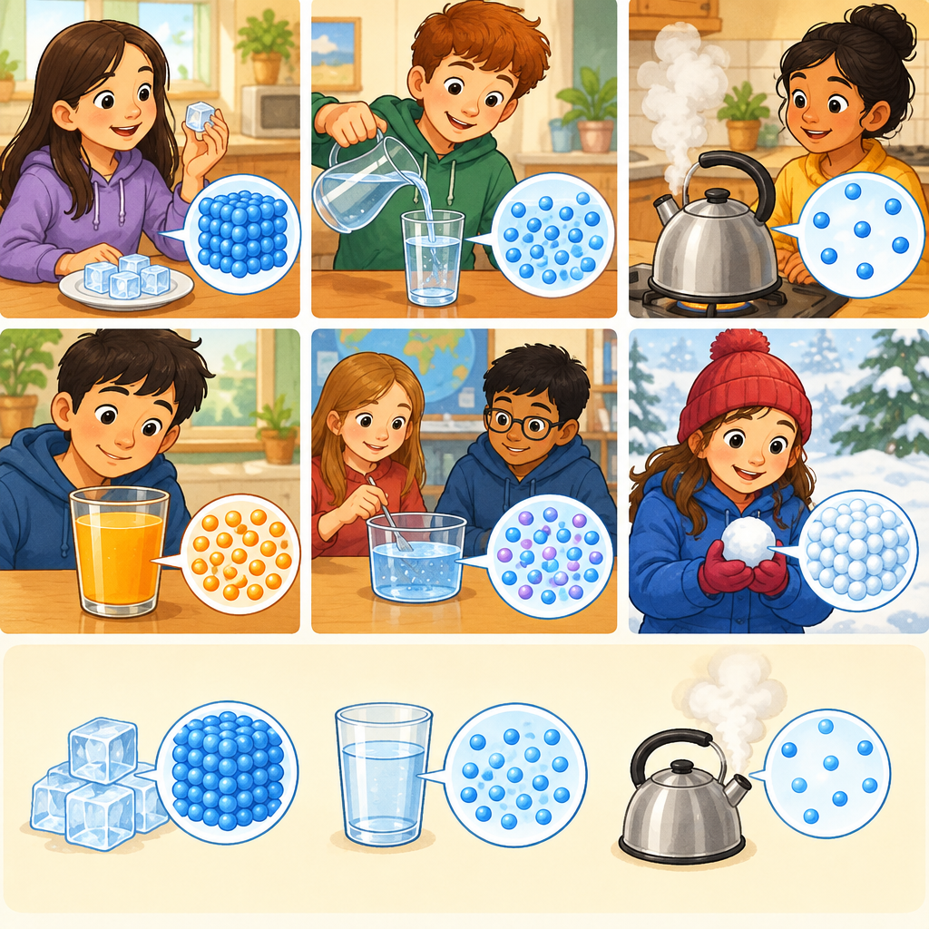
In Grade 5, you are learning how the particle model of matter explains why solids, liquids, and gases behave so differently (Outcome, Knowledge). This puzzle asks you to use what you know about how particles move and how close together they are to solve a mystery about three mystery substances.

The Puzzle
Three mystery substances sit in front of you: a block of wood, a cup of water, and a balloon full of air. You cannot see inside them, but you know one fact about each.
Substance A: When you push on it hard, it does not get smaller at all. It keeps its shape no matter what.
Substance B: When you push on it, it gets noticeably smaller. You can squeeze it down to half its size.
Substance C: When you push on it gently, it does not change size much. It takes the shape of whatever container you pour it into, but it stays about the same volume.
Which substance is the wood, which is the water, and which is the air? Write A, B, or C next to each one. Then explain your answer using what you know about how particles are arranged and how they move.

Hints
Hint 1: Think about the spaces between particles. Which state of matter has the biggest spaces between its particles?
Hint 2: In solids, particles are packed tightly and vibrate in place. In liquids, particles have some space between them but are still fairly close. In gases, particles are spread far apart with huge spaces between them.
Hint 3: Compressibility means how much something can be squeezed smaller. Gases are easy to compress because there is so much empty space between the particles. Liquids are hard to compress because the particles are already close together. Solids cannot be compressed because the particles are locked in place.

Answer Key
Wood = A, Water = C, Air = B
The reasoning:
Wood is a solid. Solids have particles packed closely together with strong attractive forces holding them in place (Knowledge). When you push on wood, the particles cannot move closer together because they are already as close as they can be. The wood does not get smaller.
Water is a liquid. Liquids have particles separated by spaces, but the particles can slide past each other (Knowledge). When you pour water into a container, it takes the shape of that container but keeps roughly the same volume. Pushing on water does not make it much smaller because the particles are already fairly close together.
Air is a gas. Gases have particles separated by large spaces and are constantly moving in all directions (Knowledge). When you push on air in a balloon, the particles get pushed closer together, so the balloon shrinks. Gases are compressible because there is so much empty space between the particles (Knowledge). You can squeeze that space out.

AILI game · en · claude-haiku-4-5-20251001 · 2026-09-17

