Enthalpy Changes and Calorimetry
Using measured temperature changes to calculate the energy released or absorbed in a chemical reaction.
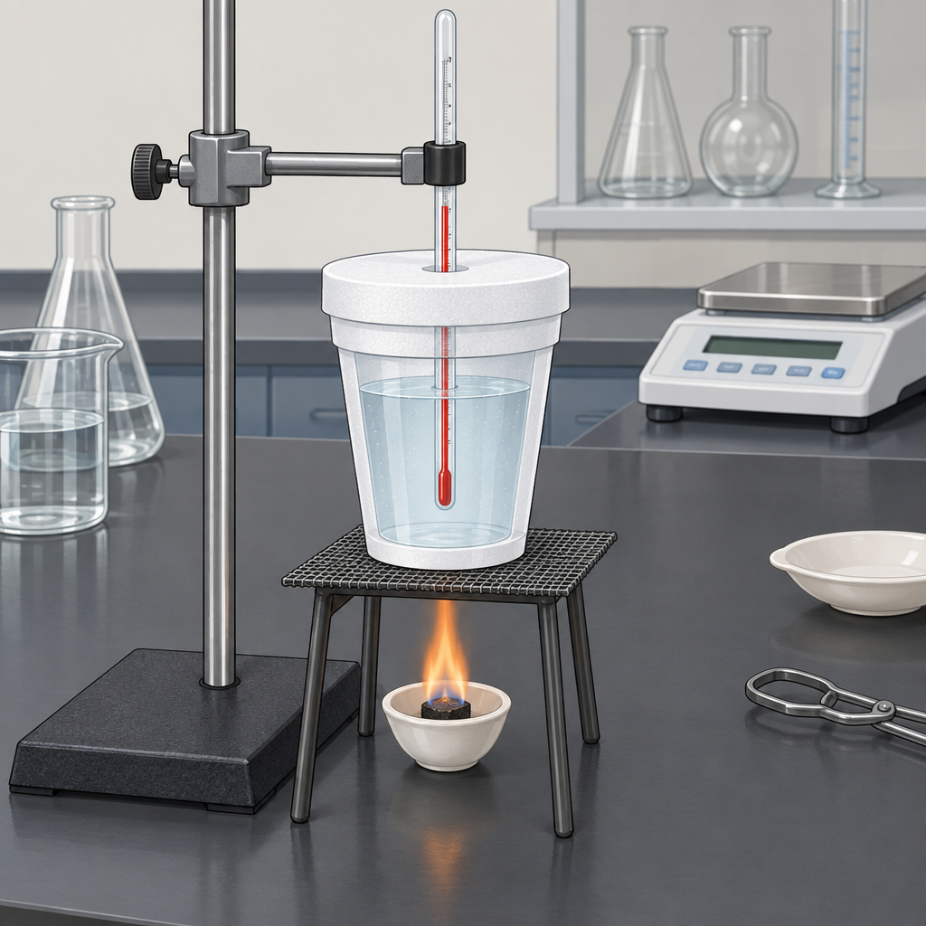

Learning intentions
We are learning to calculate heat transfer using Q = mcΔt and to use calorimetry data to determine the enthalpy change of a reaction, expressing that change with correct ΔH notation.

Success criteria
I can define enthalpy and molar enthalpy for a chemical reaction.
I can apply Q = mcΔt to calculate the heat absorbed or released by a substance.
I can use calorimetry data (mass, specific heat capacity, temperature change) to calculate ΔH for a reaction, including molar enthalpy.
I can write and interpret ΔH notation correctly, including sign conventions for exothermic and endothermic processes.

Curriculum alignment
- 30-A1.1k: recall the application of Q = mcΔt to the analysis of heat transfer (Outcome, Outcome)
- 30-A1.3k: define enthalpy and molar enthalpy for chemical reactions (Outcome, Outcome)
- 30-A1.5k: use and interpret ΔH notation to communicate and calculate energy changes in chemical reactions (Outcome)
- 30-A1.8k: use calorimetry data to determine the enthalpy changes in chemical reactions (Outcome)

Materials
- Whiteboard or projector for worked examples
- Student calculators
- Handout with the calorimetry data table (mass of water, initial and final temperatures, mass of fuel burned) for the guided and independent practice problems
- Specific heat capacity of water reference value (4.19 J/(g·°C))
- Optional: photographs or short clip from the nut-combustion calorimetry investigation for context (Resource)
- Optional: reference to the polystyrene-cup calorimeter construction lab for a follow-up hands-on lesson (Resource)

Lesson sequence
1. Hook (5 minutes)
Write on the board: "A 2.10 g sample of a peanut is burned under a can of water. The water's temperature rises from 22.0°C to 45.5°C. The can holds 100.0 g of water."
Ask the class: "Without doing any math yet, which direction is the energy moving, from the peanut to the water, or from the water to the peanut? How do you know?"
Take two or three verbal answers. Confirm: energy moves from the burning peanut to the water, so the water gains heat and the reaction (combustion) releases heat. This is the setup used in Resource.
2. Direct instruction (10 minutes)
State the definitions: enthalpy (H) is the heat content of a system at constant pressure. Enthalpy change (ΔH) is the heat absorbed or released during a reaction at constant pressure. Molar enthalpy is the enthalpy change per mole of a specified substance in the reaction, expressed in kJ/mol (Outcome).
Write the sign convention on the board:
Exothermic reaction: heat is released, ΔH is negative, temperature of the surroundings (the water) increases.
Endothermic reaction: heat is absorbed, ΔH is positive, temperature of the surroundings decreases.
Present the formula: Q = mcΔt, where Q is heat in joules, m is the mass of the substance absorbing or releasing heat (usually the water) in grams, c is the specific heat capacity in J/(g·°C), and Δt is the final temperature minus the initial temperature (Outcome).
Work the hook example on the board step by step:
Q = mcΔt
Q = (100.0 g)(4.19 J/(g·°C))(45.5°C − 22.0°C)
Q = (100.0 g)(4.19 J/(g·°C))(23.5°C)
Q = 9846.5 J
Q ≈ 9.85 kJ
State: "This is the heat gained by the water. Since energy is conserved, the peanut released 9.85 kJ. Because the reaction released energy, the enthalpy change for the reaction is negative: ΔH = −9.85 kJ for this sample" (Outcome, Outcome).
Show how to convert to molar enthalpy. Molar mass of the fuel is needed. If the peanut sample has an approximate molar mass and 2.10 g corresponds to 0.0120 mol of fuel (fictional value for illustration), then:
ΔH(molar) = ΔH ÷ n
ΔH(molar) = −9.85 kJ ÷ 0.0120 mol
ΔH(molar) ≈ −821 kJ/mol
3. Guided practice (10 minutes)
Distribute or display this problem and work through it together, calling on students for each step:
"In a calorimetry trial, 150.0 g of water is heated from 19.5°C to 38.2°C by burning 1.35 g of a fuel with a molar mass of 46.07 g/mol (ethanol). Calculate the heat absorbed by the water, the enthalpy change for the combustion of this sample, and the molar enthalpy of combustion."
Ask: "What is Δt?" (38.2°C − 19.5°C = 18.7°C)
Ask: "What is Q?" Have a student calculate at the board:
Q = (150.0 g)(4.19 J/(g·°C))(18.7°C) = 11,753 J ≈ 11.75 kJ
Ask: "What is ΔH for the reaction, and what sign does it have, and why?" (ΔH = −11.75 kJ, negative because combustion is exothermic and the water gained heat.)
Ask: "How many moles of ethanol were burned?"
n = 1.35 g ÷ 46.07 g/mol = 0.0293 mol
Ask: "What is the molar enthalpy of combustion?"
ΔH(molar) = −11.75 kJ ÷ 0.0293 mol ≈ −401 kJ/mol
Checkpoint question to the whole class: "Why do we divide by moles instead of grams to get molar enthalpy?" Listen for: molar enthalpy compares reactions on a per-particle (per-mole) basis rather than a per-gram basis, which allows fair comparison between different substances.
4. Independent practice (10 minutes)
Students work individually or in pairs on this problem, writing full solutions with units at each step:
"A student burns 0.85 g of a candle wax sample under 200.0 g of water. The water temperature rises from 21.0°C to 33.4°C. The molar mass of the wax is 226 g/mol. Calculate: (a) the heat gained by the water, (b) the enthalpy change for the sample burned, with correct sign and ΔH notation, and (c) the molar enthalpy of combustion for the wax."
Circulate and check that students are:
using Δt as final minus initial temperature.
carrying the correct sign through from Q to ΔH.
converting grams of fuel to moles before dividing.
reporting ΔH with units of kJ or kJ/mol as appropriate (Outcome, Outcome).
5. Consolidation (5 minutes)
Bring the class back together. Ask one pair to share their final answer for part (c) and their reasoning for the sign.
Ask the whole class: "If this had been an endothermic process instead, for example an ice pack absorbing heat from your hand, what would change in this calculation?" Listen for: the water (or surroundings) would lose heat, Δt would be negative, and ΔH for the process would be reported as positive.
Close by connecting to the next lesson: "Next class, we will use a calorimeter you construct yourselves to collect this kind of data firsthand" (Resource).

Differentiation
Extension: Ask students who finish early to research the accepted literature value for the molar enthalpy of combustion of ethanol or paraffin wax and calculate the percentage difference between their calculated value and the literature value. Ask them to propose two sources of experimental error that would explain a lower magnitude than the literature value (for example, heat loss to the surroundings rather than to the water).
Support: Provide a filled-in formula triangle or step template (Q = mcΔt written with blanks for each variable, followed by a separate line for n = mass ÷ molar mass, followed by ΔH(molar) = ΔH ÷ n) so students can substitute values without holding the full sequence in memory. Reduce the independent practice problem to two steps (calculate Q, then state ΔH with correct sign) and offer the molar enthalpy step as a stretch goal rather than a requirement.

Assessment
Formative check: collect or visually scan the independent practice solutions during the last five minutes of class.
Look for: correct substitution into Q = mcΔt with matching units, correct calculation of Δt (final minus initial, not the reverse), the correct sign assigned to ΔH based on whether the water gained or lost heat, and correct conversion from grams to moles before calculating molar enthalpy. A student who reaches a numerically correct Q but assigns the wrong sign to ΔH needs a quick one-on-one reminder on the exothermic and endothermic convention before the next lesson.

AILI rapid lesson · en · claude-sonnet-5 · 2026-09-17

