Quadratic Functions in Mathematics 20-1
Central concept: Quadratic Functions

Connections
- Quadratic Functions (expressed as) -> Vertex Form
- Quadratic Functions (expressed as) -> Standard Form
- Quadratic Functions (has) -> Vertex
- Quadratic Functions (has) -> Axis of Symmetry
- Quadratic Functions (has) -> Direction of Opening
- Quadratic Functions (has) -> Domain and Range
- Quadratic Functions (has) -> Intercepts
- Vertex Form (reveals) -> Vertex
- Standard Form (identifies) -> Intercepts
- Quadratic Functions (leads to) -> Quadratic Equations
- Quadratic Functions (leads to) -> Quadratic Inequalities
- Quadratic Functions (used in) -> Systems of Equations
- Quadratic Functions (models) -> Real-World Applications

Notes
- Quadratic Functions: Functions of the form y=ax²+bx+c or y=a(x-p)²+q analyzed for key characteristics Outcome, Outcome, Outcome
- Vertex Form: y=a(x-p)²+q where (p,q) is the vertex; reveals vertex and direction directly Outcome, Outcome
- Standard Form: y=ax²+bx+c; used to identify intercepts and requires analysis for vertex Outcome
- Vertex: Maximum or minimum point of the parabola; determined from both forms Outcome, Outcome, Outcome
- Axis of Symmetry: Vertical line x=p through the vertex; divides parabola into mirror halves Outcome, Outcome, Outcome
- Direction of Opening: Determined by sign of a; upward if a>0, downward if a<0 Outcome, Outcome, Outcome
- Domain and Range: Domain is all real numbers; range depends on vertex and direction of opening Outcome, Outcome, Outcome
- Intercepts: x-intercepts (zeros) and y-intercept; found algebraically or graphically Outcome, Outcome, Outcome
- Quadratic Equations: Equations of the form ax²+bx+c=0; solved by factoring, completing the square, or quadratic formula Outcome, Resource
- Quadratic Inequalities: Inequalities involving quadratic expressions; solved using graphical and algebraic methods Outcome
- Systems of Equations: Linear-quadratic and quadratic-quadratic systems solved algebraically and graphically Outcome
- Real-World Applications: Parabolic paths, trajectories, structures, and design problems modelled by quadratic functions Resource, Resource, Resource
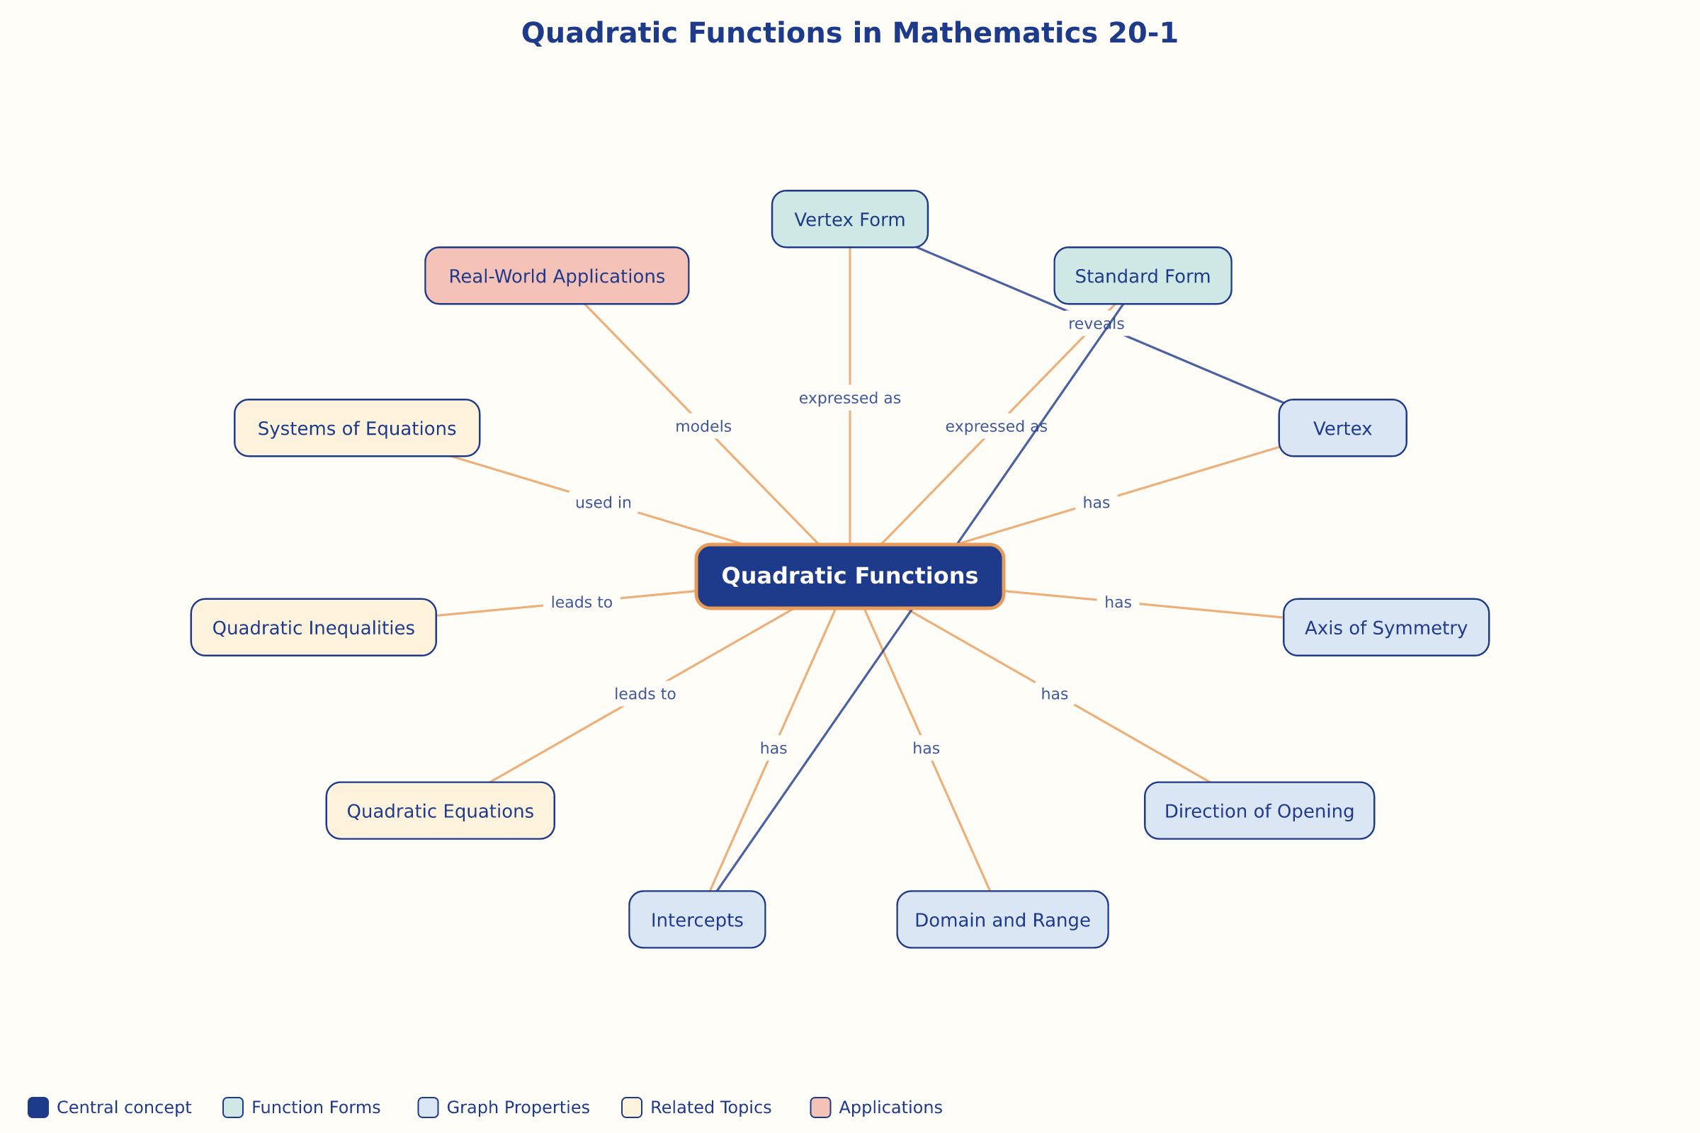

AILI word map · en · claude-haiku-4-5-20251001 · 2026-09-17

