The Particle Model of Matter
Central concept: Particle Model of Matter

Connections
- Particle Model of Matter (includes) -> Basic Ideas
- Particle Model of Matter (describes) -> Solids
- Particle Model of Matter (describes) -> Liquids
- Particle Model of Matter (describes) -> Gases
- Particle Model of Matter (involves) -> Attractive Forces
- Particle Model of Matter (explains) -> Physical Properties
- Particle Model of Matter (leads to) -> Representing Particles
- Attractive Forces (strongest in) -> Solids
- Attractive Forces (weakest in) -> Gases
- Physical Properties (includes) -> Mass
- Physical Properties (includes) -> Volume
- Physical Properties (includes) -> Density
- Physical Properties (includes) -> Compressibility
- Mass (compared to volume) -> Density
- Volume (used to find) -> Density

Notes
- Particle Model of Matter: Explains the behaviour of particles in matter. Understanding, PDF p.1
- Basic Ideas: All matter is made of small particles that are always moving, with spaces between them. Knowledge, PDF p.1
- Solids: Particles are close together and vibrate in place. Knowledge, Resource
- Liquids: Particles have spaces and can slide past each other. Knowledge, Resource
- Gases: Particles have large spaces and move constantly in all directions. Knowledge, Resource
- Attractive Forces: Strongest in solids, weakest in gases, affecting particle movement and arrangement. Knowledge, Skills
- Physical Properties: Include state, mass, volume, density, and compressibility. Knowledge, Understanding
- Mass: Amount of matter, measured in grams (g) and kilograms (kg). Knowledge, Skills
- Volume: Amount of space matter takes up, measured in millilitres (mL) and litres (L). Knowledge, Skills
- Density: Compares mass to volume; denser objects sink, less dense objects float. Knowledge, Skills
- Compressibility: Ability of liquids and gases to reduce in volume under pressure. Knowledge, Skills
- Representing Particles: Students represent and relate particle movement to states of matter. Skills, Skills
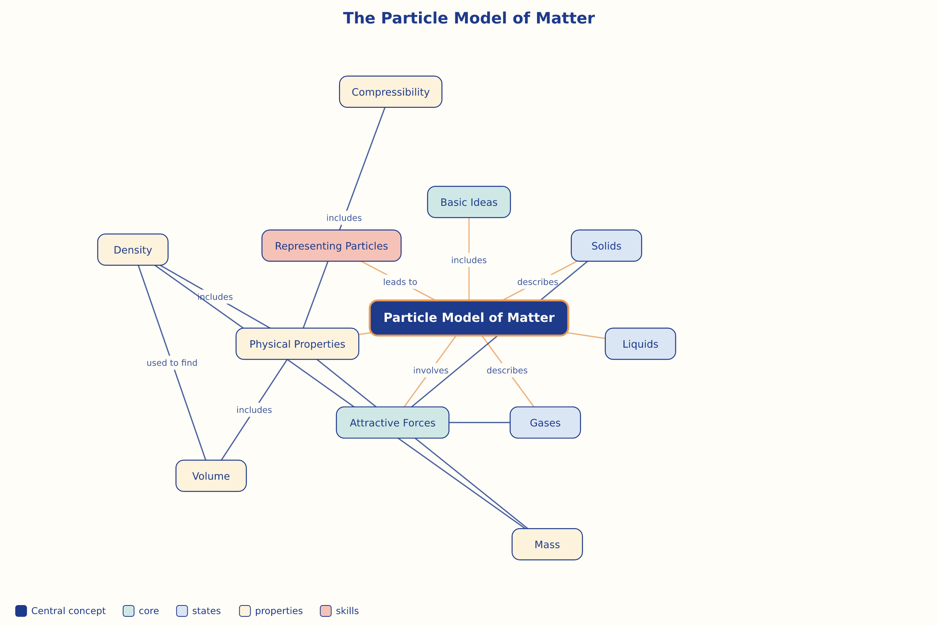

AILI word map · en · claude-sonnet-5 · 2026-09-17

