Enthalpy Changes and Calorimetry
Calculate the heat released in a chemical reaction using calorimetry data and express the result as molar enthalpy.
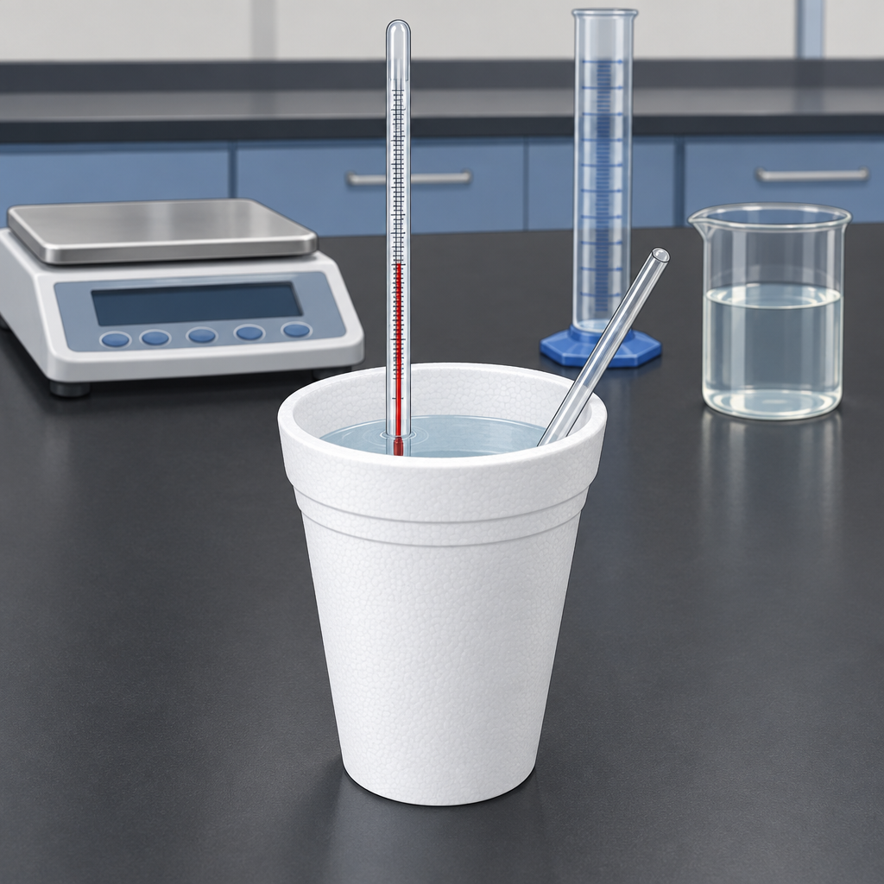

Learning intentions
We are learning to:
- apply the equation Q = mcΔt to find heat transferred in a chemical reaction
- define enthalpy and molar enthalpy
- use calorimetry data to calculate enthalpy changes for chemical reactions
- express enthalpy changes using ΔH notation

Success criteria
I can:
- calculate the heat absorbed or released by a substance using Q = mcΔt
- distinguish between enthalpy and molar enthalpy
- use calorimetry experimental data to determine ΔH for a reaction
- interpret and write ΔH values with correct signs and units

Curriculum alignment
- Students determine and interpret energy changes in chemical reactions (Topic)
- Students recall the application of Q = mcΔt to the analysis of heat transfer (Outcome)
- Students define enthalpy and molar enthalpy for chemical reactions (Outcome)
- Students use and interpret ΔH notation to communicate and calculate energy changes in chemical reactions (Outcome)
- Students use calorimetry data to determine the enthalpy changes in chemical reactions (Outcome)
- Students analyze data and apply mathematical and conceptual models to develop and assess possible solutions (Outcome)

Materials
Per pair of students:
- polystyrene cup calorimeter (or two nested foam cups with a lid)
- thermometer (0 to 110°C, graduated to 0.1°C)
- stirring rod
- graduated cylinder (100 mL)
- digital balance (±0.01 g)
- water
- calcium chloride (anhydrous, 5 to 10 g) or ammonium nitrate (5 to 10 g)
- small beaker or weighing boat
- paper towels
Per class:
- periodic table
- calculator (scientific or graphing)
- reference sheet with Q = mcΔt and molar mass values

Lesson sequence

1. Hook: Observing an exothermic reaction (5 minutes)
Demonstrate a quick exothermic reaction. Use calorimetry data to determine enthalpy changes in chemical reactions. Ask students to observe and describe what they see: the mixture becomes hot, steam may rise, the beaker is warm to touch. Ensure all students wear safety goggles and work in a well-ventilated area during this demonstration. Ask: Where does the energy come from? What happens to the temperature of the water? How could we measure the energy released?
Write on the board: "The reaction released energy. How much?"

2. Direct instruction: Heat transfer and the Q equation (8 minutes)
Explain that when a chemical reaction occurs, energy is transferred to or from the surroundings. We measure this energy transfer by observing temperature change in a known mass of water or solution.
Write the equation on the board:
Q = mcΔt
Define each term clearly:
- Q is the heat absorbed or released, measured in joules (J)
- m is the mass of the substance (usually water), in grams (g)
- c is the specific heat capacity. For water, c = 4.18 J/(g·°C)
- Δt is the change in temperature, in °C. Calculate as: Δt = final temperature − initial temperature
Work through a sample calculation on the board:
A reaction causes 100 g of water to heat from 20°C to 28°C. Calculate the heat released.
Δt = 28 − 20 = 8°C
Q = mcΔt
Q = (100 g)(4.18 J/(g·°C))(8°C)
Q = 3344 J = 3.3 kJ
If Δt is negative, the temperature of the water decreased, indicating heat was absorbed from the water by the reaction (endothermic).

3. Direct instruction: Enthalpy and molar enthalpy (7 minutes)
Define enthalpy: Enthalpy is the heat energy released or absorbed during a chemical reaction at constant pressure. We use the symbol ΔH to represent the change in enthalpy (Outcome).
Explain the sign convention (Outcome):
- ΔH is negative for exothermic reactions (heat is released)
- ΔH is positive for endothermic reactions (heat is absorbed)
Introduce molar enthalpy: Molar enthalpy is the enthalpy change per mole of a reactant or product. It tells us how much energy is released or absorbed when one mole of a substance reacts.
Write an example on the board:
If 5.0 g of calcium chloride dissolves in water and releases 1670 J of heat, what is the molar enthalpy of dissolution?
Molar mass of CaCl₂ = 111 g/mol
Moles of CaCl₂ = 5.0 g ÷ 111 g/mol = 0.045 mol
Molar enthalpy = 1670 J ÷ 0.045 mol = 37,100 J/mol = 37.1 kJ/mol
Since heat was released, ΔH = −37.1 kJ/mol

4. Guided practice: Calculation with calorimetry data (10 minutes)
Provide students with a worked calorimetry problem. Project or distribute:
A student burns 0.50 g of a nut in a calorimeter containing 100 g of water. The water temperature rises from 22°C to 35°C. Calculate the heat released and the molar enthalpy of combustion. (Assume the molar mass of the nut fuel is 180 g/mol.)
Work through the problem step by step with the class:
Step 1: Calculate Δt.
Δt = 35 − 22 = 13°C
Step 2: Calculate Q using Q = mcΔt.
Q = (100 g)(4.18 J/(g·°C))(13°C) = 5434 J ≈ 5.4 kJ
Step 3: Calculate moles of fuel burned.
Moles = 0.50 g ÷ 180 g/mol = 0.00278 mol
Step 4: Calculate molar enthalpy.
Molar enthalpy = 5434 J ÷ 0.00278 mol = 1,954,000 J/mol ≈ 2.0 × 10³ kJ/mol
Step 5: Write the result with sign and units.
ΔH = −2.0 × 10³ kJ/mol (negative because heat was released)
Ask students: Why is ΔH negative? What would happen if we used an endothermic reaction instead?

5. Independent practice: Student calculations (7 minutes)
Distribute a problem set with three calorimetry scenarios. Students work individually or in pairs:
Problem A: A reaction heats 50 g of water from 18°C to 26°C. Calculate Q in joules.
Problem B: Dissolving 2.0 g of ammonium nitrate in 100 g of water causes the temperature to drop from 20°C to 12°C. Calculate the heat absorbed (Q) and identify whether the reaction is exothermic or endothermic.
Problem C: A combustion reaction releases 8500 J of heat. The mass of fuel burned and its molar mass can be used to determine the enthalpy changes in chemical reactions. Calculate the molar enthalpy (ΔH) of combustion.
Circulate and check student work. Ask: What does the sign of ΔH tell you? How would you know if your answer is reasonable?

6. Consolidation: Summary and preview (3 minutes)
Summarize the key ideas:
- Q = mcΔt gives us the heat transferred in a reaction
- Enthalpy (ΔH) is the heat released or absorbed at constant pressure
- Molar enthalpy tells us the energy change per mole of reactant
- Negative ΔH means exothermic; positive ΔH means endothermic
Preview the next lesson: "Next class, you will perform a calorimetry experiment to measure the enthalpy of a real chemical reaction using the methods we practiced today."

Differentiation
Extension:
- Introduce the concept of heat capacity of the calorimeter itself. Ask: Does the polystyrene cup absorb any heat, or does all the heat go into the water? Have students estimate the heat capacity of the calorimeter using a hot water mixing experiment (Resource) and recalculate Q with a correction factor.
- Present a problem where students must account for the mass of the solution, not just the water. For example, if 100 g of water and 5 g of solid reactant are mixed, what is the total mass used in Q = mcΔt?
- Ask students to predict the sign of ΔH for common reactions (combustion, neutralization, dissolution of salts) before calculating, then verify their predictions.
Support:
- Provide a calculation template with blanks for Δt, Q, moles, and ΔH. Include unit labels for every number.
- Use only exothermic reactions in the first round of problems. Introduce endothermic reactions after students are confident with the sign convention.
- Pair students with a stronger partner during independent practice. Have the partner talk through each step aloud before writing.
- Reduce the number of significant figures required in answers. Accept answers rounded to two significant figures.
- Provide a reference card with the equation Q = mcΔt, the specific heat of water (4.18 J/(g·°C)), and the formula for molar enthalpy (ΔH = Q ÷ moles).

Assessment
Formative checkpoint (during independent practice):
Collect Problem C from each student. Look for:
- Correct calculation of Δt or correct identification that this is a direct Q problem
- Correct application of Q = mcΔt with proper units
- Correct conversion of grams to moles using molar mass
- Correct division of Q by moles to find molar enthalpy
- Correct sign on ΔH (negative for exothermic)
- Proper units on the final answer (kJ/mol or J/mol)
If a student has made an error in sign or units, ask: "What does a negative ΔH mean?" or "What are the units of molar enthalpy?" to prompt self-correction. If the student has confused the calculation order, work through the steps aloud together and have them redo the problem on a fresh sheet.
Use the results to decide whether the class is ready for the hands-on calorimetry lab (Resource) or whether a second practice round is needed before the experiment.

AILI rapid lesson · en · claude-haiku-4-5-20251001 · 2026-09-17

