The Kokum's Blanket of Lights
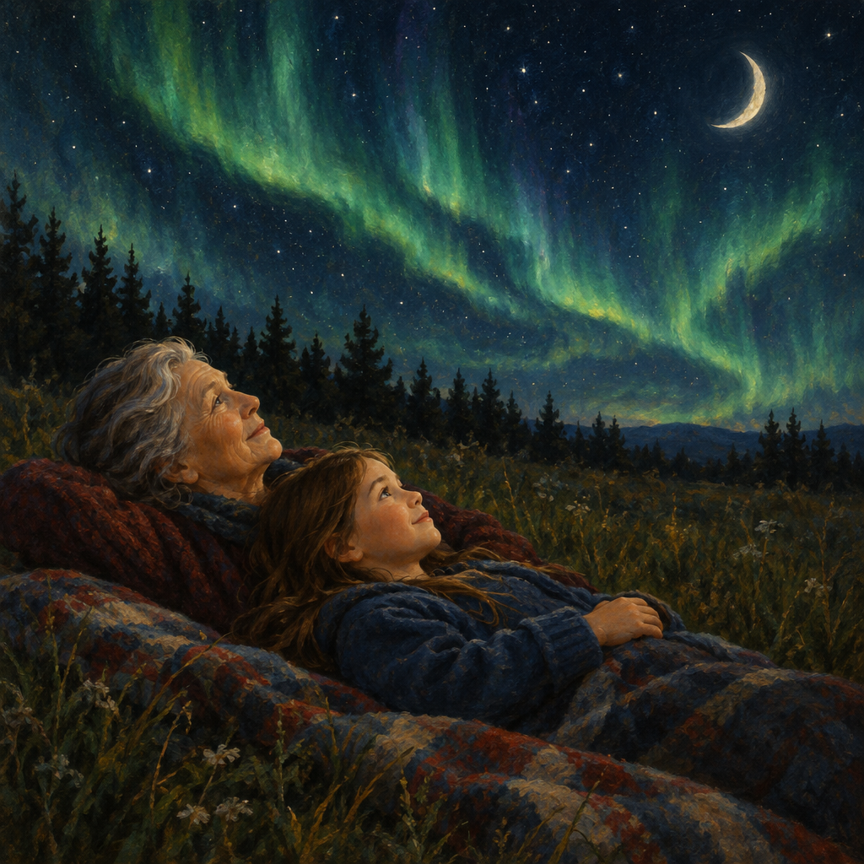
Maya wrapped a blanket around her shoulders and lay on the cold grass beside her kokum, Grandma Alice.
"Look," Grandma whispered, pointing up. "The Moon is only a sliver tonight."
"It changes shape every night," Maya said. "Last week it was a full circle."
"That's a cycle," Grandma said. "My mother taught me to watch it, the same way our people once watched it to know when to hunt and gather."
Green light rippled across the sky.
"Northern lights!" Maya gasped.
"Auroras," Grandma said softly. "There are stories about them too, passed down for generations."
Maya noticed the sky was still bright, though it was late. "Why isn't it dark yet?"
"Earth tilts differently through the year," Grandma explained. "That gives us longer days in summer."
Maya smiled, tracing the Moon's curve with her finger, feeling connected to everyone who had ever watched this same sky.

Words to know
- Moon phases: The changing shapes of the Moon we see over about a month, caused by how sunlight lights it up.
- Aurora (northern lights): Glowing, moving lights seen in the night sky, called aurora borealis in the northern hemisphere.
- Earth's tilt: The lean of Earth on its axis, which causes seasons and changes in day length.
- Cycle: A pattern of change that repeats over and over, like the Moon's phases.
Curriculum link: Outcome, Knowledge, Skills, Understanding
Listen to the narration

AILI audio story · en · claude-sonnet-5 · 2026-09-17

