Cells: The Basic Unit of Life
Discover what every living thing, from a single amoeba to a teenager, has in common at the smallest scale.
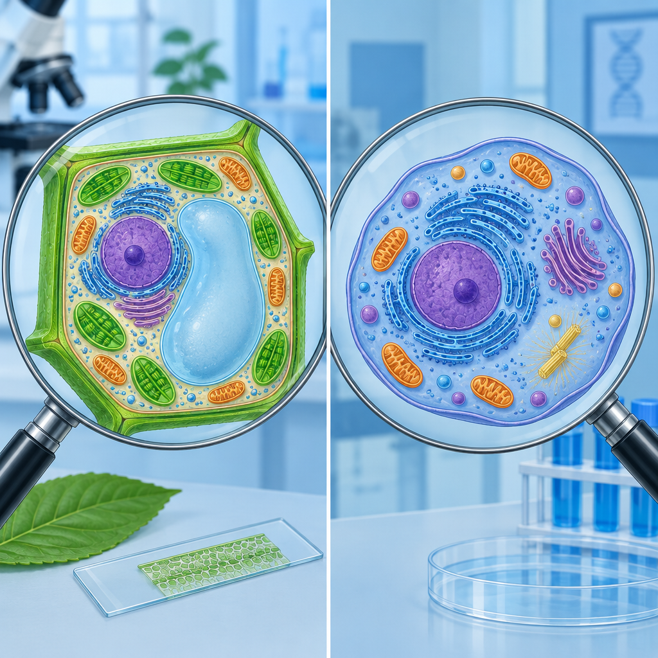

Learning intentions
We are learning to:
- Describe the cell as the basic unit of life.
- Identify similarities and differences between plant and animal cells.
- Explain how cells relate to tissues and organs in living things.

Success criteria
I can:
- State why the cell is called the basic unit of life.
- Name at least two structures found in plant cells but not animal cells.
- Explain, using an example, how cells build tissues and tissues build organs.

Curriculum alignment
- Describe the role of cells as a basic unit of life (Outcome, Outcome).
- Distinguish between plant and animal cells, including cell walls and cell membranes (Outcome, Outcome).
- Examine plant and animal structures and identify contributing roles of cells, tissues and organs (Outcome, Outcome).
- Apply the concept of system in describing familiar organisms (Outcome, Outcome).

Materials
- Diagram or slide of a plant cell and an animal cell, unlabeled and labeled versions
- Whiteboard or chart paper
- Sticky notes (two colours, enough for one pair per student)
- Student notebooks
- Optional: microscopes and prepared slides of onion skin and cheek cells, if available

Lesson sequence
1. Hook (5 minutes)
Write on the board: "You are made of about 37 trillion cells." Ask the class:
"If I took away every single cell in your body, one at a time, at what point would you stop being you?"
Take two or three quick answers, no wrong answers here. Then say: "Today we find out what a cell actually is, and why scientists call it the basic unit of life."
2. Direct instruction (10 minutes)
Explain to the class:
"A cell is the smallest unit that can carry out all the functions of life on its own: it can take in energy, get rid of waste and, in many cases, reproduce. Every living thing is made of at least one cell (Outcome). An amoeba is a single cell doing everything a living thing needs to do. A grizzly bear is trillions of cells doing the same jobs, but the work is divided among specialized types."
Display the unlabeled plant and animal cell diagrams. Ask:
"What do you notice these two cells have in common?"
Guide students to name the nucleus, cytoplasm and cell membrane as shared structures.
Then say:
"Plant cells have two extra features animal cells don't: a rigid cell wall outside the membrane, which gives the cell a fixed shape, and chloroplasts, which capture sunlight for energy. Animal cells have a flexible membrane only, no wall, which is why animal cells can be irregular shapes and plant cells tend to look boxy (Outcome)."
Reveal the labeled diagrams so students can check their earlier guesses.
3. Guided practice (10 minutes)
Hand each pair two sticky notes of different colours. Say:
"On one sticky note, write one structure found in a plant cell but not an animal cell. On the other, write one structure both cells share. You have three minutes."
Have pairs come up and place their notes on a two-column chart on the board labeled "Plant cells only" and "Shared by both." Read through the results together and correct any misplaced notes as a class.
Then introduce the next idea:
"Cells don't usually work alone in larger organisms. A group of similar cells working together is a tissue. A group of different tissues working together to do one job is an organ (Outcome, Outcome). For example, muscle cells group into muscle tissue, and muscle tissue combines with nerve tissue and connective tissue to form your heart, an organ."
Ask the class: "Can you name another organ, and one cell type you'd expect to find inside it?" Take two or three examples (for instance, skin cells forming skin, or nerve cells contributing to the brain).
4. Independent practice (10 minutes)
Students work alone in their notebooks. Give this prompt:
"Choose one organism: a poplar tree or a grizzly bear. In three or four sentences, describe how its cells are organized into tissues and organs, and identify at least one structure that would only appear if you chose the plant."
Circulate while students write. Prompt any student who is stuck with: "What job does this organism need done, like getting energy or moving nutrients, and what cells might do that job?"
5. Consolidation (5 minutes)
Ask two or three volunteers to read their sentences aloud. After each one, ask the class: "Did they mention a cell, a tissue and an organ, or just one of those?"
Close with this question, connecting back to the hook:
"So, going back to the start: does an amoeba need tissues and organs to be alive? Why or why not?"
Listen for the idea that a single cell can carry out all life functions by itself, which is why multicelled organisms are not automatically more "alive," just organized differently (Outcome).

Differentiation
Extension: Ask students to research one single-celled organism, such as an amoeba or paramecium, and compare its structures to a single cell inside a multicelled organism like a grizzly bear. Have them note one advantage and one disadvantage of being single-celled (Outcome).
Support: Provide a partially completed Venn diagram (plant cell / animal cell) with two or three structures already filled in. Students place remaining sticky-note labels rather than generating them from scratch. Pair these students with a peer during independent practice, and reduce the writing task to two sentences with a sentence starter: "A tissue is a group of ___. An organ is made when ___."

Assessment
Formative check: Collect the sticky-note chart and scan the independent practice sentences during the closing discussion.
Look for:
- Correct placement of cell wall and chloroplasts as plant-only structures.
- Correct identification of nucleus, cytoplasm and membrane as shared structures.
- A written example that shows the cell-to-tissue-to-organ sequence, not just isolated definitions.
Students who confuse cell membrane with cell wall, or who cannot connect a tissue example to an organ example, need a short reteach before the next lesson on diffusion and osmosis.

AILI rapid lesson · en · claude-sonnet-5 · 2026-09-17

