Renaissance Worldviews
Central concept: Renaissance Worldview

Connections
- Renaissance Worldview (shaped by) -> Humanist Philosophy
- Renaissance Worldview (driven by) -> Exchange of Ideas
- Renaissance Worldview (expressed through) -> Age of Discovery
- Renaissance Worldview (enabled by) -> Trade and Commerce
- Renaissance Worldview (reflects) -> Beliefs and Values
- Renaissance Worldview (becomes) -> Foundation of Western Thought
- Trade and Commerce (creates) -> City-States
- Geography of Europe (influences) -> Trade and Commerce
- Age of Discovery (involves) -> Intercultural Contact
- Exchange of Ideas (includes) -> Humanist Philosophy
- Beliefs and Values (leads to) -> Differing Perspectives
- What Was the Renaissance (defines) -> Renaissance Worldview

Notes
- Renaissance Worldview: The evolving perspective of Western Europe during the Renaissance that shaped modern Western thought Topic
- Humanist Philosophy: Thinkers and philosophers who influenced society and shaped a worldview focused on human potential Outcome
- Exchange of Ideas: Growth and spread of knowledge across Europe in astronomy, mathematics, science, politics, religion, and arts Outcome
- Age of Discovery: Exploration and imperialism as expressions of an expansionist worldview Outcome
- Trade and Commerce: Increased trade that led to the emergence of powerful city-states like Florence, Venice, and Genoa Outcome
- City-States: Powerful urban centers including Florence, Venice, and Genoa that grew from increased trade Outcome
- Geography of Europe: Physical geography that affected trade routes and competition among European countries Outcome
- Intercultural Contact: Exploration and contact with other cultures that affected European citizenship and identity Outcome
- Beliefs and Values: Shaped by time, geographic location, and societal context of Renaissance Europe Outcome
- Foundation of Western Thought: Renaissance Europe formed the basis for the worldview of the modern Western world Outcome
- Differing Perspectives: Willingness to consider different beliefs, values, and worldviews across cultures and time Outcome
- What Was the Renaissance: A period of cultural and intellectual rebirth in Western Europe Outcome
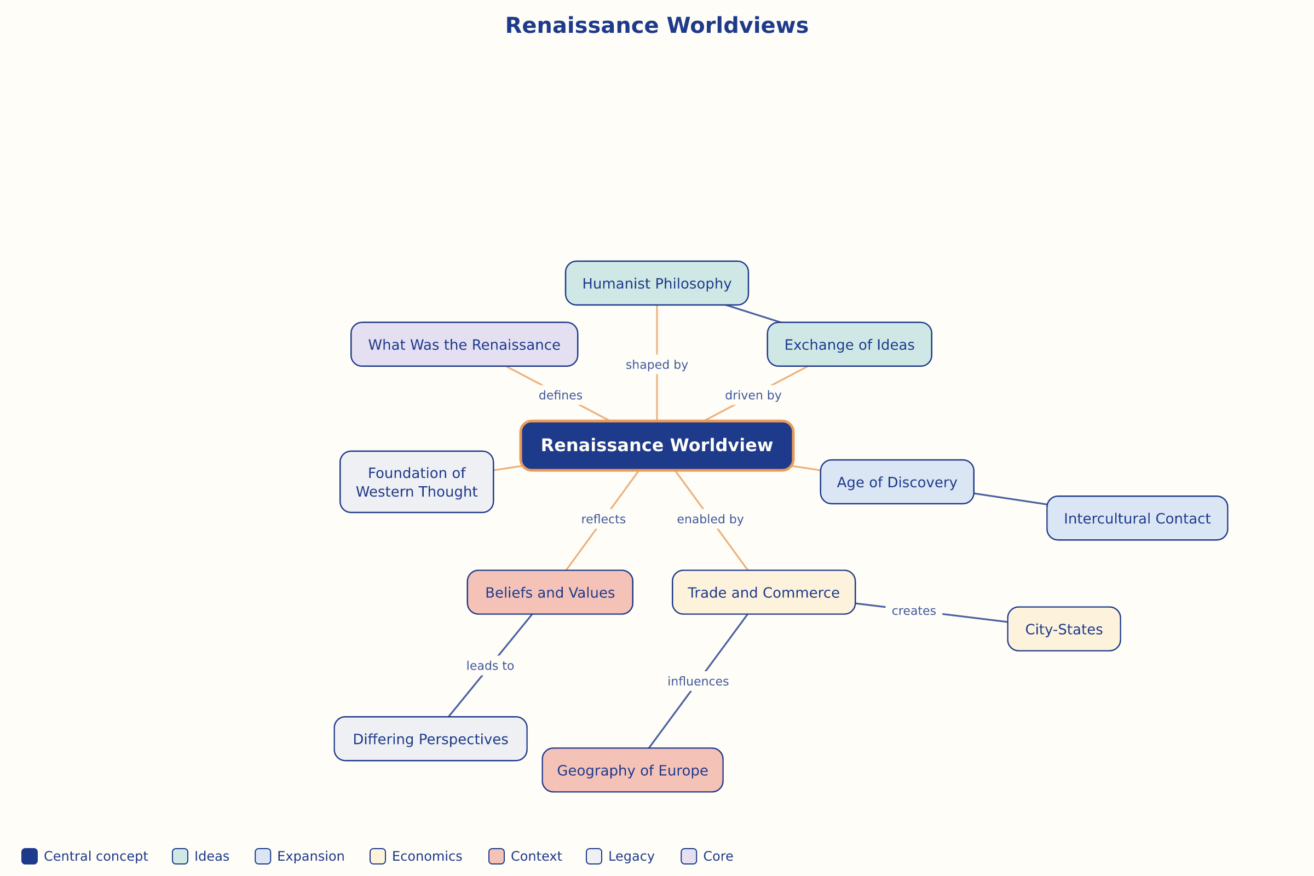

AILI word map · en · claude-haiku-4-5-20251001 · 2026-09-17

