The Market Basket
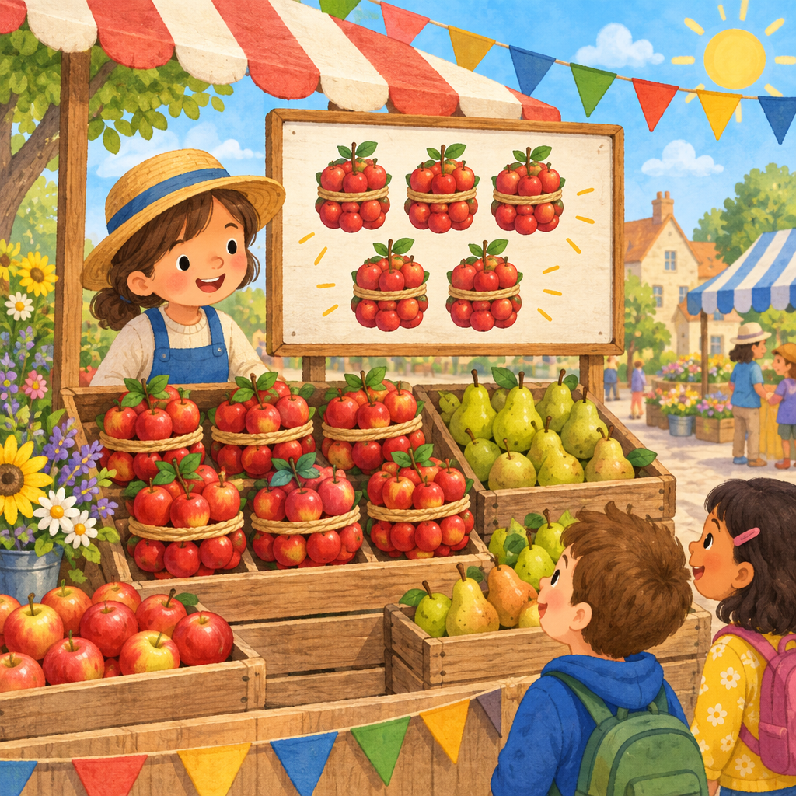
Mia and Sam ran a fruit stand at the school market.
Mia had 40 apples. Sam had 30 apples. "How many together?" asked Mia.
Sam counted by tens. "40, 50, 60, 70! We have 70 apples."
A customer bought 20 apples. "Now how many are left?" asked Sam.
Mia thought fast. "70 take away 20 is 50. Let's check it. 50 plus 20 makes 70 again, so we're right!"
Then three friends brought coins: 10, 10, and 5. "Add them any order you like," said Mia. "10 plus 10 is 20, plus 5 is 25."
Sam swapped the order. "5 plus 10 plus 10 is still 25!"
They sold pears too, using doubles: 25 plus 25 made 50 fast.
By closing time, they had sold 90 pieces of fruit, counting every ten with a smile.

Words to know
- sum: the answer when you add numbers together
- doubles: adding a number to itself, like 25 plus 25
- associative property: adding numbers in any order gives the same answer
Curriculum link: Outcome, Knowledge, Skills, Knowledge, Skills, Understanding
Listen to the narration

AILI audio story · en · claude-sonnet-5 · 2026-09-17

