Animal Detectives: The Food Chain Mystery
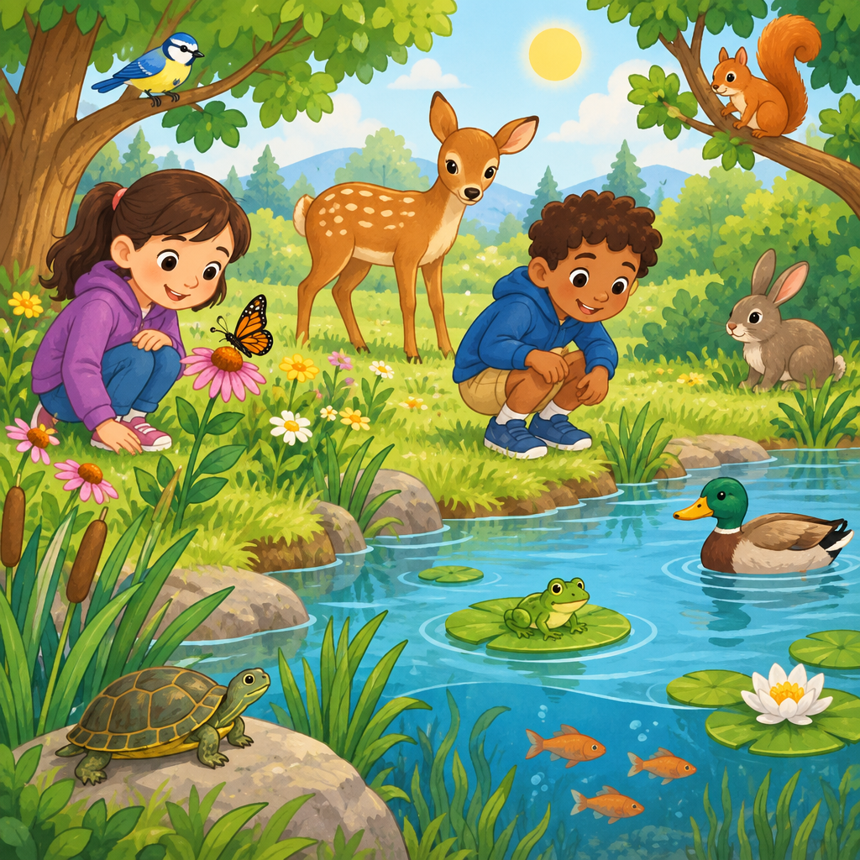
This puzzle asks you to think about how plants and animals work together. Animals eat different things. Some eat only plants. Some eat only meat. Some eat both (Outcome, Details). Solving this puzzle is fun. It helps you analyze and describe how plants and animals interact with each other and within environments. Scientists study how plants and animals interact(Guiding question, Topic).

How to play
- There are 3 students. Each one has one thing, and no two have the same thing.
- Read the 4 clues. Every clue is true.
- Write what you know in the grid. The answer key shows who has what.

The puzzle
Three students each researched a different animal for their food chain project. Use the clues to figure out how each animal gets its food.
Maya, Owen and Priya each have one item from every category below, and no two of them share an item.
- How their animal eats: eats only plants, eats mostly meat, eats both meat and plants
- Sense used to find food: sense of smell, sense of sight, sense of touch
Use the clues to work out who has what. Mark in the grid what each clue rules out.
Name | How their animal eats | Sense used to find food
Maya
Owen
Priya

- Maya has sense of sight.
- Priya does not have sense of smell.
- Owen has eats only plants.
- Maya has eats mostly meat.

Hints
- Start with clue 1. Mark in the grid what it rules out before you read on.
- Clues 1 and 2 together show that Owen has sense of smell.
- Owen has eats only plants and sense of smell.

Answer key
Name | How their animal eats | Sense used to find food
Maya | eats mostly meat | sense of sight
Owen | eats only plants | sense of smell
Priya | eats both meat and plants | sense of touch

Reasoning
- Clue 1: Maya has sense of sight. So Maya has sense of sight.
- Clue 2: Priya does not have sense of smell. So Owen has sense of smell and Priya has sense of touch.
- Clue 3: Owen has eats only plants. So Owen has eats only plants.
- Clue 4: Maya has eats mostly meat. So Maya has eats mostly meat and Priya has eats both meat and plants.

AILI game · en · claude-sonnet-5 · 2026-09-17

