Integers and Fractions
Grade 7 Mathematics: Operating on Positive and Negative Numbers, and on Fractions

Slide 1: Integers and Fractions
Grade 7 Mathematics: operating on positive and negative numbers, and on fractions
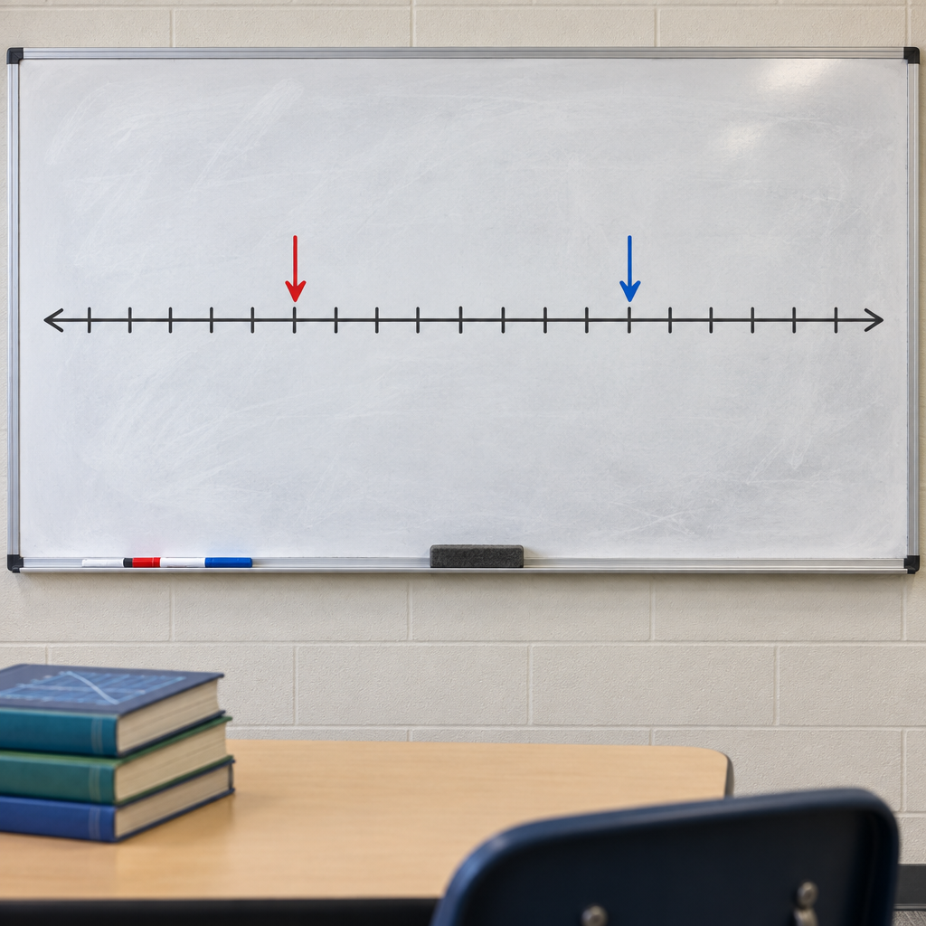
Notes: Introduce the unit: students will extend their understanding of the number line to negative numbers, apply the four operations to integers, and apply addition, subtraction, multiplication, and division to fractions. Connect to prior learning from Grade 6 on magnitude and additive inverses.

Slide 2: Learning Intentions and Success Criteria
- I can locate positive and negative numbers on a horizontal or vertical number line and compare them using <, >, or = (Outcome).
- I can add and subtract integers by expressing subtraction as addition of the opposite (Outcome).
- I can multiply and divide integers and predict whether the result is positive or negative (Outcome).
- I can add and subtract positive fractions and mixed numbers(Outcome).
- I can explain why dividing by a fraction means multiplying by its reciprocal (Outcome).
Sources: Outcome, Outcome, Outcome, Outcome
Notes: Read success criteria aloud and post them. Have students self-assess with thumbs up/down at the end of the lesson. Students investigate magnitude with positive and negative numbers. Students investigate magnitude with positive and negative numbers.

Slide 3: The Number Line: Grade 6 Foundations
Positive and Negative Numbers
Negative numbers sit to the left of zero on a horizontal line, or below zero on a vertical line (Details). Zero itself is neither positive nor negative (Details). Every positive number has an opposite negative number with the same magnitude, called an additive inverse (Details).
Why This Matters
Negative numbers describe real situations such as temperature, debt, and elevation(Details). Magnitude is the distance from zero, so −7 and 7 have the same magnitude but point in opposite directions (Details).
Sources: Details
Notes: Quick review before moving into Grade 7 operations. Use a thermometer or elevation map example. Formative check: ask students to place three integers on a number line and order them with < or >. Support: provide a pre-drawn number line template. Extension: ask students to find a rational number between two given integers, previewing Grade 9 density and rational-number concepts.

Slide 4: Adding and Subtracting Integers
- Start with the expression: The symbol negative sign can mean a negative number or subtraction, so read the expression carefully (Details).
- Rewrite subtraction as addition: a minus b is the same as a plus the opposite of b, adding the opposite (Details).
- Combine using integer rules: Adding a number and its opposite gives zero; two positives sum to a positive; two negatives sum to a negative (Outcome).
- Check reasonableness: Estimate the answer's sign and size before finalizing it (Outcome).
- Apply to fractions and decimals too: The same addition and subtraction ideas work with fractions using common denominators (Details).
Sources: Details, Outcome, Outcome
Notes: Model with a number-line walk: physically step forward for positive, backward for negative. Formative checkpoint: give three mixed integer/fraction subtraction problems and monitor whole-class whiteboards. Support: allow use of two-colour counters for integer addition. Extension: challenge students to write a real-world story problem (debt or elevation) that requires subtracting a negative integer.

Slide 5: Multiplying and Dividing: Integers and Fractions
- Positive times positive or negative times negative: The product is always positive (Outcome).
- Positive times negative: The product is always negative (Outcome).
- Fraction times fraction: Multiply numerators together and denominators together: a/b times c/d equals ac/bd, useful for adjusting a recipe (Details).
- Fraction divided by fraction: Dividing by a fraction means multiplying by its reciprocal: a/b divided by c/d equals a/b times d/c (Outcome).
- Order of operations: The conventional order of operations applies to integers, fractions, and decimal numbers alike (Guiding question).
- Checking your work: Assess whether a product or quotient makes sense by estimating first (Outcome).
Sources: Outcome, Details, Outcome, Guiding question
Notes: Use an area model to show fraction multiplication as part of a part. Students apply multiplication and division operations to positive and negative numbers. Support: provide a sign-rule reference card for integer multiplication. Extension: ask students to prove that a fraction times its reciprocal always equals 1, connecting to Outcome.

Slide 6: Bringing Integers and Fractions Together
Summary: This unit builds toward demonstrating an understanding of addition and subtraction of integers, concretely, pictorially, and symbolically (Outcome). This work connects to previously learned whole-number addition and subtraction from Grade 4, which students maintain and refine while adding and subtracting fractions and integers.
Question: If you can already order integers on a number line, how would you order fractions like 3/4 and 5/6 on that same line, and where would a negative fraction like negative 3/4 belong?
Sources: Outcome, Outcome, Outcome, Outcome
Notes: Use the closing question as an exit ticket or think-pair-share. This outcome connects to understanding addition and subtraction of integers, building on previously learned operations with whole numbers. Collect exit slips to identify students needing extra support before the next lesson on multiplying and dividing fractions.

AILI presentation · en · claude-sonnet-5 · 2026-09-17

