Fractions and Decimals: Grade 4
Central concept: Fractions and Decimals

Connections
- Fractions and Decimals (uses) -> Place Value
- Fractions and Decimals (uses) -> Decimal Notation
- Fractions and Decimals (shows) -> Equivalence
- Fractions and Decimals (applies to) -> Addition and Subtraction
- Fractions and Decimals (applies to) -> Comparing and Ordering
- Place Value (includes) -> Tenths and Hundredths
- Decimal Notation (represents) -> Money
- Equivalence (enables) -> Conversion
- Equivalence (shows on) -> Number Line
- Addition and Subtraction (uses) -> Estimation
- Comparing and Ordering (involves) -> Rounding
- Conversion (works with) -> Tenths and Hundredths

Notes
- Fractions and Decimals: Numbers that represent parts of a whole and can be expressed in different ways Knowledge, Understanding
- Place Value: Each digit's position determines its value; each place is one-tenth of the place to its left Outcome, Knowledge
- Decimal Notation: A point separates whole numbers from parts; used for money and measurements Knowledge, Understanding
- Equivalence: Fractions and decimals can represent the same number Knowledge, Understanding
- Comparing and Ordering: Use symbols <, >, or = to compare decimal and fractional numbers Skills
- Addition and Subtraction: Standard algorithms work for decimal numbers to hundredths Outcome, Knowledge
- Tenths and Hundredths: Place values that represent fractions with denominators of 10 and 100 Knowledge, Understanding
- Number Line: Fractions and decimals mark the same positions between whole numbers Skills, Understanding
- Estimation: Check if sums and differences are reasonable Knowledge, Skills
- Money: Dollars and cents show decimal notation in everyday use Skills, Understanding
- Rounding: Round decimal numbers to various places including tenths Skills
- Conversion: Express fractions as decimals and decimals as fractions with denominators 10 or 100 Skills, Knowledge
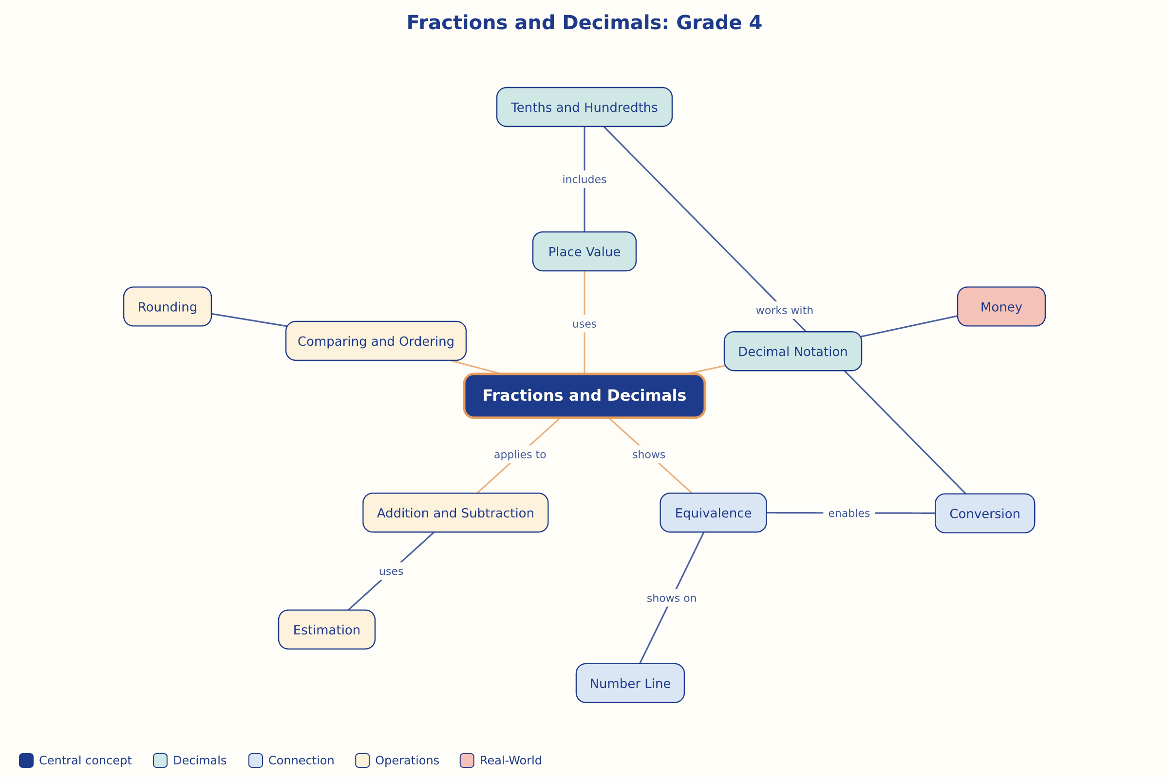

AILI word map · en · claude-haiku-4-5-20251001 · 2026-09-17

