The Calorimeter Experiment
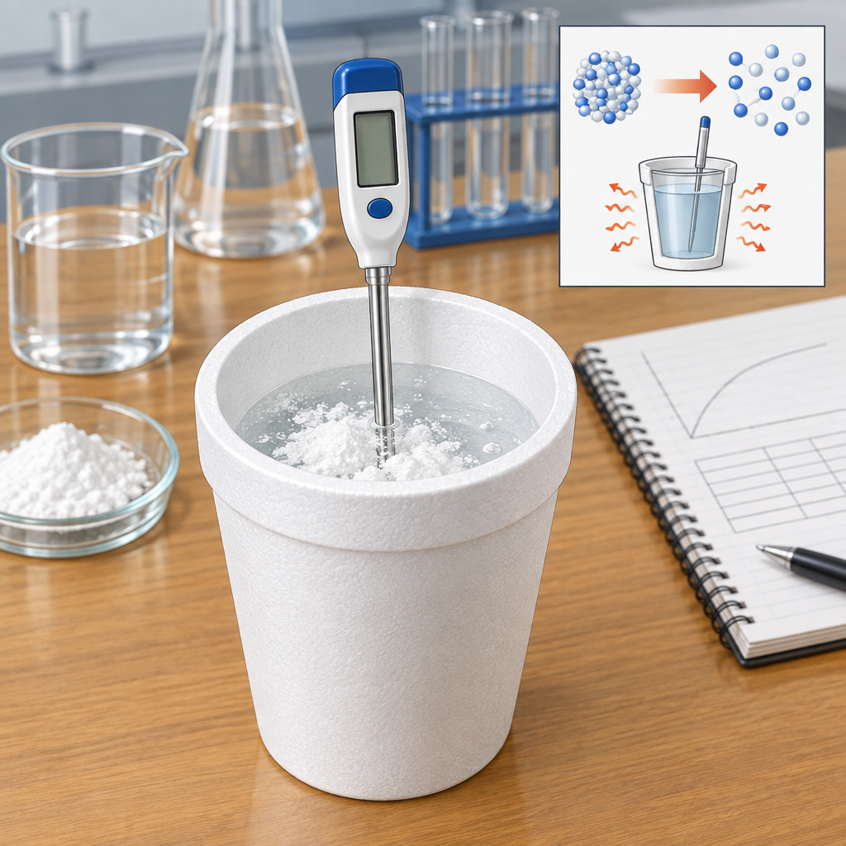
Maya put on her safety goggles and gloves, then set up the calorimeter on the lab bench, checking the thermometer twice. Her partner James, also gloved and goggled, measured out the reactants: calcium oxide and water. Under their teacher's supervision, they slowly added the water to the calcium oxide in the insulated container, keeping it behind a protective shield. They watched the temperature climb. Fifty degrees. Sixty degrees. The reaction released heat fast. James wrote down the data: 100 grams of water starting at 20°C, rising to 65°C. Heat transferred from the reaction to the water. Using Q equals m times c times delta T, they calculated the energy released: Q = 100 g × 4.18 J/g°C × 45°C = 18,810 J. Exothermic. The bonds forming in the products released more energy than was needed to break the bonds in the reactants. That difference came out as heat. Maya noted the enthalpy change: negative ΔH. They cleaned up, already thinking about the next reaction. Endothermic this time.

Words to know
- Calorimeter: An insulated container used to measure the heat energy released or absorbed during a chemical reaction
- Exothermic: A chemical reaction that releases heat energy to the surroundings, resulting in a negative ΔH
- Endothermic: A chemical reaction that absorbs heat energy from the surroundings, resulting in a positive ΔH
- Enthalpy change (ΔH): The heat energy absorbed or released during a chemical reaction at constant pressure
- Q = mcΔt: The equation used to calculate heat transfer, where Q is heat energy, m is mass, c is specific heat capacity, and Δt is temperature change
Curriculum link: Topic, Outcome, Outcome, Outcome, Outcome, Outcome
Listen to the narration

AILI audio story · en · claude-haiku-4-5-20251001 · 2026-09-17

