Maya's Big Idea
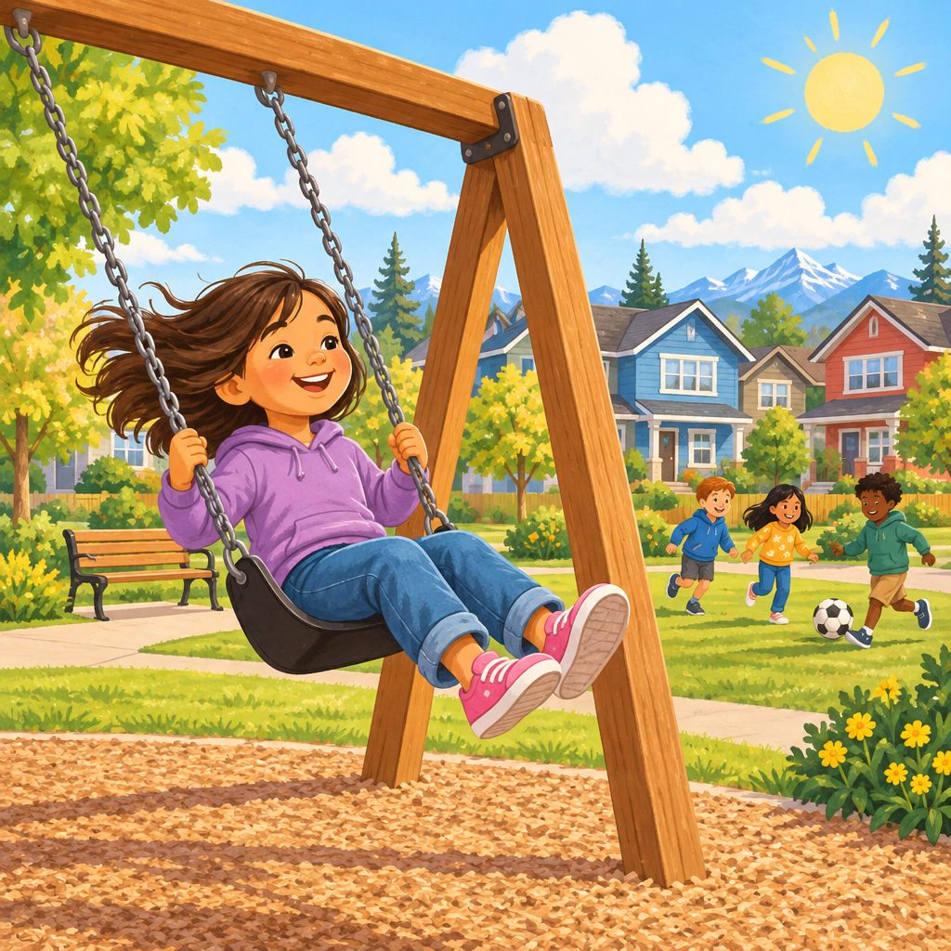
Maya lived in a small neighbourhood in Red Deer, Alberta. Every day after school, she played at the park near her house.
"It squeaks every time," she told her friend Owen, pointing at the old wooden swing. "Someone should fix it."
Owen shrugged. "Someone should."
Maya remembered what her teacher had said: citizens have responsibilities, like helping their community. She decided to find out more. First, she looked closely at the swing and asked her neighbours why it squeaked. They told her it needed oil.
Next, Maya made a plan. She wrote a letter to Red Deer City Hall and gathered signatures from her neighbours to show that many people wanted the swing fixed.
Then, the city workers came and oiled the swing so it would stop squeaking.
Finally, Maya visited the park to see her plan come to life. She swung on the fixed swing and thought about everything she had done to help.
Owen grinned, swinging high. "You did this!"
"We did," Maya said. "That's what citizens do. We don't just wait. We help."
Maya learned that when people work together, like gathering signatures and sharing ideas, they can make their community a better place for everyone.

Words to know
- citizen: A person who belongs to a community and helps take care of it.
- responsibility: Something you should do to help others or your community.
- civic participation: Taking action, like writing letters or making plans, to help your community.

Check your understanding
- What problem did Maya notice with the swing?
- What did Maya do first, second, and last to help fix the swing?
- Why does the teacher say helping the community is a responsibility?

Answer key
- The swing squeaked every time someone swung on it.
- First, Maya asked her neighbours why the swing squeaked. Second, she wrote a letter and gathered signatures to ask for help. Last, Maya visited the park and reflected on what she had done.
- Because citizens have a responsibility to take care of their community, not just wait for someone else to help.
Curriculum link: Outcome, Details
Listen to the narration

AILI audio story · en · claude-sonnet-5 · 2026-09-17

