Enthalpy Changes and Calorimetry (Chemistry 30)
Central concept: Enthalpy & Calorimetry

Connections
- Enthalpy & Calorimetry (defines) -> Enthalpy
- Enthalpy & Calorimetry (uses) -> ΔH Notation
- Enthalpy & Calorimetry (applies) -> Q = mcΔt
- Enthalpy & Calorimetry (produces) -> Calorimetry Data
- Enthalpy & Calorimetry (requires) -> Data Analysis
- Enthalpy & Calorimetry (demonstrated in) -> Combustion Lab
- Enthalpy & Calorimetry (demonstrated in) -> DIY Calorimeter
- Enthalpy & Calorimetry (part of) -> Thermochemical Changes Unit
- Enthalpy (relates to) -> Molar Enthalpy
- Q = mcΔt (generates) -> Calorimetry Data
- Data Analysis (uses) -> Instrumentation & Tools
- DIY Calorimeter (measures) -> Experimental Error
- Combustion Lab (applies) -> Q = mcΔt

Notes
- Enthalpy & Calorimetry: Central topic of Unit A: Thermochemical Changes, linking heat measurement to reaction energy changes. Resource
- Enthalpy: Defined as the heat content of a system; molar enthalpy expresses this per mole of substance reacting. Outcome, Outcome
- ΔH Notation: Used and interpreted to communicate and calculate energy changes in chemical reactions. Outcome
- Q = mcΔt: Formula recalled and applied to analyze heat transfer between substances. Outcome, Outcome
- Calorimetry Data: Used to determine enthalpy changes occurring during chemical reactions. Outcome
- Molar Enthalpy: Enthalpy change expressed per mole, defined alongside enthalpy for chemical reactions. Outcome
- Data Analysis: Involves analyzing data and applying mathematical models, including energy diagrams, to assess reactions. Outcome
- Instrumentation & Tools: Manipulating and presenting data using scientific instrumentation, calculators, or spreadsheets. Outcome
- Combustion Lab: Multimedia investigation measuring heat transfer from burning a nut to water. Resource
- DIY Calorimeter: Guided lab constructing a polystyrene-cup calorimeter and testing its precision through repeated trials. Resource
- Experimental Error: Calculated from repeated trial data when evaluating calorimeter performance. Resource
- Thermochemical Changes Unit: Broader unit covering Hess's law, molar enthalpies of formation, and energy diagrams alongside calorimetry. Resource
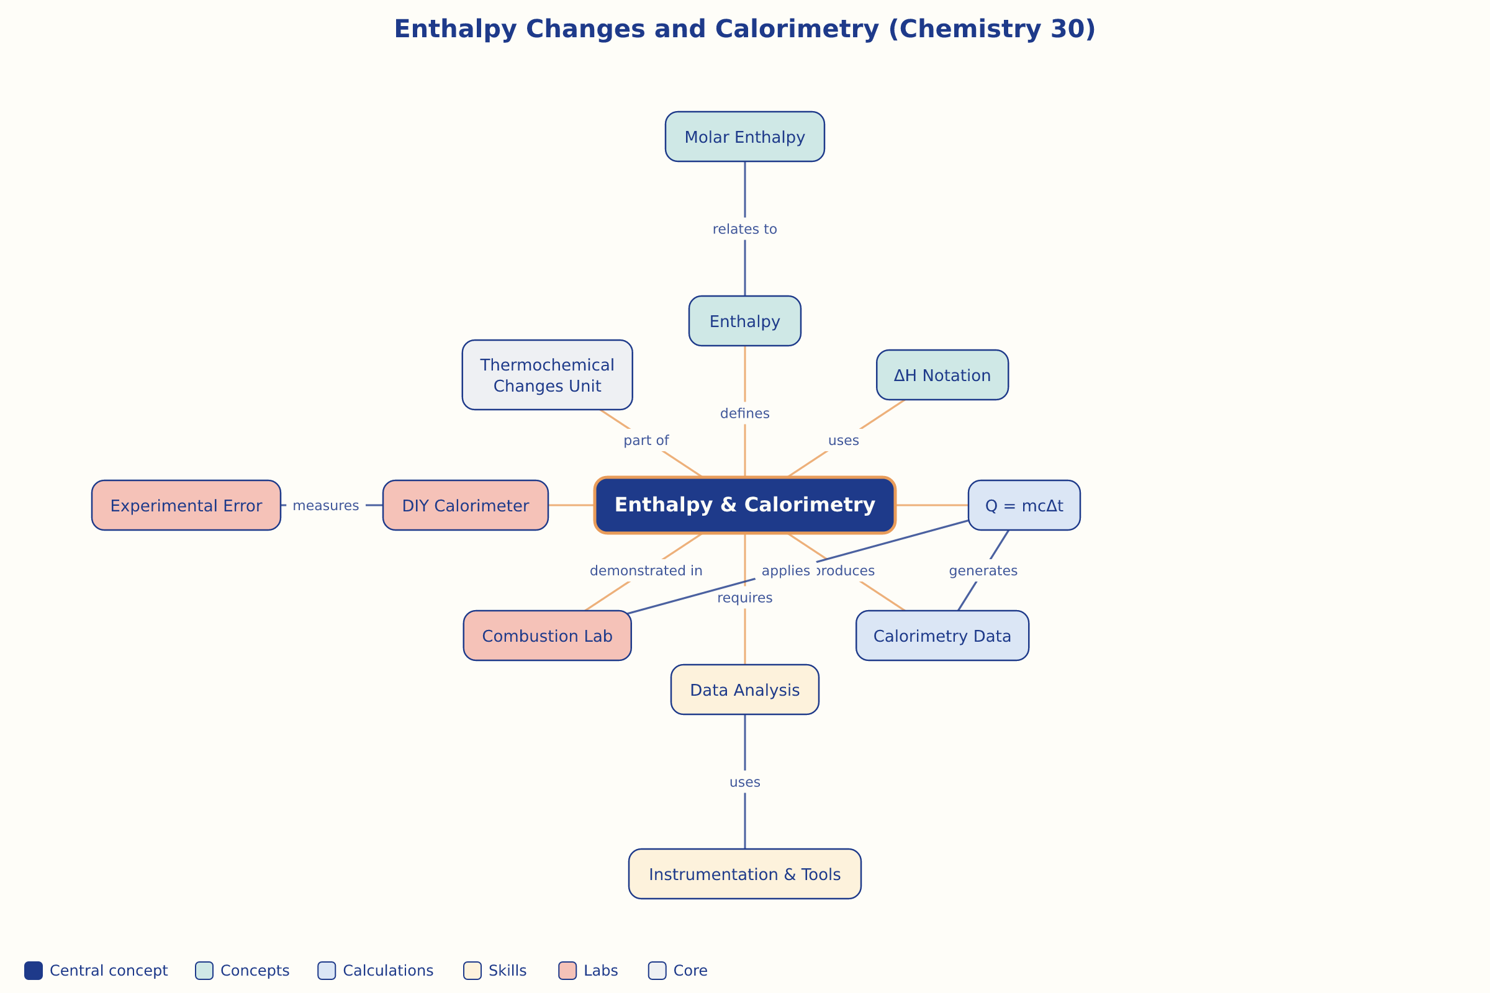

AILI word map · en · claude-sonnet-5 · 2026-09-17

