The Cell City Mystery
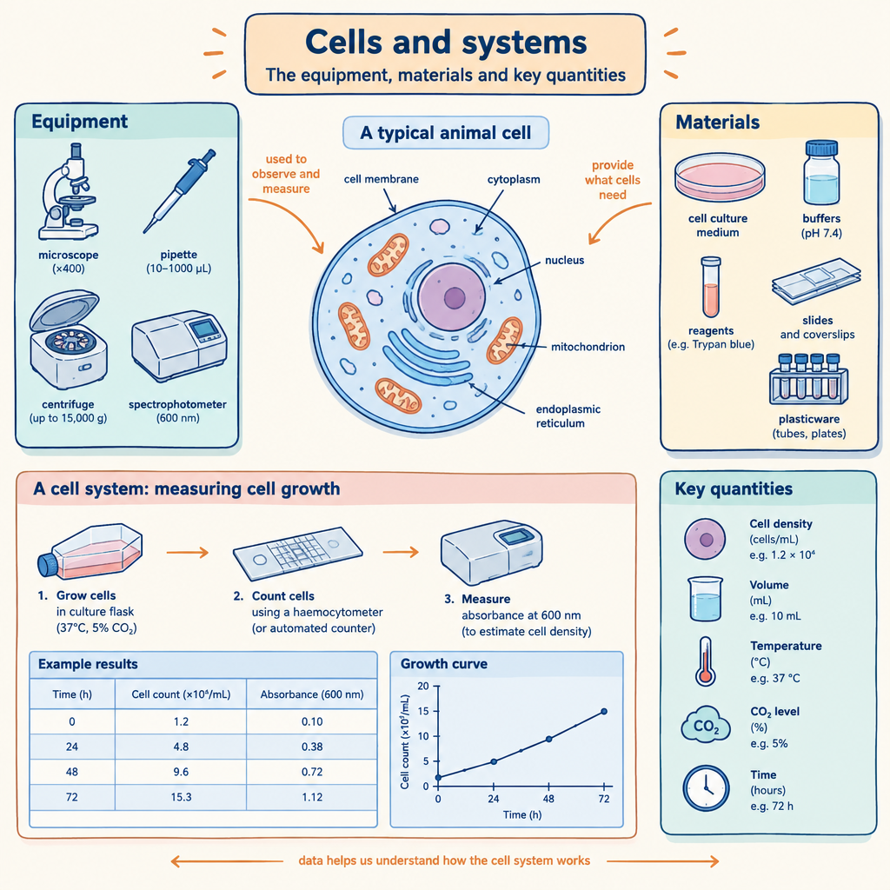
This game connects to how living things are organized as systems of cells, tissues, and organs working together (Topic). You will use what you know about cell structures and their functions to solve a logic puzzle about a fictional city that mirrors how a real organism works (Outcome).

The puzzle
Four cells in a tissue have four different jobs: energy production, waste removal, nutrient transport, and information control. Each cell is a different shape: round, elongated, cubic, and flat. Use the clues below to figure out which cell does which job and what shape it is.
Clues:
- The cell that controls information is not round and not flat.
- The cell responsible for energy production is round.
- The waste removal cell is flat.
- The nutrient transport cell is not cubic.
- The elongated cell does not control information.
Your task: Match each job to its cell shape. Write down the shape for each job.

Hints
Hint 1: Start with what you know for certain. Clues 2 and 3 tell you the exact shapes for two of the jobs. Use those to narrow down the remaining clues.
Hint 2: Clue 1 says the information control cell is neither round nor flat. That means it must be one of the two remaining shapes. Clue 5 eliminates one of those options.
Hint 3: Once you know which shape controls information, clue 4 tells you that the nutrient transport cell cannot be cubic. That leaves only one shape for nutrient transport, and one for waste removal.

Answer key
Answer:
- Energy production: round
- Waste removal: flat
- Nutrient transport: elongated
- Information control: cubic
Reasoning:
From clue 2, energy production is round. From clue 3, waste removal is flat. This leaves elongated and cubic for nutrient transport and information control.
Clue 1 says information control is not round and not flat, so it must be elongated or cubic. Clue 5 says the elongated cell does not control information. Therefore, information control must be cubic.
That leaves elongated for nutrient transport. Clue 4 confirms this: the nutrient transport cell is not cubic, so it can be elongated.
This puzzle mirrors how real cells specialize in different functions (Outcome). Mitochondria produce energy, the nucleus controls information, the cell membrane transports materials, and lysosomes remove waste, each with a structure suited to its role.

Note: 2 learning outcome blocks were left out to fit the 4000-token curriculum budget for this kind of material. Use "Split into parts" to generate one document per organizing idea.

AILI game · en · claude-haiku-4-5-20251001 · 2026-09-17

