Enthalpy Changes and Calorimetry
Students calculate heat transfer using Q = mcΔt and use calorimetry data to determine the molar enthalpy change of a combustion reaction.
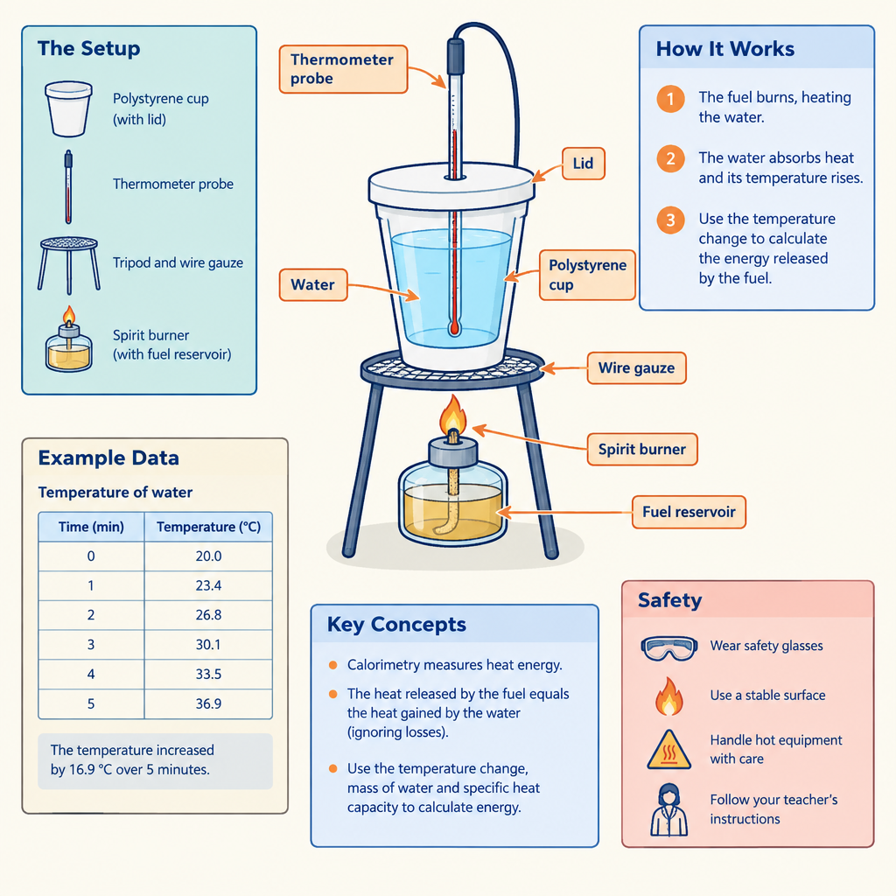

Learning intentions
We are learning to:
- Define enthalpy and molar enthalpy for a chemical reaction.
- Apply Q = mcΔt to calculate heat absorbed or released during a reaction.
- Use calorimetry data to calculate the molar enthalpy change of a combustion reaction.
- Classify a reaction as endothermic or exothermic and represent the energy change using correct ΔH notation.

Success criteria
I can:
- State the definition of enthalpy and molar enthalpy in my own words.
- Substitute mass, specific heat capacity and temperature change correctly into Q = mcΔt, with correct units and sign.
- Convert a heat value (Q) into a molar enthalpy value (ΔH, in kJ/mol) using moles of substance reacted.
- Write ΔH with the correct sign and units for a given reaction, and justify whether the reaction is endothermic or exothermic.

Curriculum alignment
- 30-A1.3k: define enthalpy and molar enthalpy for chemical reactions (Outcome)
- 30-A1.5k: use and interpret ΔH notation to communicate and calculate energy changes (Outcome)
- 30-A1.1k: recall the application of Q = mcΔt to the analysis of heat transfer (Outcome)
- 30-A1.8k: use calorimetry data to determine the enthalpy changes in chemical reactions (Outcome)
- 30-A1.10k: classify chemical reactions as endothermic or exothermic (Outcome)
- 30-A1.2s: perform calorimetry experiments and use thermometers or temperature probes appropriately (Outcome)
- 30-A1.3s: compare energy changes through analysis of data and energy diagrams (Outcome)
- 30-A1.4s: use appropriate SI units and significant digits in communicating results (Outcome)
- General Outcome 1: determine and interpret energy changes in chemical reactions (Topic)

Materials
- Whiteboard or projector for worked examples
- Student calculators
- Handout: Q = mcΔt reference card (specific heat capacity of water = 4.19 J/g°C)
- Sample calorimetry data set (printed or projected) for the ethanol combustion example
- Exit ticket slips
- Optional: coffee-cup calorimeter, thermometer or temperature probe, spirit burner with ethanol, 100 mL water, balance (for teacher demonstration only, if time and safety protocols allow)

Lesson sequence
1. Hook (5 minutes)
Project this question and ask students to discuss with a neighbour for one minute:
"A student burns 0.68 g of ethanol under a cup containing 100 g of water. The water temperature rises from 21.0°C to 45.0°C. Where did that energy come from, and where did it go?"
Take two or three verbal answers. Do not correct yet. Tell students: "By the end of this lesson, you will calculate exactly how much energy this reaction released, per mole of ethanol burned."
2. Direct instruction (15 minutes)
Define terms on the board:
"Enthalpy (H) is the heat content of a system at constant pressure. We cannot measure H directly, but we can measure ΔH, the change in enthalpy during a reaction." (Outcome)
"Molar enthalpy (ΔH_molar) is the enthalpy change per mole of a specified substance in the reaction, expressed in kJ/mol." (Outcome)
Write the sign convention:
- Exothermic reaction: heat released to the surroundings, ΔH is negative.
- Endothermic reaction: heat absorbed from the surroundings, ΔH is positive. (Outcome, Outcome)
Write the formula and label each term:
Q = mcΔt
Q = heat absorbed or released, in joules (J)
m = mass of the substance being heated or cooled, in grams (g)
c = specific heat capacity, in J/g°C (for water, c = 4.19 J/g°C)
Δt = final temperature minus initial temperature, in °C (Outcome)
Explain the calorimetry logic: "In a calorimetry experiment, the water absorbs the heat released by the reaction. Q for the water is positive, and Q for the reaction is the same magnitude but negative, since the reaction is the source of that heat." (Outcome)
Work the hook example on the board, step by step:
Q(water) = mcΔt = (100 g)(4.19 J/g°C)(45.0°C − 21.0°C)
Q(water) = (100)(4.19)(24.0) = 10 056 J = 10.1 kJ
"This is the heat gained by the water. The reaction released this same amount of heat, so Q(reaction) = −10.1 kJ."
Convert to molar enthalpy:
Moles of ethanol (molar mass 46.07 g/mol) = 0.68 g ÷ 46.07 g/mol = 0.01476 mol
ΔH_molar = Q(reaction) ÷ moles = −10.1 kJ ÷ 0.01476 mol = −684 kJ/mol
Write the final answer with correct notation: "ΔH = −684 kJ/mol for the combustion of ethanol under these experimental conditions." (Outcome)
Ask: "Is this reaction endothermic or exothermic? How do you know?" Expected answer: exothermic, because ΔH is negative and heat flowed from the reaction into the water. (Outcome)
3. Guided practice (15 minutes)
Project a second data set and work through it with the class, calling on different students for each step:
"A 1.20 g sample of propanol is burned beneath a calorimeter containing 150 g of water. The water temperature rises from 19.5°C to 52.5°C. The molar mass of propanol is 60.10 g/mol."
Ask the class, in sequence:
- "What is Δt?" (32.5°C)
- "What is Q(water)?" Have a student calculate: Q = (150)(4.19)(32.5) = 20 426 J = 20.4 kJ
- "What is Q(reaction)?" (−20.4 kJ, since the reaction released the heat the water absorbed)
- "How many moles of propanol were burned?" (1.20 g ÷ 60.10 g/mol = 0.01997 mol)
- "What is the molar enthalpy of combustion?" ΔH = −20.4 kJ ÷ 0.01997 mol = −1022 kJ/mol
Ask: "Why must we report this to the correct number of significant digits?" Reinforce that data from measured instruments (mass, temperature) carries only as many significant digits as the least precise measurement allows. (Outcome)
Sketch a simple energy diagram on the board: reactants at a higher energy level than products, with an arrow labelled ΔH pointing down, showing the released energy graphically alongside the numeric answer. (Outcome)
4. Independent practice (15 minutes)
Distribute this problem for students to solve individually or in pairs:
"A student burns 0.85 g of methanol (molar mass 32.04 g/mol) beneath a calorimeter containing 200 g of water. The water temperature increases from 20.0°C to 38.6°C.
a) Calculate Q(water).
b) State Q(reaction), with the correct sign.
c) Calculate the number of moles of methanol burned.
d) Calculate the molar enthalpy of combustion, ΔH, in kJ/mol, to the correct number of significant digits.
e) State whether this reaction is endothermic or exothermic, and justify your answer using the sign of ΔH."
Circulate while students work. Check that students:
- Use Δt = final − initial, not the reverse.
- Carry the negative sign from Q(reaction) through to the final ΔH value.
- Convert mass to moles before dividing, not after.
- Round to an appropriate number of significant digits given the data (three significant digits works for this data set).
5. Consolidation (10 minutes)
Review the answer as a class: Q(water) = 15 561 J = 15.6 kJ, Q(reaction) = −15.6 kJ, moles = 0.02653 mol, ΔH = −588 kJ/mol, exothermic.
Ask: "Why is the experimental value for methanol's molar enthalpy of combustion likely lower in magnitude than the accepted literature value of −726 kJ/mol?" Guide students toward heat loss to the surroundings and incomplete combustion as sources of experimental error, connecting back to why controlled calorimetry technique matters. (Outcome)
Close with the exit ticket (see Assessment).

Differentiation
Extension: Ask students who finish early to calculate the mass of methanol needed to raise the temperature of 250 g of water by 40.0°C, working backward from ΔH to mass, then to compare their calculated molar enthalpy values across the three fuels used in class (ethanol, propanol, methanol) and rank them by energy released per mole, per gram.
Support: Provide a filled-in template with each variable of Q = mcΔt labelled and boxed for substitution, and allow students to work through the independent practice problem using the ethanol example as a line-by-line model, substituting new numbers into each labelled step rather than deriving the sequence from scratch.

Assessment
Formative check: Exit ticket
"A calorimetry experiment burns 0.50 g of a fuel beneath 100 g of water. The water temperature rises from 22.0°C to 34.0°C. The fuel has a molar mass of 46.0 g/mol.
Calculate Q(water), state Q(reaction), calculate the moles of fuel burned, and calculate the molar enthalpy of combustion in kJ/mol. State whether the reaction is endothermic or exothermic."
Look for:
- Correct substitution into Q = mcΔt with matching units (J, g, J/g°C, °C).
- The sign flip from Q(water) to Q(reaction).
- Correct mole conversion (mass divided by molar mass, not multiplied).
- A final ΔH value with a negative sign and correct units (kJ/mol).
- A justification for the endothermic or exothermic classification that references the sign of ΔH, not just a memorized label.
Students who mix up the sign convention, or who divide Q by mass instead of moles, need targeted reteaching before moving to Hess' law calculations in the next lesson.

AILI rapid lesson · en · claude-sonnet-5 · 2026-09-17

