Cells and Systems
Central concept: Living Things

Connections
- Living Things (made of) -> Cells
- Living Things (shows) -> Structure and Function
- Living Things (displays) -> Response to Stimuli
- Cells (form) -> Tissues
- Cells (types include) -> Plant and Animal Cells
- Cells (undergo) -> Diffusion and Osmosis
- Cells (organize as) -> Single and Multicelled Organisms
- Tissues (form) -> Organs
- Organs (make up) -> Body Systems
- Body Systems (includes) -> Respiration and Circulation
- Body Systems (includes) -> Digestion and Excretion
- Body Systems (enables) -> Response to Stimuli

Notes
- Living Things: Organisms with diverse structures and functions that respond to their environment Topic
- Cells: Basic unit of life; all living things are made of cells Outcome, Outcome
- Tissues: Groups of similar cells working together to perform a function Outcome, Outcome
- Organs: Structures made of different tissues that work together for a specific function Outcome, Outcome
- Body Systems: Groups of organs working together to perform major functions in the body Outcome
- Structure and Function: How an organism's physical form relates to what it does Outcome, Outcome
- Plant and Animal Cells: Plant cells have cell walls and animal cells have cell membranes Outcome, Outcome
- Single and Multicelled Organisms: Single-celled organisms like amoebas versus multicelled organisms like bears and trees Outcome, Outcome
- Diffusion and Osmosis: Movement of gases and liquids into and out of cells based on concentration differences Outcome, Outcome
- Respiration and Circulation: Systems that exchange oxygen and carbon dioxide and carry oxygen and nutrients throughout the body Outcome
- Digestion and Excretion: Systems that break down food and remove waste from the body Outcome
- Response to Stimuli: How organisms react to changes in their internal and external environment Outcome
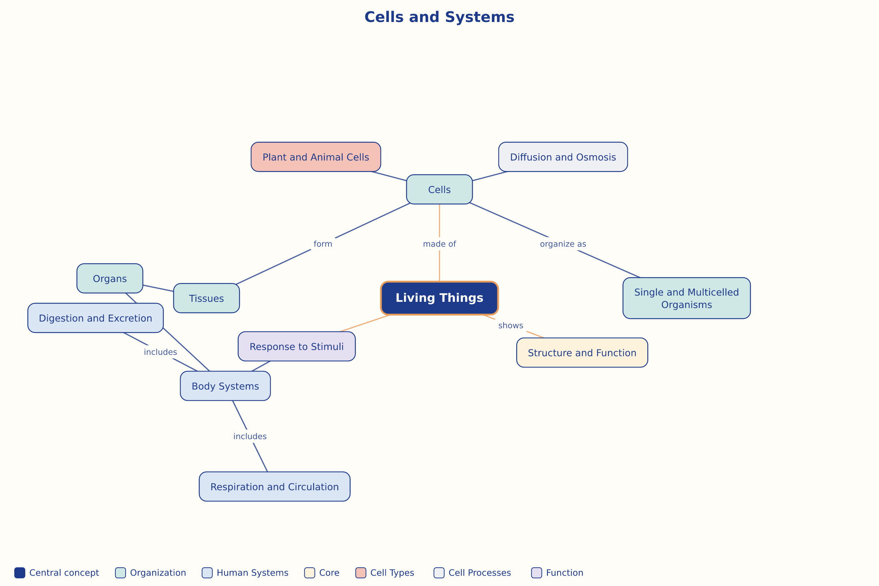

AILI word map · en · claude-haiku-4-5-20251001 · 2026-09-17

