Healthy Eating and Active Living
A Grade 2 look at moving our bodies and eating well

Slide 1: Healthy Eating and Active Living
Moving our bodies and eating good food to feel our best
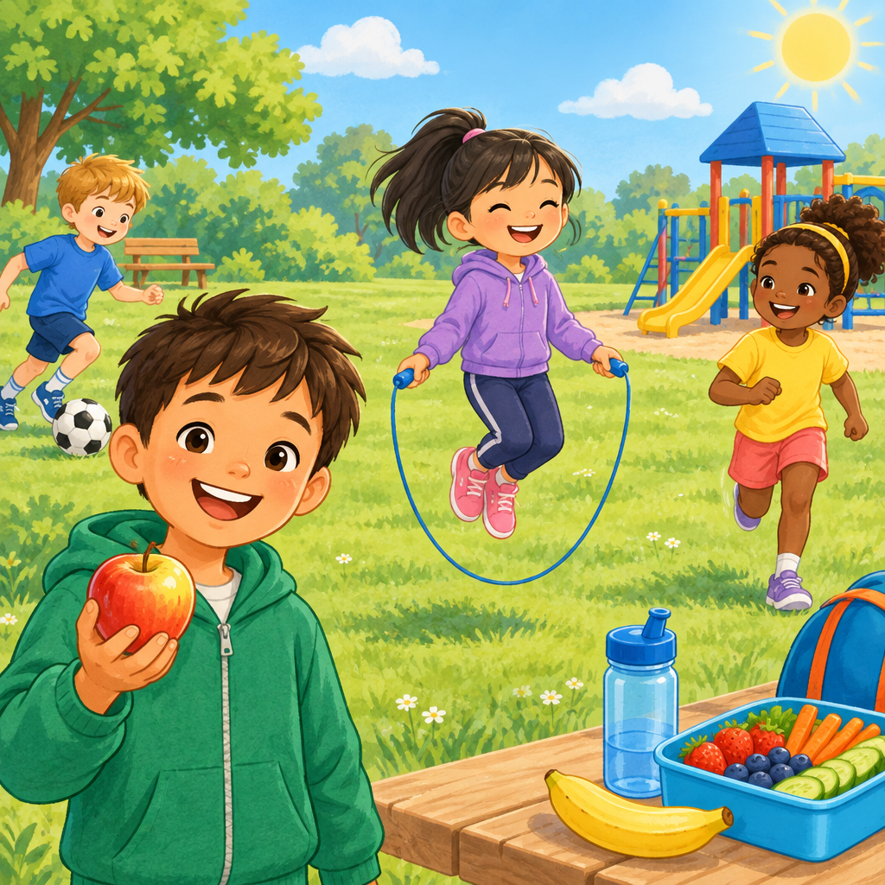
Notes: Welcome slide. Introduce the topic: our bodies need both movement and good food to grow strong. Ask students what they like to eat and how they like to move.

Slide 2: Why Do We Move Our Bodies?
- Moving our bodies helps us grow strong and stay well (Outcome).
- We can try many kinds of activities: dancing, gymnastics, games, and more (Details).
- Trying new activities builds our skills and makes us feel proud (Details).
- Some activities we do alone, some we do with friends (Details).
Sources: Outcome, Details
Notes: Grade 4 Active Living outcome, simplified. Discuss the list of activity types (rhythmic, gymnastic, expressive, individual, challenging, adventurous, cultural) using kid-friendly examples like dance, tumbling, tag, and cultural games. Formative check: have students name one activity from each category they enjoy.

Slide 3: Our Body Gets Stronger
Active living options include activities that are rhythmic, gymnastic, expressive, individual, challenging, adventurous, or cultural.
- Active living options can vary for individuals over time due to factors such as time, preference, access and availability, and sense of purpose(Details).
- Active living options include gymnastic activities that develop physical capabilities(Details).
- Active living options include challenging activities that individuals can choose based on their preferences and access (Details).
Sources: Details
Notes: Introduce four simple ideas about how our bodies get stronger (strength, flexibility, heart and lungs, endurance) as supporting background; note that the Grade 4 curriculum outcome cited addresses types of active living activities and factors such as time, preference, access, and purpose. Have students act out each one: flex an arm for strength, touch toes for flexibility, jog in place for heart/lungs, hold a plank briefly for endurance. Support: use fewer terms and just act them out. Extension: ask which activities build more than one component.

Slide 4: Food Gives Us Power
The food we eat helps our brain think and our body move (Details). Eating a mix of foods gives us the nutrients we need (Details).
- Good food helps us learn and pay attention (Details).
- Good food helps us feel our best and stay healthy (Details).
- In First Nations, Métis, and Inuit communities, nutrition can contribute to holistic, medicinal, or healing practices(Details).
- Eating many kinds of foods keeps our body balanced (Details).
Sources: Details
Notes: Grade 5 Healthy Eating outcome, simplified for grade 2. Discuss how food fuels learning and play. Mention that many cultures, including First Nations, Metis, and Inuit communities, connect food to traditions and celebrations. Checkpoint: ask students to name one food from their own family traditions.

Slide 5: What Helps Us Stay Motivated?
- Feel Enjoyment: We like to move when it feels fun (Details).
- Feel Safe: We try harder when we feel safe and supported (Details).
- Set a Goal: Small goals help us keep going (Details).
- Get Support: Family, friends, and teachers cheer us on (Details).
- Feel Proud: Finishing something makes us want to try more (Details).
Sources: Details, Details
Notes: Simplify Grade 5 and Grade 6 motivation concepts (internal/external motivation, community supports) for young learners. Walk through the flow together and ask students to share what motivates them to move. Support: focus on just enjoyment and support steps. Extension: ask about a personal goal they could set this week for being active.

Slide 6: Let's Keep Moving and Eating Well
Summary: Our bodies need movement and good food every day (Outcome, Details). Trying new active living activities helps us grow strong, learn well, and feel happy(Details, Details).
Question: What is one new activity or one new healthy food you want to try this week?
Sources: Outcome, Details, Details, Details
Notes: Wrap up by reviewing the two big ideas: active living and healthy eating. Invite each student to share one small goal aloud or draw it. Use this as an exit-ticket style formative check.

AILI presentation · en · claude-sonnet-5 · 2026-09-17

