Living Systems: Plants and Animals
Central concept: Plant and Animal Interaction

Connections
- Plant and Animal Interaction (includes) -> Food Chain
- Plant and Animal Interaction (involves) -> Animal Diet Types
- Plant and Animal Interaction (requires) -> Sensing and Responding
- Plant and Animal Interaction (needs) -> Environmental Protection
- Food Chain (shown as) -> Food Chain Representation
- Animal Diet Types (includes) -> Carnivores
- Animal Diet Types (includes) -> Herbivores
- Animal Diet Types (includes) -> Omnivores
- Sensing and Responding (detects) -> Sensory Stimuli
- Sensing and Responding (enables) -> Food Detection
- Environmental Protection (preserves) -> Habitat and Survival
- Food Chain (depends on) -> Habitat and Survival

Notes
- Plant and Animal Interaction: Plants and animals interact with each other in various environments. Outcome, Understanding
- Food Chain: Shows the order in which plants and animals depend on each other for food. Knowledge
- Animal Diet Types: Animals classified by what they eat: carnivores, herbivores, or omnivores. Understanding
- Sensing and Responding: Plants and animals sense and respond to stimuli in order to survive. Understanding
- Environmental Protection: Awareness of plant and animal interactions helps humans protect them. Understanding
- Carnivores: Animals that eat mostly meat. Knowledge
- Herbivores: Animals that eat only plants. Knowledge
- Omnivores: Animals that eat both meat and plants. Knowledge
- Sensory Stimuli: Water, food, temperature, and light that plants and animals respond to. Knowledge
- Food Detection: Animals use senses to detect the presence of food, predators, or other organisms. Knowledge
- Food Chain Representation: Food chains shown through illustrations, diagrams, stories, and words. Knowledge
- Habitat and Survival: Plants and animals depend on each other and their environments for food and habitat. Knowledge
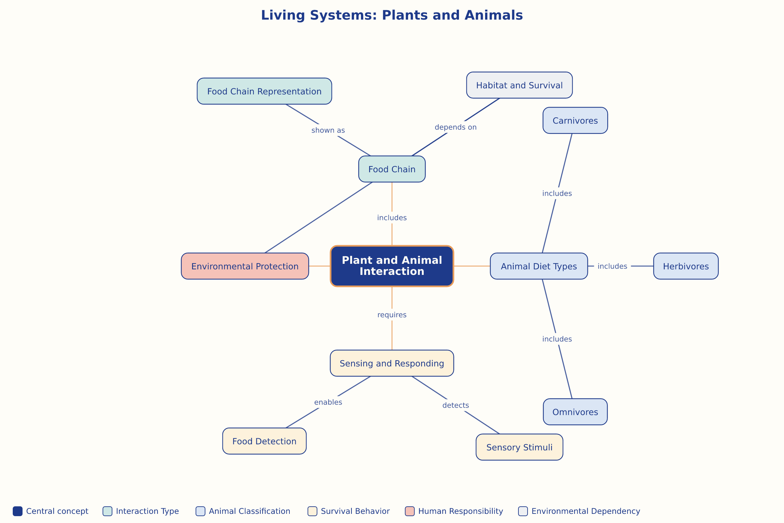

AILI word map · en · claude-haiku-4-5-20251001 · 2026-09-17

