Cells and Systems
Grade 8 Science: from the basic unit of life to whole-body systems

Slide 1: Cells and Systems
Grade 8 Science: from the basic unit of life to whole-body systems
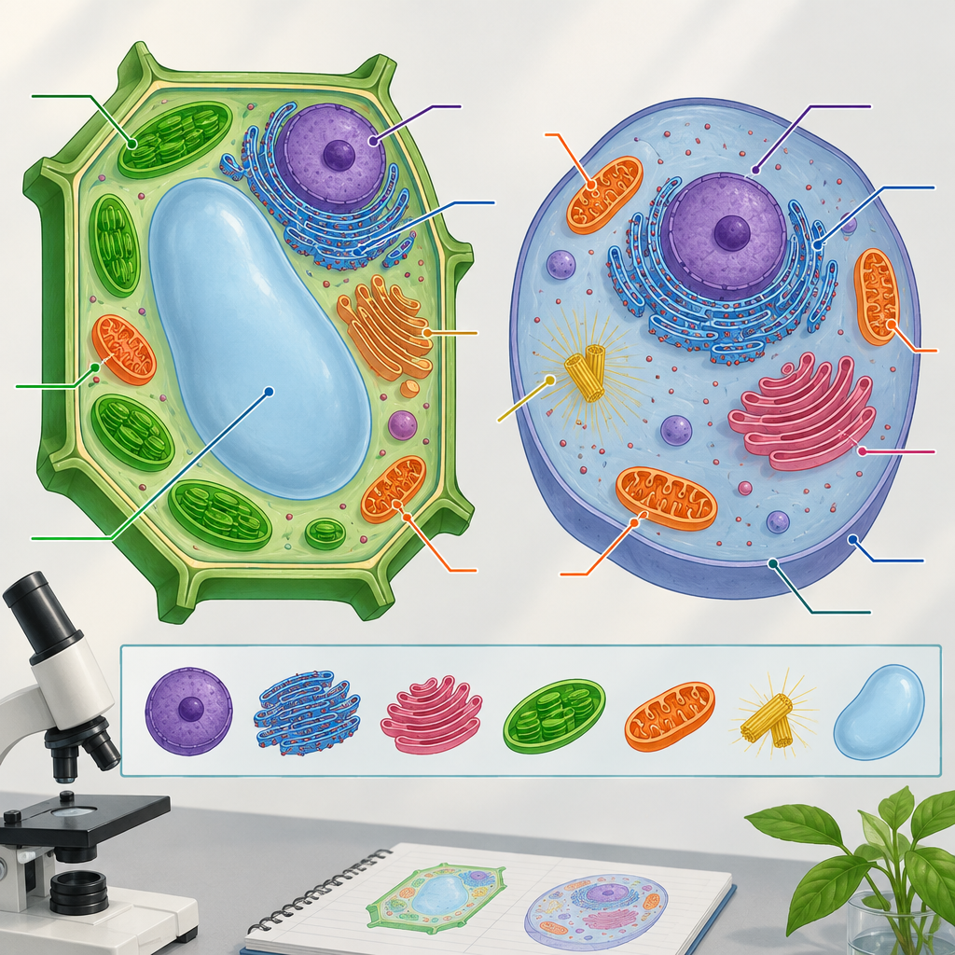
Notes: Introduce the unit by connecting today's lesson to prior learning in Grade 5 about body systems. Ask students what they remember about the digestive, respiratory, circulatory, and musculoskeletal systems before moving into the cellular level.

Slide 2: Learning Intentions and Success Criteria
- I can describe the cell as the basic unit of life (Outcome).
- I can distinguish between plant and animal cells (Outcome).
- I can explain diffusion and osmosis in general terms as movement of gases and liquids into and out of cells (Outcome).
- I can apply the concept of system to describe how organisms are structured and function (Outcome).
- I can describe how body systems keep humans healthy and respond to stimuli (Outcome).
Sources: Outcome, Outcome, Outcome, Topic
Notes: Read success criteria aloud and have students restate one in their own words with a partner (think-pair-share). This addresses Specific Outcome 2 by having students investigate and describe the role of cells within living things. Organizing idea: Science Grade 8, Nature of Science emphasis (Topic).

Slide 3: Plant Cells vs. Animal Cells
Plant Cells
Plant cells have a cell wall in addition to a cell membrane, giving them rigid structure (Outcome). They also contain chloroplasts, involved in energy capture, and typically a large vacuole for storage (Outcome).
Animal Cells
Animal cells have a cell membrane but no cell wall, allowing more flexible shapes (Outcome). Structures such as the nucleus, mitochondrion, and endoplasmic reticulum carry out life processes in both plant and animal cells (Outcome).
Sources: Outcome, Outcome
Notes: Formative checkpoint: give students unlabeled diagrams of a plant and animal cell and ask them to circle the one structure that tells them which is which (the cell wall). Support: provide a word bank with cell wall, cell membrane, chloroplast, vacuole. Extension: ask students to research one additional organelle not covered here.

Slide 4: How Oxygen and Nutrients Reach Your Cells
- Digestive system: Breaks down food and absorbs nutrients through the mouth, stomach, intestines, liver, and pancreas (Details).
- Respiratory system: Exchanges oxygen and carbon dioxide using the trachea, lungs, and diaphragm (Details).
- Circulatory system: Moves blood, carrying oxygen and nutrients, through the heart and blood vessels (Outcome).
- Body cells and tissues: Individual cells in nerves, muscle, blood, skin, and bone use the delivered oxygen and nutrients to function (Outcome).
Sources: Details, Outcome
Notes: This flowchart bridges Grade 5 prior knowledge of body systems (Details) with the Grade 8 focus on cells within those systems (Outcome). Ask students to trace a breath of oxygen from lungs to a muscle cell as a quick oral check. Support: allow students to use the diagram while explaining. Extension: have students add the musculoskeletal system's role in movement to the chain.

Slide 5: Cells, Tissues, Organs, Systems: Levels of Organization
- Cell: The basic unit of life; single-celled organisms like an amoeba carry out all life functions alone, while multicelled organisms like a grizzly bear divide the work among many cells (Outcome).
- Tissue: Groups of similar cells working together, such as those forming plant and animal structures (Outcome).
- Organ: Functional units such as lungs or the heart that play specific roles in supporting the healthy functioning of the human body(Outcome).
- System: Organs working together, such as respiration, circulation, digestion, excretion, and sensory awareness, to keep the body healthy (Outcome).
Sources: Outcome, Outcome
Notes: Formative checkpoint: students sort picture cards (a single cell, a muscle sample, a heart, the circulatory system) into the correct level of organization. Support: provide the four-level ladder printed as a scaffold. Extension: ask students to explain why a single-celled organism does not need separate tissues, organs, or systems (Outcome).

Slide 6: Wrapping Up Cells and Systems
Summary: Today we connected the cell, the basic unit of life, to the roles of cells, tissues and organs in living things. Cells are the basic unit of life and differ between plants and animals (Outcome). Cells contribute to healthy body function in nerves, muscle, blood, skin, and bone, and body systems change in response to conditions like exercise or temperature (Outcome). Applying the concept of system helps us interpret structure and function across familiar organisms(Outcome).
Question: If a single cell can carry out all of life's basic functions on its own, why do larger organisms like humans need trillions of specialized cells organized into tissues, organs, and systems instead?
Sources: Outcome, Outcome, Outcome
Notes: Use the closing question as an exit ticket. Students can respond by describing the role of cells as a basic unit of life or analyzing similarities and differences between single-celled and multicelled organisms. Collect responses to check for misconceptions about specialization before the next lesson on diffusion and osmosis in more depth.

AILI presentation · en · claude-sonnet-5 · 2026-09-17

