Making Ten to Add Two-Digit Numbers
A grade 2 lesson on using friendly numbers to add and subtract within 100.
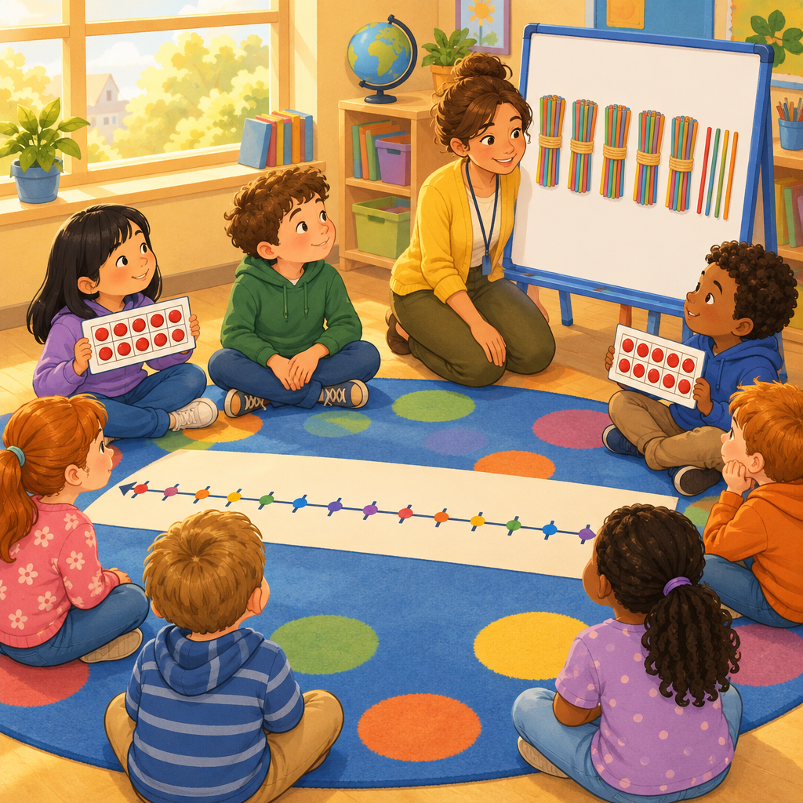

Learning intentions
We are learning to add and subtract two-digit numbers by making groups of ten.
We are learning that a sum can be made in more than one way.

Success criteria
I can break a number apart to make a ten.
I can add two two-digit numbers using a ten-making strategy.
I can check my answer using the opposite operation.
I can show my thinking with pictures, numbers, or objects.

Curriculum alignment
- Students investigate addition and subtraction within 100 (Outcome, Outcome).
- Addition and subtraction strategies for two-digit numbers include making multiples of ten and using doubles (Knowledge, Knowledge).
- Add numbers up to a sum of 100 and subtract numbers with a maximum minuend of 100 (Skills, Skills).
- Verify a sum or difference, using inverse operations (Skills, Skills).
- A sum can be composed in multiple ways (Understanding, Understanding).
- Visualize 100 as a composition of multiples of 10 (Skills, Skills).

Materials
- Base-ten blocks or bundled straws (tens and ones), enough for pairs
- One hundred chart, one per student
- Small whiteboards and markers
- Ten-frame cards (optional, for support group)
- Two-digit addition and subtraction problem cards (prepared ahead, see stage 3)
- Counters or unifix cubes for the support group

Lesson sequence

1. Hook (5 minutes)
Gather students on the rug. Hold up two ten-bundles of straws and say: "I have 20 straws. My friend gives me 8 more. How many do I have now?"
Let a few students share their guess with a partner. Ask: "Did anyone add 20 plus 8 in your head fast? How did you do it?"
Say: "Today we are going to learn a trick that makes adding two-digit numbers much faster. It is called making a ten."

2. Direct instruction (10 minutes)
Write on the board: 28 + 5 =?
Say: "Watch how I break 5 apart. I know 28 needs 2 more to make 30. So I split the 5 into 2 and 3."
Write: 28 + 2 = 30, then 30 + 3 = 33.
Say: "28 plus 5 equals 33. I made a ten first, and it was easier."
Do a second example: 46 + 7 =?
Ask students: "How much does 46 need to reach 50?" (4)
Write: 46 + 4 = 50, then 50 + 3 = 53.
Now connect to subtraction. Write: 33 − 5 =?
Say: "I can check my answer using the opposite operation. If 28 plus 5 equals 33, then 33 minus 5 must equal 28." Point back to the earlier example (Skills).
Say: "Numbers can also be added in a different order and the sum stays the same. Watch: 8 plus 5 plus 2. I can add 8 plus 2 first to make 10, then add 5. That gives me 15 either way" (Knowledge, Knowledge).

3. Guided practice (10 minutes)
Pair students. Give each pair a whiteboard and base-ten blocks.
Write these problems on the board one at a time. Solve the first together as a class, then release pairs to try the next two with blocks and whiteboards.
- 34 + 9 =?
- 47 + 6 =?
- 52 − 8 =? (Prompt: "What number plus 8 makes 52? Use your blocks to check.")
Circulate and ask: "Which number did you break apart? Why did you pick that one?"
After each problem, ask one pair to share their strategy with the class.

4. Independent practice (10 minutes)
Hand out problem cards with a mix of addition and subtraction, matched to student readiness (see differentiation). Students work alone, using a hundred chart or blocks if needed, and record their strategy on paper: the broken-apart number, the two steps, and the final answer.
Sample problems for the on-level set:
- 26 + 7 =?
- 63 + 9 =?
- 41 − 6 =?
- 58 + 4 + 6 =? (three addends, connects to Skills)
- 74 − 9 =?
Tell students: "For one problem, show me a second way to make the same sum." This targets the idea that a sum can be composed in multiple ways (Understanding).

5. Consolidation (5 minutes)
Bring students back to the rug. Ask two or three volunteers to share one problem and their ten-making strategy on the whiteboard easel.
Ask the class: "How did making a ten help you?"
Ask: "How can you check if your subtraction answer is correct?" Listen for students naming the inverse addition fact (Skills).
Close with: "Tomorrow we will use this same trick with even trickier numbers."

Differentiation
Extension: Give problems with three or four addends, such as 24 + 18 + 6 + 2, and ask students to find two different orders that reach the same sum, recording both to show the sum stays the same regardless of order (Knowledge). Also ask these students to write their own word problem using a measurable length, such as centimetres of string, connecting addition and subtraction to real quantities (Understanding).
Support: Provide ten-frames and physical counters instead of abstract numbers. Investigate addition and subtraction within 100. Allow students to build both starting numbers with blocks first, then physically move ones over to make a ten, narrating each move aloud with a partner or the teacher.

Assessment
Formative check: during independent practice, collect one recorded strategy sheet per student.
Look for:
- The student correctly identifies how many more are needed to reach the next ten.
- The two-step written work matches the final answer.
- The student can verify at least one subtraction answer using addition, either on paper or when asked aloud.
Students who consistently count by ones instead of jumping to a ten need a small group reteach with ten-frames before moving further with two-digit strategies.

AILI rapid lesson · en · claude-sonnet-5 · 2026-09-17

