Enthalpy Changes and Calorimetry
Chemistry 30, Unit A: Energy, Change and Systems

Slide 1: Enthalpy Changes and Calorimetry
Chemistry 30, Unit A: Energy, Change and Systems
Sources: Topic
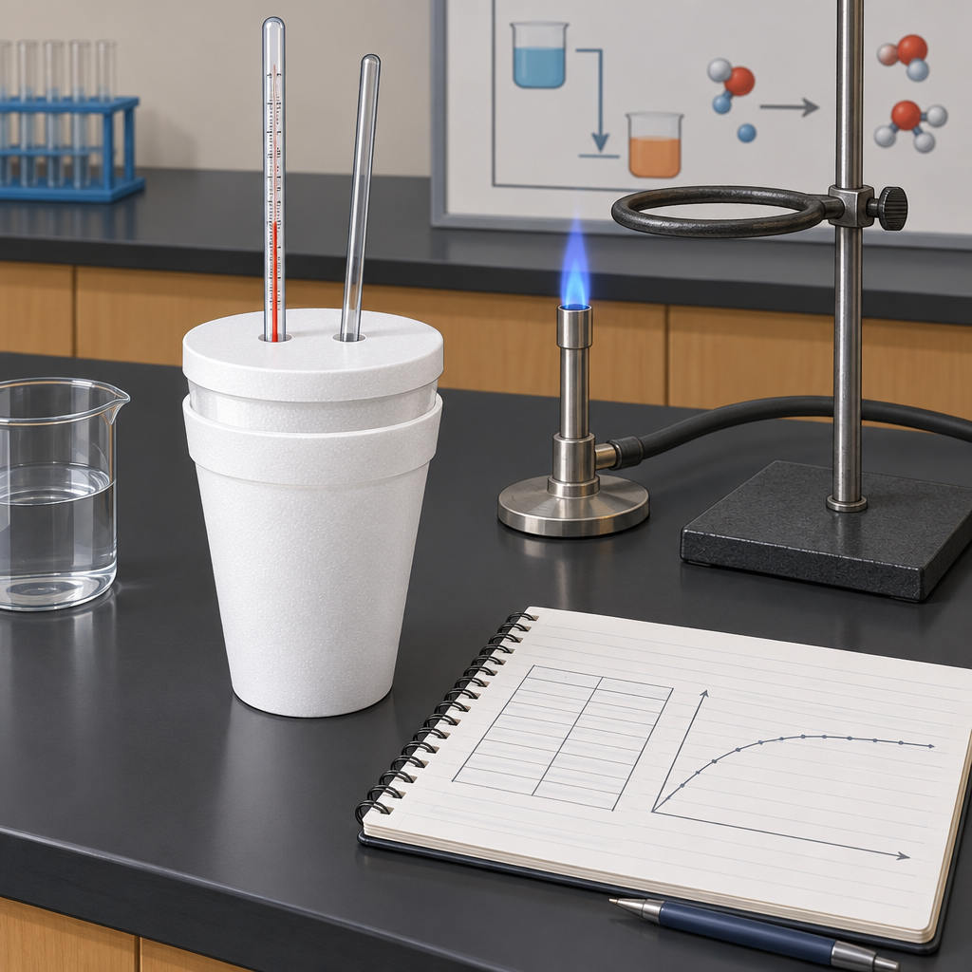
Notes: Introduce the unit theme of Energy, Change and Systems. Frame the focusing questions: how society uses chemical energy, the impacts of energy use, and how chemists quantify energy change (Topic). Preview that the unit covers roughly 20% of course time.

Slide 2: Unit Outcomes at a Glance
- Determine and interpret energy changes in chemical reactions (Topic).
- Explain and communicate energy changes in chemical reactions (Topic).
- Key concepts include enthalpy of formation, enthalpy of reaction, ΔH notation, Hess' law, molar enthalpy, energy diagrams, activation energy, catalysts, and calorimetry (Topic).
- This unit builds on Grade 7 Heat and Temperature and Science 10 Energy and Matter concepts (Topic).
Sources: Topic, Topic, Topic
Notes: Use this slide to orient students to the two general outcomes before moving into specific outcomes. Ask students to recall prior learning from Science 10 on energy flow before proceeding. Checkpoint: cold-call one example of energy change from daily life.

Slide 3: Enthalpy: Definitions and Notation
Enthalpy and Molar Enthalpy
Enthalpy is the heat content of a system at constant pressure, and molar enthalpy expresses this quantity per mole of substance reacted (Outcome). Reactions are classified as endothermic or exothermic based on whether they absorb or release energy, including photosynthesis, cellular respiration and hydrocarbon combustion (Outcome).
ΔH Notation and Bonding
ΔH notation communicates and quantifies the enthalpy change of a reaction (Outcome). Energy changes during reactions arise from bonds breaking and forming, and from shifts between potential and kinetic energy of particles (Outcome).
Sources: Outcome, Outcome, Outcome, Outcome
Notes: Have students write ΔH for a sample exothermic reaction (e.g., combustion) and a sample endothermic reaction (e.g., photosynthesis) using proper sign convention. Support: provide a sentence frame connecting bond breaking (energy absorbed) and bond forming (energy released). Extension: ask students to justify why combustion of hydrocarbons is always exothermic in terms of bond energies.

Slide 4: From Data to Enthalpy: The Calorimetry Process
- Measure temperature change: Record initial and final temperature of the calorimeter contents using a thermometer.
- Apply Q = mcΔt: Recall and use this equation to analyze heat transfer between the reaction and its surroundings (Outcome).
- Use calorimetry data: Use the calculated heat value to determine the enthalpy change of the chemical reaction (Outcome).
- Express as ΔH: Report the result using ΔH notation for the reaction (Outcome).
Sources: Outcome, Outcome, Outcome
Notes: Walk through a worked example: a known mass of water with measured ΔT, calculate q using Q = mcΔt, then convert to molar enthalpy by dividing by moles of limiting reactant. Formative checkpoint: give students a partially completed calorimetry table and have them finish the calculation. Support: provide the specific heat capacity of water (4.19 J/g°C) on a reference sheet. Extension: ask students to identify sources of heat loss in a coffee-cup calorimeter and how this affects accuracy.

Slide 5: Calculating Enthalpy Without a Calorimeter
- Standard enthalpies of formation: Predict the enthalpy change for a reaction using tabulated standard enthalpies of formation of reactants and products (Outcome).
- Hess' law: Explain and use Hess' law to calculate the energy change for a net reaction by combining a series of known reactions (Outcome).
- Energy diagrams: Analyze and label energy diagrams showing reactants, products, enthalpy change and activation energy (Outcome).
- Activation energy and catalysts: Recognize activation energy as the energy barrier a reaction must overcome, and catalysts as a way to lower that barrier (Topic).
Sources: Outcome, Outcome, Outcome, Topic
Notes: Compare the formation-enthalpy method and Hess' law method with a worked example that gives the same ΔH both ways. Have students sketch and label an energy diagram for an exothermic and an endothermic reaction, marking Ea and ΔH. Checkpoint: exit-ticket question asking students to state which method they would choose given a set of thermochemical equations versus a table of formation enthalpies.

Slide 6: Bringing It Together
Summary: Across this unit, students learn to quantify heat transfer with Q = mcΔt, define and calculate enthalpy and molar enthalpy, use ΔH notation, apply Hess' law and standard enthalpies of formation, interpret energy diagrams, and use calorimetry data to determine enthalpy changes for real chemical reactions (Outcome, Outcome, Outcome, Outcome).
Question: If you ran a calorimetry experiment and your calculated ΔH was smaller in magnitude than the accepted value, what sources of heat loss might explain the discrepancy?
Sources: Outcome, Outcome, Outcome, Outcome, Topic
Notes: Use the closing question as a discussion or short written response to assess understanding of experimental error in calorimetry. Connect back to the unit's focusing question about how chemists determine energy produced or absorbed in a reaction (Topic). Consider assigning a lab report or practice problem set as follow-up.

AILI presentation · en · claude-sonnet-5 · 2026-09-17

