Movement Patterns and Working Through Conflict
Building transferable movement patterns and practising fair conflict resolution in games
Audience: Grade 6 Physical Education and Wellness students, ages eleven to twelve, in a gymnasium or outdoor field setting
Grades: Grade 6
Subjects: Physical Education and Wellness
Time: about 60 minutes
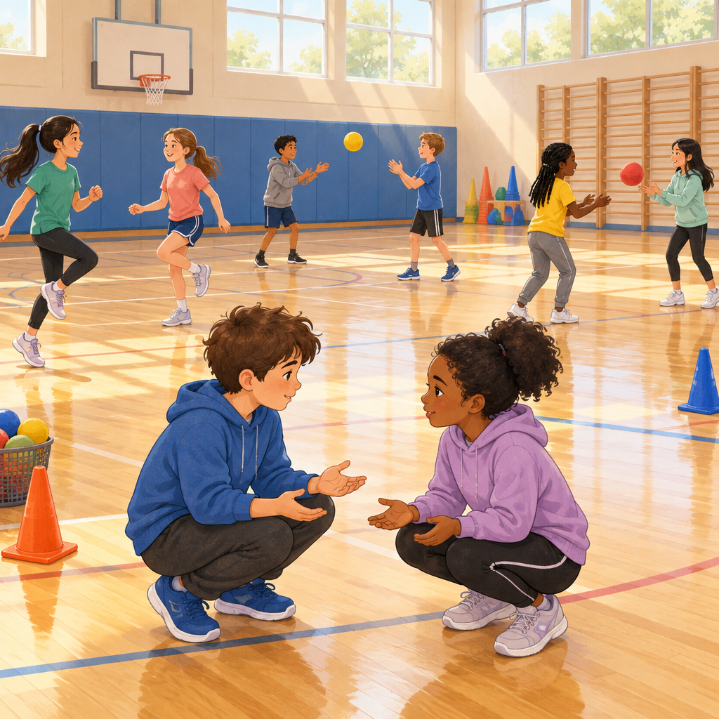

Overview
This 60-minute lesson connects a Grade 6 organizing idea in Movement Skill Development: how movement patterns transfer across activities to improve performance(Outcome, Outcome). Students move through a warm-up that responds to changing stimuli, rotate through skill stations that build the same movement pattern from controlled to dynamic conditions, and then apply both their movement skills and a five-step conflict-resolution routine in a cooperative-competitive mini-game (Knowledge, Understanding, Knowledge). A closing circle brings the learning together, asking students to name a transferable pattern they used.
The lesson treats movement skill as real content. Students are expected to notice, name, and adjust their physical patterns, since successful teams need these skills to work well together(Understanding, Understanding, Understanding).

Outcomes covered
- Students adapt and apply movement patterns in controlled and dynamic physical activities. (Outcome)
Recognizing that many sports and games share the same underlying movement patterns helps students transfer skill from one activity to another instead of starting from scratch every time.
- Students adapt and apply movement patterns in controlled and dynamic physical activities. (Outcome)
Students adapt and apply movement patterns in controlled and dynamic physical activities. Adapting and applying movement patterns supports team effectiveness and continued engagement in physical activity.

Materials
- Cones or floor markers for stations
- Soft balls, balloons (with note about latex allergy and burst/choking hazard), or beanbags for throwing and catching station
- Paddles or rackets and a lightweight ball for the striking station
- Agility ladder or extra cones for footwork station
- Whiteboard or poster with the five conflict-resolution practices listed
- Music player or drum for tempo and rhythm cues
- Pinnies or coloured bands to mark teams for the mini-game

Sequence of activities

1. Introduction and Lesson Framing (7 min, whole class)
- Gather students and explain today's two connected goals: getting better at movement patterns that transfer across sports, and practising how to solve disagreements during physical activity (Outcome, Outcome).
- Ask students to share one sport or game they play and name one movement it uses (a throw, a jump, a pivot, a dodge).
- Explain that many of these movements share similar underlying patterns, and today's stations will let them practise those patterns in both controlled and dynamic ways (Knowledge, Understanding, Understanding).
- Explain that conflicts (disagreements, close calls, unequal turns) happen in almost every game, and that strong teams have practices ready to work through them fairly (Understanding).
- Preview the five conflict-resolution practices students will use later: acknowledging emotions, clarifying facts, listening to understand, discussing possible outcomes, and proposing solutions (Knowledge).
This is a short framing talk. Keep energy up and move quickly into the warm-up so students are not sitting for long. Post the five conflict practices on a whiteboard or poster so students can reference them all lesson.
Sources: Outcome, Outcome, Knowledge, Understanding, Understanding, Understanding, Knowledge

2. Warm-Up: Pattern Tag and Stimulus Response (10 min, whole class)
- Students spread out in the gym or field space.
- Call out or hold up different stimuli (a clap pattern, a colour card, a drumbeat, a word like "skip" or "slide") and students respond with a matching movement pattern (skip, slide, gallop, hop) travelling through general space (Knowledge, Skills).
- Change the tempo (fast, slow) and rhythm every 30 to 45 seconds so students adjust their movement pattern to the new stimulus.
- Add a partner version: one partner leads a movement pattern, the other mirrors it, then switch roles.
- Finish with a quick freeze and stretch to bring heart rates down before moving into skill stations.
Watch for students who default to running only. Prompt them to vary the pattern (skip, gallop, slide, hop) so the warm-up actually samples different movement patterns, not just cardio. This links directly to the idea that similar patterns exist across many activities and can be adapted to a stimulus (Knowledge, Knowledge).
Sources: Knowledge, Skills, Knowledge

3. Skill Stations: Controlled to Dynamic Movement Patterns (18 min, small group)
- Set up three or four stations around the gym, each using a movement pattern common to more than one sport (for example: an underhand throw and catch station, a footwork/agility ladder or cone station, a striking station with a paddle and balloon or soft ball, and a balance and pivot station).
- Explain that each station starts in a controlled, structured way (students practise alone or with a steady partner, repeating the pattern) and then becomes more dynamic (a partner adds unpredictable timing, movement, or a defender) (Knowledge, Understanding).
- Groups rotate through two stations, spending about 7 minutes at each: 3 minutes controlled practice, 3 minutes dynamic practice, and 1 minute transition and instruction.
- At each station, students try to improve one thing about their pattern, such as accuracy, speed, or smoothness, and say out loud what they changed (Skills).
- Before rotating, each group names one other sport or game where they think this same movement pattern would help (Skills, Understanding).
Circulate to each station and ask one guiding question: "What did you adjust to make that pattern work better?" Listen for language about accuracy, speed, or control (Skills). If time and space allow, include a station based on a First Nations, Métis, or Inuit game (for example, a target or ring-toss game) to show unique movement patterns from those traditions. Consult curriculum resources specific to First Nations, Métis, and Inuit physical activities and games.
Sources: Knowledge, Skills, Understanding, Skills, Understanding, Knowledge

4. Cooperative-Competitive Mini-Game with Built-In Conflict Points (15 min, small group)
- Divide the class into teams of four or five for a small-sided game that uses the movement patterns just practised (for example, a modified team handball or newcomb-style game using the throw, catch, and footwork skills from the stations).
- Before playing, review the five practices for managing conflict: acknowledging emotions, clarifying facts, listening to understand, discussing possible outcomes, and proposing solutions (Knowledge).
- Play in short rounds of about 3 minutes each, deliberately including one cooperative task (teams must complete a set number of passes before scoring) and one competitive task (teams try to score more points than the other team) so students feel the two situations differently (Knowledge).
- When a disagreement comes up (a close call, a rule question, an unequal turn), pause the game and have the involved students use the five practices out loud before play resumes (Skills, Skills).
- Rotate teams once partway through so students practise the routine with new teammates.
Plant a low-stakes disagreement scenario if none arises naturally, such as a disputed line call, so every group gets a chance to practise the five conflict practices (Knowledge, Skills). Notice whether students adjust their approach between the cooperative round and the competitive round, since a team's ability to manage conflict affects how well they work together (Understanding, Understanding).
Sources: Knowledge, Skills, Knowledge, Skills, Understanding, Understanding

5. Circle Debrief: Reflecting on Patterns and Conflict (10 min, whole class)
- Gather the class in a circle, seated or standing, to cool down.
- Ask: "Name one movement pattern from today that you could use in a different sport. Which sport, and why?" Take three or four quick responses (Skills, Understanding).
- Ask: "What was one moment today where your team had a disagreement or a close call? Which practice did you use to work it out: acknowledging feelings, clarifying facts, listening, discussing outcomes, or proposing a solution?" (Knowledge, Skills).
- Ask one or two students to share how the cooperative round felt different from the competitive round, and what that meant for how they solved problems (Knowledge, Understanding).
- Close with a shared stretch and a reminder that both movement patterns and conflict-resolution practices get stronger with repeated use, in games and in everyday life.
Keep responses short and specific. If the group is shy, use a think-pair-share for 1 minute before opening to the whole circle. This debrief is the main place to hear direct evidence of the reflect-on-practices outcome (Skills).
Sources: Skills, Understanding, Knowledge, Skills, Knowledge, Understanding

Differentiation
Extension
- Ask students who master the basic pattern quickly to add a challenge constraint at their station, such as using their non-dominant hand, adding a second object, or moving to a smaller target, to keep the dynamic practice demanding (Skills, Knowledge).
- During the mini-game, invite advanced students to act as peer conflict coaches, quietly prompting a group through the five practices if a disagreement is slow to resolve (Knowledge).
- Have students design their own two-station movement pattern circuit at home or for a future class, identifying which sports share the pattern they chose (Understanding).
Support
- Reduce the station rotation to fewer, simpler patterns and let students stay longer at controlled practice before adding a dynamic partner (Knowledge).
- Offer a visual card with the five conflict-resolution practices in simple icons or short phrases so students can point to a step during a real disagreement (Knowledge).
- Pair students needing more support with a patient partner for the mirroring warm-up so the pace can be slowed to match their comfort (Skills).
Inclusive supports
- Offer alternate equipment (larger, softer, slower-moving balls, or a scarf instead of a ball) at any station for students with different motor abilities, while keeping the same underlying movement pattern (Knowledge).
- Allow students who are uncomfortable with physical contact or crowded space to take a station role such as timekeeper or pattern caller so they can still participate in a meaningful way.
- Use visual and verbal stimuli together during the warm-up (colour cards plus spoken words) so students with different processing needs can all respond to the pattern cue (Skills).

Assessment
Formative. During the skill stations, the teacher listens for students naming what they adjusted (accuracy, speed, control).
Look for: Student can describe a specific adjustment to their movement pattern and name a transfer sport, showing they can adapt patterns to improve proficiency and identify how patterns support skill development (Skills, Skills). (Skills, Skills)
Formative. During the mini-game, the teacher observes whether students use the five conflict-resolution practices when a disagreement or close call happens, rather than escalating or ignoring it.
Look for: Student pauses, names the practice being used (for example, "let's clarify what happened"), and reaches a resolution with teammates or opponents. (Knowledge, Skills, Skills)
Self. In the closing circle, students reflect out loud on one movement pattern they could transfer to another activity.
Look for: Student gives a specific, personal example rather than a general statement, showing genuine reflection on both movement transfer and conflict practices. (Understanding, Skills)
Peer. During partner mirroring in the warm-up and paired drills at stations, partners give each other one piece of feedback on how closely their movement pattern matched the stimulus or model.
Look for: Student offers a specific, kind observation (for example, "you slowed down on the turn, try keeping the same speed") rather than a vague comment. (Knowledge, Skills)

Vocabulary
- Movement pattern: A repeatable way the body moves in response to a stimulus, such as a throw, a slide step, or a pivot. Similar patterns show up across many different sports and games.
- Controlled physical activity: A structured activity, done alone or with a steady partner, that lets you repeat a movement pattern the same way each time to build the skill.
- Dynamic physical activity: An activity with less fixed structure, where things change quickly and you need to make decisions and adjust your movement pattern on the spot.
- Conflict resolution: Strategies for working through disagreements that support engagement in physical activity.
- Group physical activity: A time during an activity when students engage in physical activities together.
- Physical activity: Any movement of the body produced by the muscles that uses energy, such as running, throwing, dancing, or playing a game.

For families
- Ask your child which movement pattern from gym class they think would help in a sport or game you play together at home, like catching, pivoting, or sliding.
- Practise the five conflict-resolution steps as a family the next time a disagreement comes up during a board game or backyard game: name the feeling, get the facts straight, listen first, talk about options, then agree on a solution.
- Play a simple stimulus-response game at home, such as calling out different animal walks or dance moves, to keep building comfort with changing movement patterns quickly.

Sources
- Outcome: "Students adapt and apply movement patterns in controlled and dynamic physical activities."
- Outcome: "Students analyze and apply conflict resolution in physical activity."
- Knowledge: "Similar patterns exist across a variety of physical activities."
- Skills: "Demonstrate how movement patterns are applied across various physical activities."
- Understanding: "Patterns can be transferred across a variety of physical activities for individual or group success."
- Knowledge: "Controlled physical activities allow for repeated practice of movement skills."
- Skills: "Adapt movement patterns to improve accuracy, speed, and proficiency in a variety of controlled and dynamic physical activities."
- Understanding: "Controlled and dynamic physical activities can support movement skill patterns in a variety of physical activities."
- Knowledge: "Creativity in movement can be supported by including objects and changing tempo and rhythm."
- Skills: "Implement movement patterns in response to a variety of physical, verbal, visual, and musical stimuli."
- Understanding: "Movement combinations, patterns, and sequences can be adapted using creativity."
- Knowledge: "Practices to manage conflict include acknowledging emotions, clarifying facts and understanding, listening to understand, discussing possible outcomes, proposing solutions"
- Skills: "Practise conflict resolution. Reflect on practices used to resolve conflict."
- Understanding: "Team effectiveness can be influenced by the ability to manage conflict."
- Knowledge: "Individuals and groups in both cooperative and competitive situations can experience conflict differently."
- Skills: "Discuss how cooperative and competitive situations influence thinking and actions to resolve conflict."
- Understanding: "Cooperative and competitive situations may require group members to adjust thinking or actions to resolve conflict."

All activities use age-appropriate equipment and low-contact game formats suitable for Grade 6 students, and the conflict-resolution content models respectful, calm communication with no reference to sensitive personal topics.

AILI detailed pack · en · claude-sonnet-5 · 2026-09-17

