Four Readers, One Story
This puzzle is about how readers understand texts in different ways. Grade 9 students learn that two people can read the same story and come away with different ideas, depending on what they already know and what they have experienced (Outcome, Outcome). Talking about these differences helps readers understand the story better (Outcome). The choices characters make, the main idea of the story, and who is telling the story all change how a reader feels about it (Outcome). This puzzle also shows that different readers can have different ideas—even opposite ideas—and both can be right if the text supports them (Outcome).
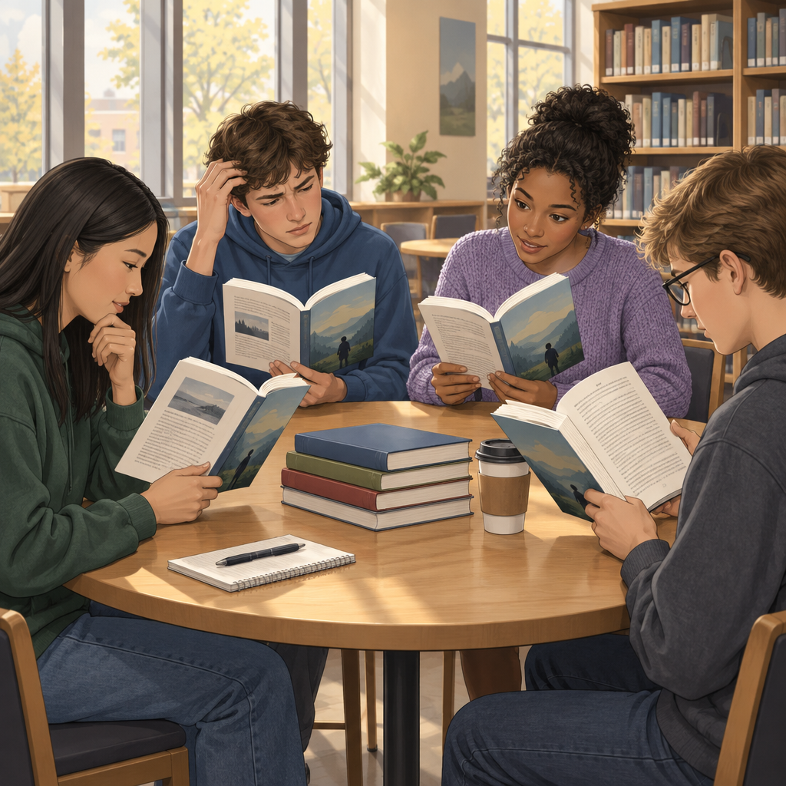

The puzzle
Four students in a grade 9 class read the same short story together. Their names are Priya, Marcus, Talia, and Deshawn. The teacher asks each student what shaped how they understood the story the most. Each student gives a different answer. The four answers are: a personal experience, a book or story they read before, the way the story uses symbols, and who is telling the story.
Use these clues to match each student to the factor that shaped their reading:
- The student who focused on prior reading did not read a story with a similar setting before; they recognized a plot pattern from a novel studied in grade 8.
- Priya has never moved schools, but the story's narrator does, and Priya said the biggest influence on her reading was noticing whose eyes the story was told through.
- Marcus said a scene with a wilting plant meant something because his grandmother once used the same image to talk about hope.
- Talia is the one who connected the story to a similar novel she read last year.
- Deshawn has changed schools three times and said the story felt personal to him before he even reached the twist ending.
Name which factor shaped each student's interpretation. The four factors are personal experience, prior reading, symbolism, and point of view.

Hints
- Start with clue 2: it tells you directly which factor shaped Priya's reading. Cross that factor off the list for everyone else.
- Clue 4 gives you a direct match for Talia. That leaves only two factors for Marcus and Deshawn.
- Compare clue 3 and clue 5 carefully: one student connects a story detail to a memory tied to a specific object or image, the other connects the story to their own life circumstances in a general way, not to one symbol.

Answer key
- Priya: point of view. Clue 2 states her focus was on "whose eyes the story was told through," which is the definition of point of view (Outcome).
- Talia: prior reading. Clue 4 says she connected the story to a novel she read last year, and clue 1 confirms the prior-reading student drew on a novel studied in grade 8, matching a past reading experience rather than her own life (Outcome).
- Marcus: symbolism. Clue 3 describes him linking a specific image, the wilting plant, to a meaning beyond the literal object, which is how symbolism works in a text (Outcome).
- Deshawn: personal experience. Clue 5 shows him relating the story to his own life circumstances (changing schools) rather than to a symbol or another book, matching the idea that readers use personal experience to interpret texts (Outcome).
This puzzle shows that four readers can read one story and understand it in four different ways. Each way is valid and fair because each reader used a different reading strategy to support their ideas (Outcome, Outcome).

AILI game · en · claude-sonnet-5 · 2026-09-17

