Enthalpy Changes and Calorimetry
Chemistry 30, Unit A: Energy, Change and Systems

Slide 1: Enthalpy Changes and Calorimetry
Chemistry 30, Unit A: Energy, Change and Systems
Sources: Topic
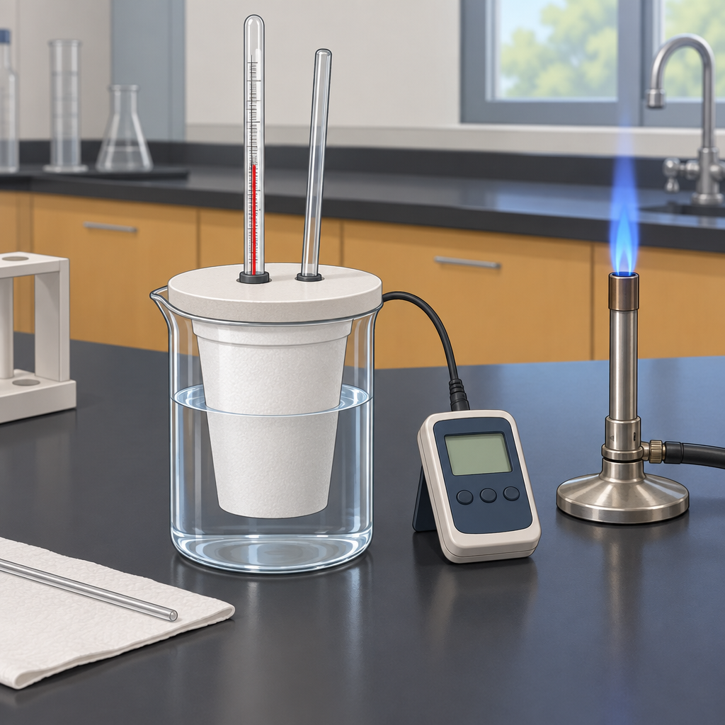
Notes: Introduce the unit focus: quantifying energy changes in chemical reactions using calorimetry and enthalpy concepts. Connect to prior learning from Science 10 Unit A and Grade 7 Unit C (Topic).

Slide 2: Why Study Energy in Chemical Reactions?
- Chemists quantify how much energy a reaction produces or absorbs (Topic).
- This unit builds on Science 10 energy concepts and Grade 7 heat and temperature (Topic).
- Students will determine and interpret energy changes in chemical reactions (Topic).
- Students will explain and communicate energy changes in chemical reactions (Topic).
- Society relies on chemical reactions for energy, from combustion to metabolism (Topic).
Sources: Topic, Topic, Topic
Notes: Frame the unit's two general outcomes. Ask students how they already encounter thermochemistry in daily life (heating fuels, food energy, hand warmers). Reference focusing questions from Topic.

Slide 3: From Heat Transfer to Enthalpy Notation
- Q = mcΔt: Recall this equation to analyze heat transfer between substances (Outcome).
- Define Enthalpy: Enthalpy and molar enthalpy describe energy content of chemical reactions (Outcome).
- Balanced Equations: Write balanced equations that include energy changes as terms (Outcome).
- ΔH Notation: Use ΔH notation to communicate and calculate energy changes (Outcome).
- Classify Reactions: Classify reactions as endothermic or exothermic, including photosynthesis and combustion (Outcome).
Sources: Outcome, Outcome, Outcome, Outcome, Outcome
Notes: Walk through this sequence with a worked example: measure temperature change of water in a calorimeter, calculate q using Q=mcΔt, then express the reaction with ΔH notation. Checkpoint: have students apply Q = mcΔt to analyze heat transfer in three given scenarios.

Slide 4: Calculating ΔH: Two Approaches
Standard Enthalpies of Formation
Predict the enthalpy change for a chemical equation using standard enthalpies of formation of reactants and products (Outcome). This method uses tabulated ΔHf° values and the relationship ΔH reaction equals the sum of ΔHf products minus the sum of ΔHf reactants.
Hess' Law
Explain and apply Hess' law to calculate the energy change for a net reaction by combining a series of known reactions (Outcome). This method allows chemists to determine ΔH for reactions that are difficult to measure directly.
Sources: Outcome, Outcome
Notes: Contrast the two calculation methods with worked examples. Support: provide a table of ΔHf values and a step-by-step Hess' law addition template. Extension: ask students to derive ΔH for combustion of propane using both methods and compare results.

Slide 5: Calorimetry in the Lab
Calorimetry data allows students to determine the enthalpy change occurring in a chemical reaction (Outcome). In a typical lab, a known mass of solution reacts inside an insulated calorimeter while a thermometer records temperature change. Students apply Q = mcΔt to find the heat absorbed or released by the water, then relate this value to moles of reactant to calculate molar enthalpy.
Measuring enthalpy change with a coffee-cup calorimeter
Calorimetry data allows students to determine the enthalpy change occurring in a chemical reaction (Outcome). In a typical lab, a known mass of solution reacts inside an insulated calorimeter while a thermometer records temperature change. Students apply Q = mcΔt to find the heat absorbed or released by the water, then relate this value to moles of reactant to calculate molar enthalpy.
Sources: Outcome
Notes: Formative checkpoint: run a mock calorimetry calculation as a class, then have students complete a similar problem independently. Support: provide a fill-in-the-blank calculation template. Extension: ask students to identify sources of error (heat loss to surroundings) and how these affect calculated ΔH.

Slide 6: Bringing It Together
Summary: This unit connects heat transfer calculations, enthalpy notation, energy diagrams and calorimetry to explain how chemists quantify energy changes in reactions (Topic). Students learn to analyze energy diagrams labelling reactants, products, enthalpy change and activation energy (Outcome), and to explain energy changes in terms of bond breaking, bond forming and changes in potential and kinetic energy (Outcome).
Question: If a calorimetry experiment loses heat to the surroundings during the reaction, will the calculated enthalpy change be too large or too small in magnitude, and why?
Sources: Topic, Outcome, Outcome
Notes: Use the closing question as an exit ticket. Strong answers will note that heat loss to surroundings means less heat is measured by the calorimeter water, leading to an underestimated magnitude of ΔH. Extension: connect to real instrumentation like bomb calorimeters used for combustion reactions.

AILI presentation · en · claude-sonnet-5 · 2026-09-17

