Movement Skills and Healthy Relationships
We are learning to adapt movement patterns and use conflict resolution to work together in physical activities.
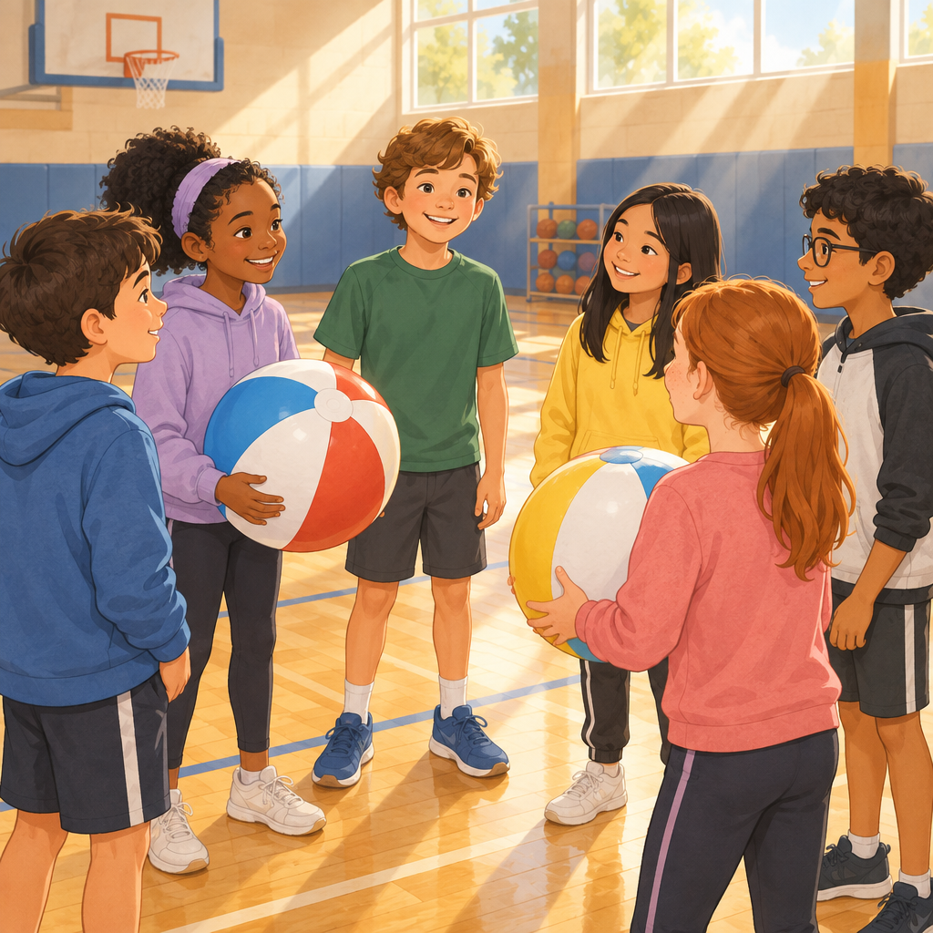

Learning intentions
We are learning to adapt movement patterns in physical activities (Outcome).
We are learning to analyze and apply conflict resolution in physical activity (Outcome).

Success criteria
I can adapt movement patterns to improve accuracy and speed in controlled and dynamic activities (Skills).
I can identify and use conflict resolution practices when working with others in physical activities (Skills).
I can explain how managing conflict helps a team work better together (Understanding).

Curriculum alignment
Students adapt and apply movement patterns in controlled and dynamic physical activities (Outcome). Similar patterns exist across a variety of physical activities, and patterns can be customized to enhance proficiency of movement (Knowledge). Controlled physical activities allow for repeated practice of movement skills, while dynamic physical activities require immediate decision making and refinement of movement skills (Knowledge). Patterns are movements that enable the body to move in response to a stimulus (Knowledge).
Students analyze and apply conflict resolution in physical activity (Outcome). Team success can be influenced by conflict, and practices to manage conflict include acknowledging emotions, clarifying facts and understanding, listening to understand, discussing possible outcomes, and proposing solutions (Knowledge). Individuals and groups in both cooperative and competitive situations can experience conflict differently (Knowledge). Team effectiveness can be influenced by the ability to manage conflict, and successful teams develop practices to manage conflict (Understanding).

Materials
- One large soft ball (beach ball or foam ball) per group of four to six students
- Open gymnasium or outdoor space with clear boundaries
- Optional: cones or tape to mark zones
- Chart paper and markers for recording conflict resolution steps

Lesson sequence
1. Hook (5 minutes)
Gather students in a standing circle. Explain that today they will work together in movement activities and learn how to solve problems when disagreements happen.
Ask: "When you are playing a game with friends and someone disagrees about the rules, what happens?" Allow two or three brief responses. Say: "Today we will practise moving together and also learn how to handle disagreements so everyone can keep playing and having fun."
Introduce a simple movement pattern: step forward with the right foot, tap the ground with the left foot, then step back. Demonstrate it slowly. Ask students to copy the pattern three times with you, then speed it up slightly. Say: "This pattern is the same every time because it is controlled. We can practise it over and over to get better at it."
2. Direct instruction: Movement patterns (8 minutes)
Divide students into groups of four to six. Give each group a soft ball.
Explain: "Controlled physical activities are structured and let you practise the same movement over and over. Dynamic physical activities change quickly and you have to make quick decisions" (Knowledge).
Teach a controlled passing pattern: students stand in a circle, pass the ball to the right, then to the left, then across the circle. Have groups practise this pattern for two minutes. Ask: "What stays the same each time? What helps you get better at this pattern?" Answers might include: the direction, the distance, the footwork.
Now teach a dynamic version: students stand in a circle, but the person with the ball can pass to anyone. That person must move one step closer or one step farther away before passing. Say: "Now the pattern changes because people move in different ways. You have to decide quickly where to pass and how to move." Have groups try this for two minutes.
Ask: "How is the dynamic version different from the controlled version?" Expected responses: it is faster, people move differently, you have to think quickly.
3. Direct instruction: Conflict resolution (6 minutes)
Bring the whole class together. Say: "When you work with others in physical activities, sometimes people disagree. Maybe someone thinks the pass was wrong. Maybe someone thinks the rule is different. When that happens, you can use conflict resolution practices" (Knowledge).
Write on chart paper or say aloud the five practices:
- Acknowledge emotions: Say what you are feeling. "I am frustrated because..."
- Clarify facts and understanding: Ask what happened. "What did you see?"
- Listen to understand: Really hear what the other person says.
- Discuss possible outcomes: Talk about what could happen next.
- Propose solutions: Suggest a way forward that works for everyone.
Give an example: "Two students are passing a ball. One student says the pass was too hard. The other student says it was the right speed. Instead of arguing, they say: 'I felt frustrated because the ball was moving fast. What did you think?' Students can analyze and apply conflict resolution in physical activity. Let me pass softer next time.' They agree to try again with a slower pass."
Ask: "What practice did they use?" Expected responses: they acknowledged emotions, they listened, they proposed a solution.
4. Guided practice: Movement and conflict resolution together (15 minutes)
Bring groups back to their circles with their soft balls. Say: "Now we will play a game where you pass the ball using the dynamic pattern. But if someone disagrees about something, you will stop and use conflict resolution."
Explain the game: "Pass the ball to anyone in the circle. Students adapt and apply movement patterns in the physical activity. The person who receives it adapts their movement pattern before passing. If anyone thinks something is unfair or wrong, raise your hand and the group stops. Then you use the five practices to solve the problem together."
Start the game. Circulate among groups. Watch for moments where students might disagree (for example, someone passes too quickly, or someone does not move far enough, or two people reach for the ball at the same time).
When a disagreement happens, pause the group and ask:
"What is the problem right now?"
"How does each person feel about it?"
"What did each person see happen?"
"What could you do differently next time?"
Guide the group to agree on one change. For example: "You will count to three before passing so everyone is ready" or "You will move at least one big step, not a small step."
Restart the game. Repeat this two or three times with different groups.
Ask the whole class to pause and analyze the movement patterns being used. Ask: "What conflict resolution practice did you use?" Possible answers: we listened to each other, we talked about how we felt, we agreed on a new rule.
5. Independent practice and consolidation (6 minutes)
Say: "Now each group will play the game one more time. This time, try to use conflict resolution on your own without me helping. If you disagree, stop and talk it through using the five practices."
Groups play for four minutes. Circulate and observe. Do not interrupt unless safety is at risk.
Bring the class together. Ask: "What was one conflict your group solved today? How did you solve it?" Allow two or three groups to share briefly.
Close by saying: "When you adapt movement patterns, you get better at the skill. When you use conflict resolution, you get better at working together. Both of these make physical activity more fun and fair for everyone."

Differentiation
Support
For students who struggle with the dynamic pattern, allow them to stay in a controlled version longer. They can pass the ball in a set order (right, left, across) before moving to passing to anyone.
For students who have difficulty with conflict resolution language, provide a sentence starter card: "I felt ___ because ___. What did you see?" and "Let's try ___ next time."
Pair students who are confident with conflict resolution alongside students who are learning it.
Extension
Challenge students to create their own movement pattern using a ball. The pattern must have at least three steps and can change speed or direction. Groups teach their pattern to another group.
Ask: "If two groups disagree about whose pattern is better, how would you resolve it fairly?" Encourage students to discuss how cooperative situations (working together) and competitive situations (trying to win) might change how they solve the problem (Skills, Understanding).
Have students reflect in writing or conversation: "What conflict resolution practice was hardest for you today? Why? How could you practise it more?"

Assessment
Formative check: Observation during guided practice
Watch for these signs of success:
Movement adaptation: Students adjust their step size, speed, or direction based on what happens in the game. They are not just repeating the same movement every time.
Conflict resolution: When a disagreement happens, students stop and talk instead of arguing or giving up. They use at least two of the five practices: acknowledging emotions, clarifying facts, listening, discussing outcomes, or proposing a solution.
Collaboration: Students listen to each other and agree on a change before restarting the game.
If a student struggles to adapt movement, ask: "What could you change about your step?" or "How could you move differently?"
If a student struggles with conflict resolution, prompt with: "How do you feel right now?" or "What did you see happen?" or "What could we try next time?"

AILI rapid lesson · en · claude-haiku-4-5-20251001 · 2026-09-17

