Cell Systems Detective
This puzzle draws on Grade 8 Science outcomes about cells as the basic unit of life, the differences between plant and animal cells, and diffusion and osmosis as ways that gases and liquids move into and out of cells (Outcome). It also uses the idea that organisms are interpreted as systems built from cells, tissues, and organs working together (Outcome).

The puzzle
A research team is studying four unlabelled samples under a microscope. Each sample is either a plant cell or an animal cell, and each one is sitting in a different type of solution. Use the clues below to figure out, for each sample, whether it is a plant or animal cell and whether it is gaining water, losing water, or staying the same.
The four samples are numbered 1, 2, 3, and 4.
Clue A: Sample 1 has a rigid outer boundary that keeps its shape fixed no matter what solution surrounds it, and it also contains chloroplasts.
Sample 2 has no rigid outer wall, so it changes shape depending on the water content inside it.
Sample 3 has a rigid outer boundary like Sample 1, but it has no chloroplasts.
Sample 4 has no rigid outer wall and is currently shrinking, becoming smaller and more wrinkled.
Clue B: Water moves across a cell membrane from an area of higher water concentration to an area of lower water concentration, by osmosis, until the concentration is equal on both sides.
Sample 3 is placed in a solution with a lower concentration of dissolved particles than the inside of the cell.
Sample 2 is placed in a solution with the same concentration of dissolved particles as the inside of the cell.
Sample 1 is placed in a solution with a higher concentration of dissolved particles outside the cell than inside it.
Sample 4's surrounding solution has a lower concentration of dissolved particles inside the cell than outside it.
Questions to answer:
- Which two samples are plant cells, and which two are animal cells?
- For each sample, state whether water is moving into the cell, out of the cell, or staying balanced.
- Explain why Sample 1 keeps its overall shape even though water is moving out of it, while Sample 4, which lacks the cell wall that Sample 1 has, shrinks and wrinkles.
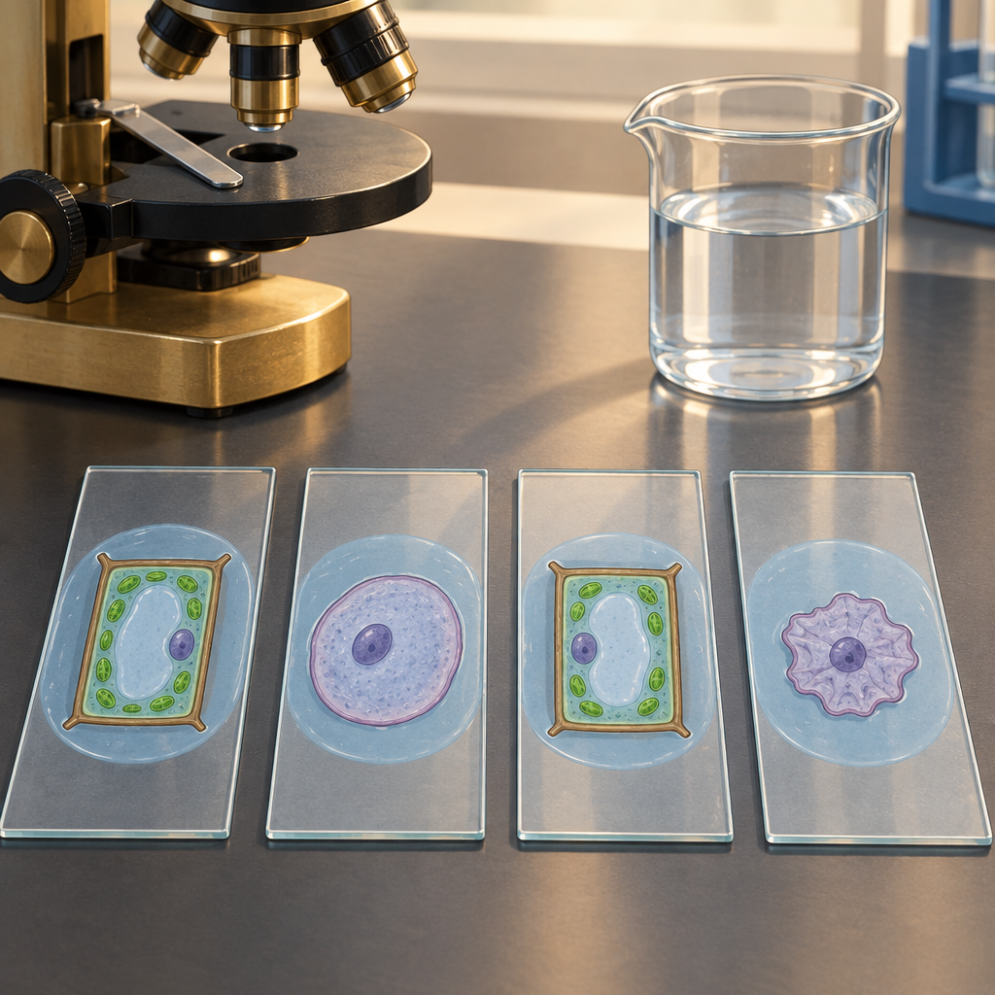

Hints
Hint 1: Start by sorting the samples into two groups based on which structural feature only plant cells have. That structural feature is what keeps a cell's shape fixed regardless of the surrounding solution.
Hint 2: For each sample, compare the concentration of dissolved particles inside the cell to the concentration outside it. Water always moves toward the side with the higher concentration of dissolved particles, because that is the side with lower water concentration.
Hint 3: Sample 1 is a plant cell surrounded by a solution with more dissolved particles than the cell itself, so water is leaving the cell. Because Sample 1 has a rigid boundary, it cannot swell or burst even when full, and it does not collapse completely even when losing water, since that same rigid boundary holds its overall shape. Apply this same reasoning to the other three samples.

Answer key
Sample 1 and Sample 3 are plant cells, because both have a rigid outer boundary, the cell wall, described as distinguishing plant cells from animal cells (Outcome). Sample 1 also contains chloroplasts, a structure found in plant cells but not animal cells (Outcome).
Sample 2 and Sample 4 are animal cells, because neither has a rigid outer wall and both change shape based on internal water content, consistent with the distinction between cell walls and cell membranes (Outcome).
Water movement for each sample, based on diffusion and osmosis moving liquids according to concentration differences (Outcome):
Sample 1: the surrounding solution has a higher concentration of dissolved particles than the inside of the cell, so water moves out of the cell.
Sample 2: the solution has the same concentration as the inside of the cell, so water moves in and out at equal rates and the cell stays the same overall size.
Sample 3: the surrounding solution has a lower concentration of dissolved particles than the inside of the cell, so water moves into the cell.
Sample 4: the surrounding solution has a higher concentration of dissolved particles than the inside of the cell, so water moves out of the cell, matching the observation that it is shrinking.
Explanation for Question 3: Sample 1 has a cell wall, the rigid structure that distinguishes plant cells from animal cells (Outcome). This wall resists changes in shape, so even as water leaves the cell by osmosis, the wall holds the cell's overall form and prevents the collapse seen in Sample 4. Sample 4 is an animal cell with only a flexible cell membrane and no wall, so when it loses water to a solution with a higher concentration of dissolved particles outside, it shrinks and wrinkles, exactly as described in the puzzle.

Note: 2 learning outcome blocks were left out to fit the 4000-token curriculum budget for this kind of material. Use "Split into parts" to generate one document per organizing idea.

AILI game · en · claude-sonnet-5 · 2026-09-17

