Enthalpy Changes and Calorimetry
Central concept: Enthalpy Changes

Connections
- Enthalpy Changes (defines) -> Enthalpy
- Enthalpy Changes (includes) -> Molar Enthalpy
- Enthalpy Changes (measured by) -> Calorimetry
- Enthalpy Changes (expressed as) -> ΔH Notation
- Enthalpy Changes (determines) -> Reaction Classification
- Calorimetry (uses) -> Heat Transfer Equation
- Calorimetry (requires) -> Calorimeter Design
- Calorimetry (applies to) -> Combustion Analysis
- Calorimetry (generates) -> Data Analysis
- ΔH Notation (visualized in) -> Energy Diagrams
- Thermochemical Systems (exhibits) -> Enthalpy Changes
- Heat Transfer Equation (enables) -> Data Analysis

Notes
- Enthalpy Changes: Energy changes in chemical reactions quantified and interpreted Topic
- Enthalpy: Defined as energy content of chemical reactions Outcome, Outcome
- Molar Enthalpy: Enthalpy per mole of reactant or product Outcome, Outcome
- Calorimetry: Experimental technique to measure heat transfer in reactions Outcome, Resource
- Heat Transfer Equation: Q = mcΔt applied to analyze heat transfer Outcome, Outcome
- ΔH Notation: Symbolic representation of enthalpy change in reactions Outcome
- Energy Diagrams: Visual representation of energy changes during reactions Topic
- Calorimeter Design: Building and testing calorimeters for precision measurement Resource
- Combustion Analysis: Measuring heat released during fuel combustion Resource
- Data Analysis: Manipulating and presenting calorimetry data using tools Outcome
- Reaction Classification: Distinguishing exothermic and endothermic processes Topic
- Thermochemical Systems: Chemical systems analyzed for energy content and transfer Topic
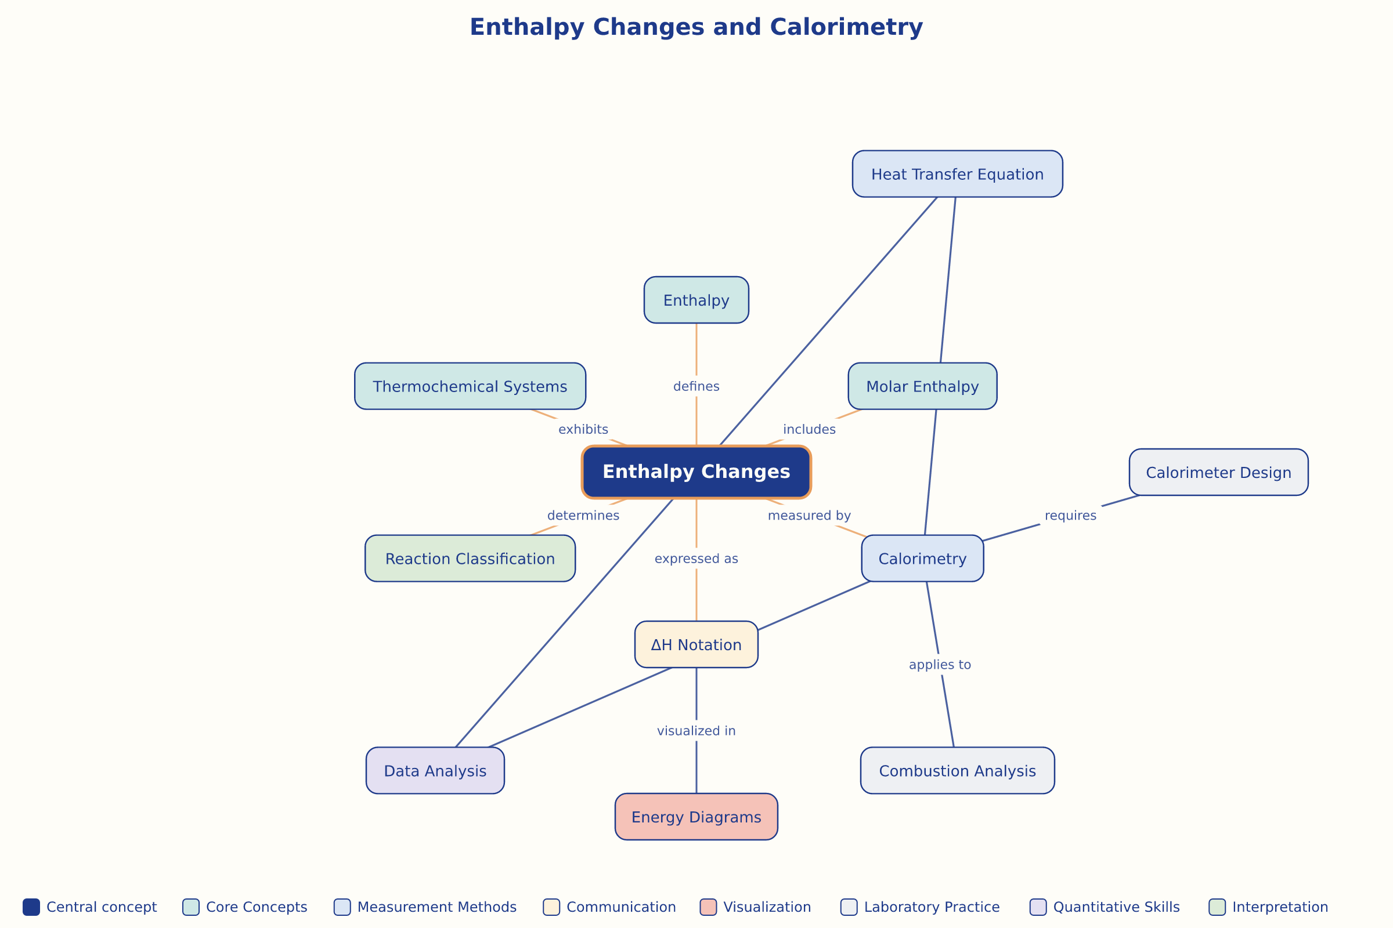

AILI word map · en · claude-haiku-4-5-20251001 · 2026-09-17

