Enthalpy Changes and Calorimetry
A Chemistry 30 lesson linking Q = mcΔt, ΔH notation, and calorimetry lab data
Audience: Chemistry 30 students in a senior high school classroom, ages 16 to 18, preparing for diploma-level quantitative problem solving.
Grades: Grade 12
Subjects: Chemistry
Time: about 60 minutes
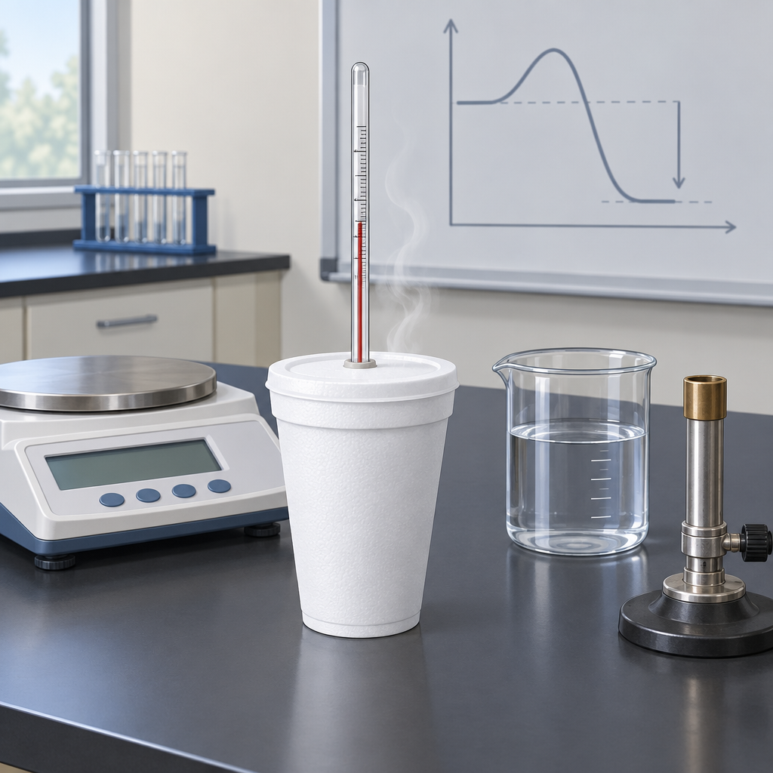

Overview
This lesson develops students' ability to define enthalpy and molar enthalpy (Outcome, Outcome), apply Q = mcΔt to heat transfer problems (Outcome, Outcome), and use calorimetry data to calculate enthalpy changes in chemical reactions (Outcome). Students practise ΔH notation to express whether reactions are exothermic or endothermic (Outcome) and apply data-analysis skills to evaluate experimental error in a hands-on calorimetry investigation (Outcome).
Students recall the application of Q = mcΔt to the analysis of heat transfer, define enthalpy and molar enthalpy for chemical reactions, and use calorimetry data to determine the enthalpy changes in chemical reactions. This structure aligns with the inquiry-based, quantitative emphasis of Unit A: Thermochemical Changes described in Resource."

Outcomes covered
- Define enthalpy and molar enthalpy for chemical reactions. (Outcome, Outcome)
Students need a precise definition of enthalpy and molar enthalpy before they can interpret ΔH notation or calculate molar enthalpy from calorimetry data.
- Recall the application of Q = mcΔt to the analysis of heat transfer. (Outcome, Outcome)
This equation is the computational foundation for every calorimetry calculation students will perform in this unit and on the diploma exam.
- Use calorimetry data to determine the enthalpy changes in chemical reactions. (Outcome)
Calorimetry is the primary experimental method for measuring enthalpy changes, connecting laboratory measurement to the abstract concept of enthalpy.
- Use and interpret ΔH notation to communicate and calculate energy changes in chemical reactions. (Outcome)
Consistent notation and correct sign conventions allow students to communicate whether a reaction releases or absorbs energy, a skill directly assessed on diploma exams.
- Analyze data and apply mathematical and conceptual models to develop and assess possible solutions, including comparing energy changes associated with a variety of chemical reactions through the analysis of data and energy diagrams. (Outcome)
Evaluating experimental error and comparing calculated results to accepted values builds the quantitative reasoning skills required for laboratory-based diploma exam questions.

Materials
- Polystyrene cups (2 nested per group) for calorimeter construction (Resource)
- Thermometers or temperature probes, one per group
- Digital balance, one per group
- 100 mL graduated cylinders
- Combustion sample (nut or candle) or alternative exothermic mixing reagents, depending on lab safety availability (Resource, Resource)
- Safety goggles for all students during combustion steps
- Tongs or clamps for handling heated materials
- Stir rods
- Whiteboard with Q = mcΔt and ΔH notation posted
- Worked-example handout summarizing both direct-instruction calculations
- Exit problem handout or projected slide

Sequence of activities

1. Activating Prior Knowledge: Heat vs. Temperature Warm-Up (8 min, whole class)
- Post the question: "A cup of coffee at 80°C and a bathtub of water at 40°C, which contains more thermal energy? Which is hotter?" Allow one minute of silent thinking.
- Take a quick poll by show of hands, then ask two students to justify opposing answers.
- Clarify that temperature measures average kinetic energy while heat (Q) measures total energy transferred, and that Q = mcΔt lets us calculate that transfer quantitatively (Outcome, Outcome).
- Write Q = mcΔt on the board and label each variable: Q (heat, in joules), m (mass, in grams), c (specific heat capacity, in J/(g·°C)), Δt (change in temperature, in °C).
- Tell students that today's lesson connects this formula to enthalpy changes measured through calorimetry.
Expect some students to conflate heat and temperature. Use the coffee/bathtub example to surface this misconception before it interferes with calorimetry calculations. Have the specific heat capacity of water (4.19 J/(g·°C)) posted for reference throughout the lesson.
Sources: Outcome, Outcome

2. Direct Instruction: Enthalpy, ΔH Notation, and Calorimetry Principles (15 min, whole class)
- Define enthalpy (H) as the heat content of a system at constant pressure, and molar enthalpy (ΔHmol) as the enthalpy change per mole of a specified substance in a reaction (Outcome, Outcome).
- Introduce ΔH notation: exothermic reactions have ΔH < 0 (energy released to surroundings); endothermic reactions have ΔH > 0 (energy absorbed from surroundings). Write both on the board with a labelled energy diagram (energy on the y-axis, reaction progress on the x-axis) (Outcome).
- Work through a fully labelled worked example on the board:
Question: When 0.500 mol of a fuel burns, it releases 275 kJ of heat. Calculate the molar enthalpy of combustion and express it using ΔH notation.
Solution: ΔHmol = −275 kJ ÷ 0.500 mol = −550 kJ/mol. Since heat is released, ΔH = −550 kJ/mol (exothermic).
- Introduce the calorimetry principle: heat lost by the reacting system equals heat gained by the surroundings (the water in the calorimeter), assuming no heat loss to the environment: Qreaction = −Qwater (Outcome).
- Present a second worked example connecting Q = mcΔt to calorimetry data:
Question: A 1.20 g sample of fuel is burned under a calorimeter containing 200.0 g of water. The water temperature rises from 22.0°C to 45.5°C. Calculate the heat absorbed by the water, then the molar enthalpy of combustion if the fuel has a molar mass of 46.0 g/mol.
Solution: Qwater = mcΔt = (200.0 g)(4.19 J/(g·°C))(23.5°C) = 19 693 J ≈ 19.7 kJ.
Moles of fuel = 1.20 g ÷ 46.0 g/mol = 0.0261 mol.
ΔHmol = −19.7 kJ ÷ 0.0261 mol = −755 kJ/mol.
- Ask students to identify sources of experimental error in this setup (heat loss to surroundings, incomplete combustion, heat absorbed by the calorimeter itself) and record these on the board for use in the lab activity (Outcome).
Keep both worked examples visible for the remainder of the lesson so students can reference the steps during the lab. Emphasize the negative sign convention carefully; this is a common source of error on diploma exams. Reinforce that ΔH refers to the reaction system, while Q calculated from mcΔt refers to the water (surroundings) and carries the opposite sign.
Sources: Outcome, Outcome, Outcome, Outcome, Outcome

3. Mini-Lab: Calorimetry with a Simple Calorimeter (25 min, small group)
- In groups of three or four, students set up a simple calorimeter following the structure described in Resource: measure 100.0 mL of water into a container, record the initial temperature, and prepare the small sample assigned by the teacher. For nut-combustion trials, use a metal can or flask of water on a stand rather than a polystyrene cup, which melts or ignites at combustion temperatures. For salt-dissolution or exothermic mixing reactions, use the polystyrene-cup calorimeter as described in Resource or Resource.
- Record all raw data in a table with these columns: mass of water (g), initial temperature of water (°C), final temperature of water (°C), Δt (°C), mass of sample before and after (g), mass of sample consumed (g).
- Perform the trial, stirring gently and recording the maximum or final steady temperature reached.
- Using the worked example from the direct instruction as a model, calculate: Qwater using Q = mcΔt, where m is the mass of water in grams (Outcome, Outcome); the heat released by the reaction, Qreaction = −Qwater; the molar enthalpy of the reaction using the moles of sample consumed (Outcome).
- Compare their calculated molar enthalpy value against a published reference value for the specific fuel or salt used (provided by the teacher or sourced from a reliable reference table, e.g., a known combustion enthalpy for the nut species or a tabulated dissolution enthalpy for the salt) and calculate percent error.
- As a group, list at least two sources of experimental error that would cause their calculated value to differ from the accepted value, referencing heat loss, incomplete reaction, or heat absorbed by the calorimeter and thermometer (Outcome).
If combustion materials are unavailable, substitute the salt-dissolution or metal-mixing calorimetry approach from Resource (e.g., dissolving a salt or mixing hot and cold water) to keep the heat-transfer principle identical. Circulate to check that groups correctly identify the negative sign for Qreaction and do not confuse it with Qwater. Have a reference enthalpy value ready for the percent error calculation. Safety: goggles required for all students; for combustion trials, use a metal can or flask on a heat-resistant stand with tongs, not bare hands, near flame. Ensure a fire extinguisher or sand bucket is accessible, hair is tied back, and the area is well-ventilated. Teacher demonstration of the combustion setup is recommended before students perform trials. Screen all students for nut allergies before any nut-combustion activity, as burning nuts releases aerosolized allergens that pose a serious risk in a school setting.
Sources: Outcome, Outcome, Outcome, Outcome

4. Consolidation: Exit Problem and Class Discussion (12 min, individual)
- Distribute or display this exit problem: "A student places a 15.0 g sample of an unknown salt into 150.0 g of water in a calorimeter. The water temperature changes from 20.0 °C to 15.5 °C. Calculate Qwater, state whether the dissolving process is endothermic or exothermic, and calculate the molar enthalpy of dissolving if the salt's molar mass is 58.5 g/mol."
- Give students 6 minutes to solve independently, showing all steps and units.
- Students use calorimetry data to calculate Qwater and determine the sign of ΔH. Since the water lost heat, the dissolving process absorbed heat from the water, so it is endothermic and ΔHmol is positive. Students calculate molar enthalpy by dividing the enthalpy change by the moles of reactant.
- Ask students to submit their solution as a ticket-out-the-door for formative feedback.
- Preview that the next lesson extends these ideas to Hess's law and enthalpies of formation, building on today's calorimetry calculations (Resource).
Watch for students who calculate Qwater correctly but assign the wrong sign to ΔH for the reaction; this is the most common error at this stage. Use the ticket-out-the-door to group students for targeted review in the next class.
Sources: Outcome, Outcome, Outcome, Outcome, Resource

Differentiation
Extension
- Ask students to derive an expression for the heat capacity of the calorimeter itself (Ccal) using a known-enthalpy reaction and incorporate it into their percent error analysis, extending Outcome and Outcome.
- Challenge students to research and compare their experimental molar enthalpy value with a published bond-enthalpy-based estimate, discussing why the two methods might disagree.
Support
- Provide a partially completed data table and formula sheet (Q = mcΔt, ΔHmol = Q ÷ n) for students who need a scaffold during the mini-lab.
- Pair students who struggle with sign conventions with a peer for the exit problem, allowing verbal talk-through before writing the final solution.
- Offer a worked-example reference card summarizing both direct-instruction examples for students to keep at their lab station.
Inclusive supports
- Provide the exit problem in both written and read-aloud format for students who benefit from auditory processing.
- Allow extra time for data collection and calculation for students with processing accommodations, and permit calculator use throughout.
- Use consistent, high-contrast labelling on the board for units and sign conventions to support students with visual processing needs.

Assessment
Formative. Circulate during the mini-lab to check that groups correctly apply Q = mcΔt (using mass of water), correctly invert the sign for Qreaction, and correctly divide by moles to obtain molar enthalpy.
Look for: Group data tables show correct units, correct sign conventions, and a plausible molar enthalpy value compared to the reference figure. (Outcome, Outcome, Outcome)
Formative. Cold-call questioning during direct instruction on the meaning of the sign of ΔH (exothermic vs. endothermic) and on the difference between enthalpy and molar enthalpy.
Look for: Students correctly state that negative ΔH indicates an exothermic reaction and that molar enthalpy is expressed per mole of a specified substance. (Outcome, Outcome, Outcome)
Formative. Exit problem calculating Qwater, identifying the sign of ΔH, and calculating molar enthalpy for an unknown salt dissolving in water.
Look for: Correct numerical answer for Qwater (−2.83 kJ), correct identification of the process as endothermic, and correct molar enthalpy calculation (+11.0 kJ/mol) with units shown at every step. (Outcome, Outcome, Outcome)

Vocabulary
- Enthalpy (H): The heat content of a system measured at constant pressure; changes in enthalpy (ΔH) describe the energy absorbed or released during a chemical reaction.
- Molar enthalpy (ΔHmol): The enthalpy change per mole of a specified substance involved in a chemical reaction, typically expressed in kJ/mol.
- Q = mcΔt: The equation used to calculate heat transfer (Q), where m is mass in grams, c is specific heat capacity in J/(g·°C), and Δt is the change in temperature in °C.
- Calorimetry: The experimental technique of measuring heat transfer during a physical or chemical process, typically using a calorimeter and the relationship Qreaction = −Qwater.
- ΔH notation: A convention for expressing enthalpy change where a negative value (ΔH < 0) indicates an exothermic reaction and a positive value (ΔH > 0) indicates an endothermic reaction.

Sources
- Outcome: "30-A1.3k define enthalpy and molar enthalpy for chemical reactions"
- Outcome: "30-A1.1k recall the application of Q = mcΔt to the analysis of heat transfer"
- Outcome: "30-A1.8k use calorimetry data to determine the enthalpy changes in chemical reactions"
- Outcome: "30-A1.1k recall the application of Q = mcΔt to the analysis of heat transfer"
- Outcome: "30-A1.3k define enthalpy and molar enthalpy for chemical reactions"
- Outcome: "30-A1.5k use and interpret ΔH notation to communicate and calculate energy changes in chemical reactions"
- Outcome: "30-A1.3s analyze data and apply mathematical and conceptual models to develop and assess possible solutions"
- Resource: "This unit covers calorimetry, enthalpy changes, Hess's law, molar enthalpies of formation, and energy diagrams, with applications in sustainable energy and fuel evaluation."
- Resource: "This lab presents a multimedia investigation of calorimetry by examining how burning a nut transfers thermal energy to water."
- Resource: "This lab presents a guided investigation of building a polystyrene-cup calorimeter and evaluating the calorimeter's performance by measuring temperature changes during mixing."

All activities require appropriate safety precautions including goggles, heat-resistant bases, fire extinguishers or sand buckets, tied-back hair, and adequate ventilation for combustion trials. Nut-combustion activities require allergy screening and teacher demonstration. Specific hazards and WHMIS information for all salts and fuels used must be reviewed with students before the lab.

AILI detailed pack · en · claude-sonnet-5 · 2026-09-17

