Heat in a Cup
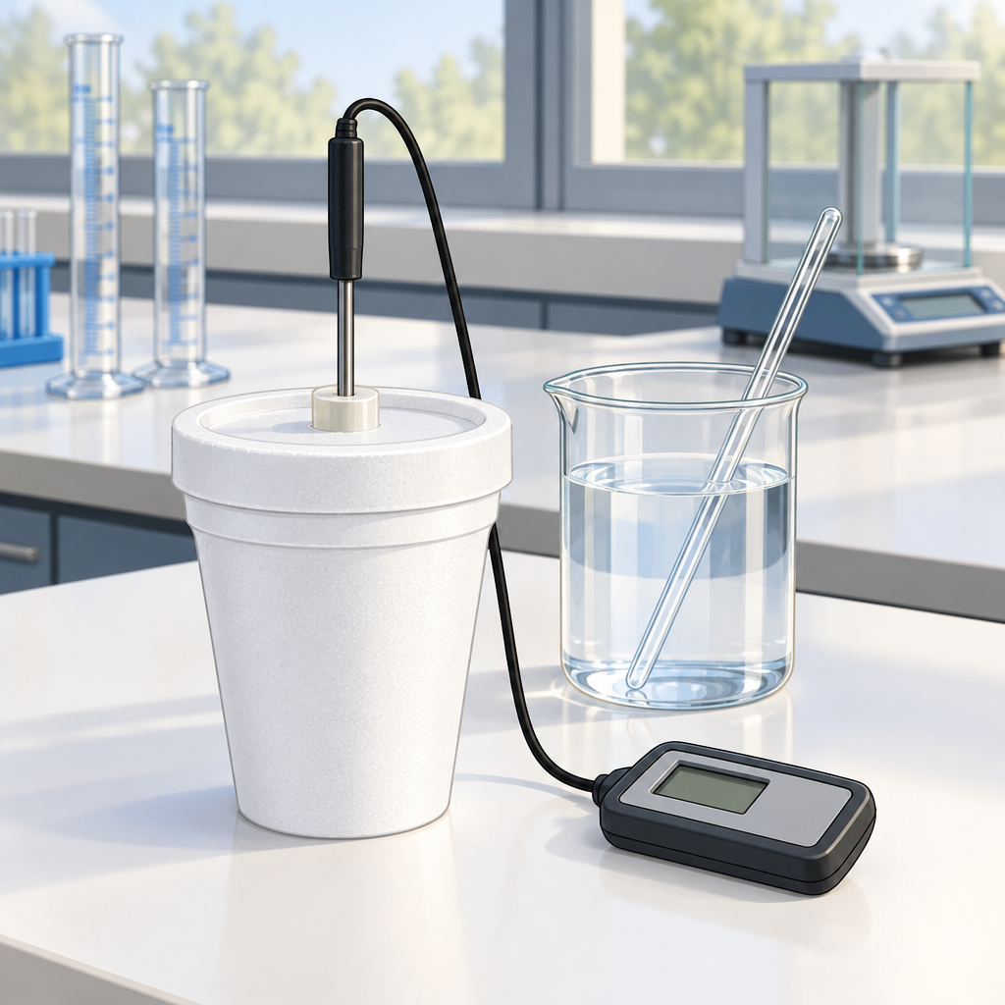
Maya watched the thermometer in the polystyrene cup climb. Seven degrees. Eight. Beside her, Kai stirred the mixture of acid and base, their reaction unmistakable. Heat released. Energy transferred. "The water absorbed all of it," Kai said, reading the final temperature. Twelve degrees higher than when they started. They'd designed a calorimeter from a cup and lid, nothing fancy. Maya entered the numbers into the equation: Q equals mass times specific heat times the change in temperature. The heat released by the reaction flowed into the water around it, measurable and real. "So the reaction itself," Maya said, "gave up energy." "Enthalpy change," Kai nodded. Negative. Exothermic. The chemical system lost what the water gained. Energy didn't vanish. It moved..

Words to know
- enthalpy: the total heat energy of a chemical system; symbolized as H
- exothermic: a reaction that releases heat energy to the surroundings
- calorimeter: an apparatus designed to measure heat absorbed or released during a chemical reaction
- specific heat: the amount of energy required to raise the temperature of one gram of a substance by one degree Celsius
- molar enthalpy: the heat energy change per mole of a substance involved in a chemical reaction
- Q: the symbol representing heat energy in joules
- ΔH: the symbol representing the change in enthalpy of a reaction
Curriculum link: Outcome, Outcome, Outcome, Outcome, Resource, Resource
Listen to the narration

AILI audio story · en · claude-haiku-4-5-20251001 · 2026-09-17

