The Cell Detective Challenge
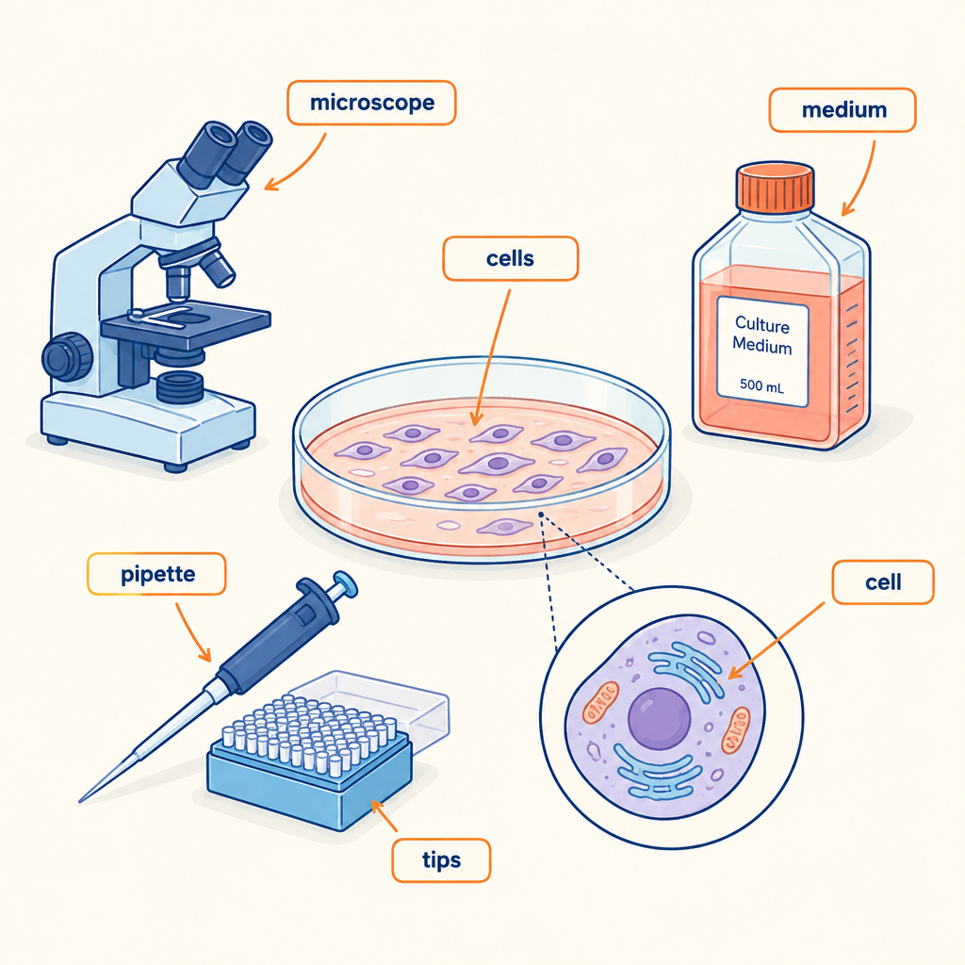
In Grade 8 Science, you explore cells and systems to understand how living organisms function (Topic). Cells are the basic unit of life that carry out vital functions in both single-celled and multicellular organisms (Outcome). This puzzle tests your understanding of how different cell structures work together and how plant and animal cells differ in their form and purpose.

The puzzle
A biologist is studying four different cells under a microscope. Each cell has a specific role in keeping an organism alive. Read the clues carefully and figure out which cell type matches each description.
The four cell types are: root hair cell, red blood cell, nerve cell, and leaf cell.
Clue 1: One cell is extremely long and thin to help transmit signals quickly through the body. It is not found in plants.
Clue 2: One cell is flat and disc-shaped with no nucleus, making it ideal for squeezing through tiny blood vessels and carrying oxygen.
Clue 3: One cell has a large surface area because it is covered with tiny hair-like extensions. It absorbs water and minerals from the soil.
Clue 4: One cell contains many chloroplasts and is elongated, packed near the leaf surface to capture light efficiently.
Your task: Match each cell type to its description using the clues above. Then explain why the structure of each cell suits its function in the organism.

Hints
Hint 1: Think about where each cell is located. Is it in an animal body, a plant root, a plant leaf, or the blood? The location tells you what job it must do.
Hint 2: Two of the cells are plant cells (they have cell walls), and two are animal cells (they have only a cell membrane). Use what you know about plant and animal cell differences (Outcome) to narrow down your choices.
Hint 3: Consider the relationship between cell structure and function. Cells that need to move materials in or out quickly have large surface areas. Cells that transmit information are long and thin. Cells that carry oxygen are shaped to fit through small spaces.

Answer key
Correct matches:
- Root hair cell matches Clue 3. Root hair cells have extensions that increase surface area for absorbing water and minerals from soil. They are plant cells with cell walls.
- Red blood cell matches Clue 2. Red blood cells are disc-shaped, lack a nucleus (in mammals), and are small enough to squeeze through capillaries while carrying oxygen throughout the body.
- Nerve cell matches Clue 1. Nerve cells are long and thin, which allows electrical signals to travel quickly from one end to the other. They are animal cells found only in nervous systems.
- Leaf cell (palisade or spongy mesophyll cell) matches Clue 4. These cells are thin and contain many chloroplasts for photosynthesis. Their flat shape allows light to penetrate, and they are plant cells with cell walls.
Why structure matches function:
Each cell's shape and internal structures are adapted to perform its specific role (Outcome). Root hair cells have a large surface area to increase contact with soil water. Red blood cells are small and flexible to fit through blood vessels and maximize oxygen transport. Nerve cells are elongated to conduct electrical impulses over long distances. Leaf cells are thin and contain chloroplasts to capture light energy for photosynthesis. This relationship between structure and function is a core principle of how cells support life processes in both plants and animals (Outcome).

Note: 2 learning outcome blocks were left out to fit the 4000-token curriculum budget for this kind of material. Use "Split into parts" to generate one document per organizing idea.

AILI game · en · claude-haiku-4-5-20251001 · 2026-09-17

