The Renaissance Thinkers Logic Puzzle
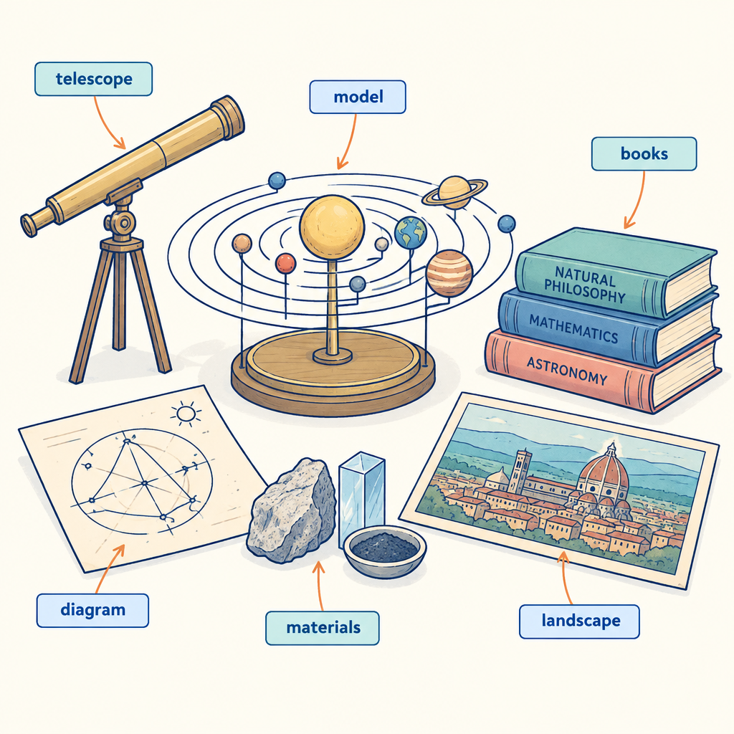
This brain teaser challenges you to reason through clues about four figures connected to Renaissance Europe, testing how well you can trace the growth and exchange of ideas across astronomy, mathematics, science, politics, religion and the arts that shaped a new Western worldview (Topic, Outcome). Working through the puzzle also builds the habit of considering differing beliefs, values and worldviews with care and precision (Outcome), while showing how those beliefs were shaped by time, place and society (Outcome).

How to play
- The puzzle is about 4 students and 3 categories. Each one has exactly one value in each category, and each value is used once.
- Read the 11 clues. Every clue is true. Use the grid to mark what is certain and cross out what is impossible.
- Exactly one arrangement fits every clue; the server has checked it. The hints go from gentle to direct, and the answer key shows the solution with the reasoning.

The puzzle
A class studying Renaissance Europe researches powerful city-states and the fields of knowledge that flourished as trade and ideas spread across the continent. Each student presents findings on one city-state.
Florence, Venice, Genoa and Milan each have one item from every category below, and no two of them share an item.
- Student presenting: Priya, Marcus, Sofia, Ahmed
- Field of knowledge researched: astronomy, humanist philosophy, trade and geography, the arts
- Order of presenting (in order, from first presentation to fourth presentation): first presentation, second presentation, third presentation, fourth presentation
Use the clues to work out who has what. Mark in the grid what each clue rules out.
Name | Student presenting | Field of knowledge researched | Order of presenting
Florence
Venice
Genoa
Milan

- The student with Sofia is between the student with the arts and the student with Priya in order of presenting.
- The student with the arts also has second presentation.
- The student with humanist philosophy comes before the student with the arts in order of presenting.
- The student with Marcus comes before the student with Ahmed in order of presenting.
- The student with astronomy does not have third presentation.
- Milan does not have second presentation.
- Milan does not have Sofia.
- Milan does not have Marcus.
- Venice does not have humanist philosophy.
- Venice does not have the arts.
- Florence does not have Ahmed.

Hints
- Start with clue 1. Mark in the grid what it rules out before you read on.
- Clues 1 to 8 together show that Milan has Priya.
- Milan has Priya, astronomy and fourth presentation.

Answer key
Name | Student presenting | Field of knowledge researched | Order of presenting
Florence | Marcus | humanist philosophy | first presentation
Venice | Sofia | trade and geography | third presentation
Genoa | Ahmed | the arts | second presentation
Milan | Priya | astronomy | fourth presentation

Reasoning
- Clue 1: The student with Sofia is between the student with the arts and the student with Priya in order of presenting. Nothing is fixed yet; 2304 arrangements remain.
- Clue 2: The student with the arts also has second presentation. Nothing is fixed yet; 288 arrangements remain.
- Clue 3: The student with humanist philosophy comes before the student with the arts in order of presenting. Nothing is fixed yet; 96 arrangements remain.
- Clue 4: The student with Marcus comes before the student with Ahmed in order of presenting. Nothing is fixed yet; 48 arrangements remain.
- Clue 5: The student with astronomy does not have third presentation. Nothing is fixed yet; 24 arrangements remain.
- Clue 6: Milan does not have second presentation. Nothing is fixed yet; 18 arrangements remain.
- Clue 7: Milan does not have Sofia. Nothing is fixed yet; 12 arrangements remain.
- Clue 8: Milan does not have Marcus. This fixes Milan has Priya, Milan has astronomy and Milan has fourth presentation; 6 arrangements remain.
- Clue 9: Venice does not have humanist philosophy. Nothing is fixed yet; 4 arrangements remain.
- Clue 10: Venice does not have the arts. This fixes Venice has Sofia, Venice has trade and geography and Venice has third presentation; 2 arrangements remain.
- Clue 11: Florence does not have Ahmed. This fixes Florence has Marcus, Genoa has Ahmed, Florence has humanist philosophy, Genoa has the arts, Florence has first presentation and Genoa has second presentation, and only one arrangement remains.

AILI game · en · claude-sonnet-5 · 2026-09-17

