Nationalism: Identity, Loyalty and National Interest
Understanding how nationalism shapes identity and drives political action in the modern world.
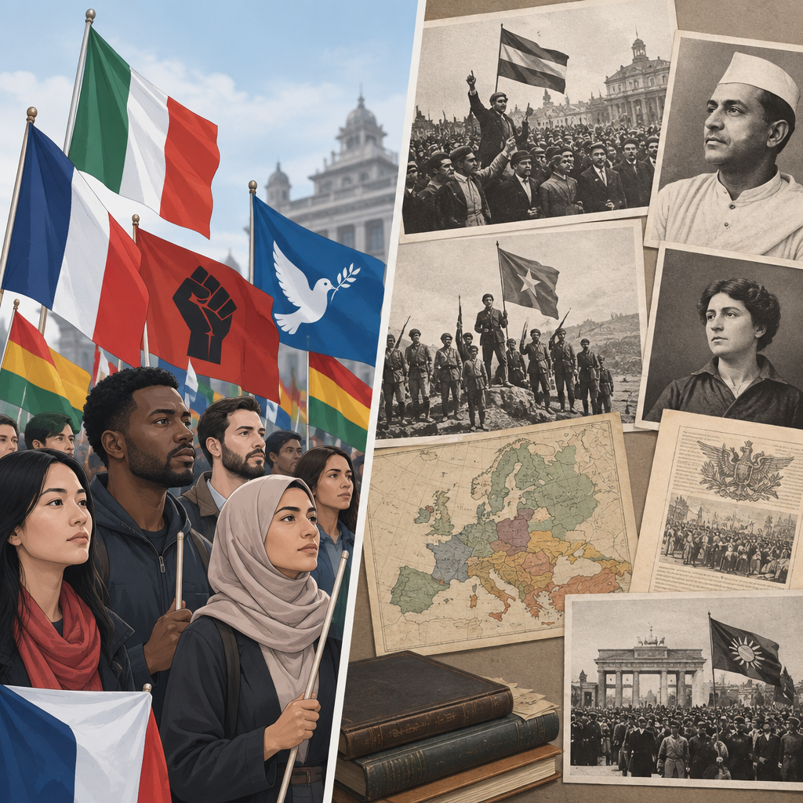

Learning intentions
We are learning to understand nationalism as a form of identity and collective consciousness, and to recognize how nationalist sentiment can drive both constructive and destructive political outcomes.

Success criteria
I can:
- define nationalism and distinguish it from patriotism, ethnic identity and civic belonging
- identify examples of nationalism from different historical periods and contexts
- analyze how nationalism shapes individual and collective identity
- evaluate the tension between different nationalist loyalties within a single state
- assess the relationship between nationalism and the pursuit of national interest

Curriculum alignment
- Students will explore the relationships among identity, nation and nationalism (Topic, Topic)
- Students will analyze nationalism as an identity, internalized feeling and collective consciousness shared by a people (Outcome, Outcome)
- Students will evaluate the importance of reconciling contending nationalist loyalties (Outcome, Outcome)
- Students will assess impacts of nationalism and the pursuit of national interest (Topic, Topic)

Materials
- Whiteboard or chart paper and markers
- Handout: "Defining Nationalism" (definitions and historical examples)
- Case study cards (one per group): Canadian nationalism, Québecois nationalism, First Nations nationalism, civic nationalism, ethnic nationalism
- Exit ticket template (printed or digital)

Lesson sequence
1. Hook: What does nationalism mean to you? (5 minutes)
Display the following prompt on the board:
"When you hear the word 'nationalism,' what images, feelings or events come to mind? Write two or three words or phrases."
Allow students two minutes of silent writing. Then ask four or five volunteers to share aloud without comment. Write their responses on the board. Point out the range: some responses will be positive (pride, unity, identity), others negative (conflict, war, exclusion), and some neutral (flag, country, anthem).
Say: "You have just shown that nationalism means different things to different people. Today we are going to build a shared understanding of what nationalism is, where it comes from, and why it matters in politics and identity."
2. Direct instruction: Defining nationalism and its forms (10 minutes)
Distribute the "Defining Nationalism" handout. Read aloud or have a student read:
"Nationalism is an internalized feeling of belonging to a nation and a collective consciousness shared by a people who identify with a common identity. Nationalism can be rooted in geography, language, religion, ethnicity, history, shared values or political institutions. It is both a personal identity and a political force."
Write on the board:
Civic nationalism: Identity based on shared political values, institutions and commitment to a state (regardless of ethnic or cultural background). Example: Canadian civic nationalism emphasizes multiculturalism and shared democratic values.
Ethnic nationalism: Identity based on shared ancestry, language, culture or ethnicity. Example: some forms of nationalism in Canada emphasize shared ethnic heritage, while Québecois nationalism is more accurately described as a civic and linguistic-cultural nationalism centred on language, territory and institutions rather than ancestry alone.
First Nations and Métis nationalism: Identity rooted in Indigenous sovereignty, self-determination, land relationships and distinct governance. Example: Métis nationalism centres on Métis rights and self-government.
Ask the class: "Which of these forms of nationalism do you see in Canada today?" Take two or three responses. Do not correct; note that students will develop these ideas through the case studies.
3. Guided practice: Analyzing nationalism through case studies (18 minutes)
Divide the class into four groups. Assign each group one of these case studies:
Group 1: Canadian Civic Nationalism
Your case study: Canada's national identity is built on civic values: democracy, the rule of law, multiculturalism, and individual rights. The Canadian flag, national anthem and symbols represent these shared values rather than a single ethnic or cultural group. Citizens of many ethnic, religious and cultural backgrounds identify as Canadian.
Questions for your group:
- What makes this form of nationalism "civic" rather than "ethnic"?
- What are the strengths of civic nationalism as a way to build national identity?
- What challenges or tensions might arise?
Group 2: Québecois Nationalism
Your case study: Québecois nationalism emphasizes the French language, Québec culture, and the distinct society of Québec within Canada. It has roots in the Quiet Revolution of the 1960s, when Québécois sought greater control over their own affairs. Québecois nationalism has driven debates over language laws, education and sovereignty.
Questions for your group:
- What is the basis of Québecois national identity?
- How does Québecois nationalism relate to Canadian nationalism? Are they in conflict?
- What does "national self-determination" mean in this context?
Group 3: First Nations Nationalism
Your case study: First Nations nationalism is rooted in Indigenous sovereignty, treaty rights, land relationships and distinct governance systems. First Nations assert their right to self-determination and self-government. This nationalism predates Canadian nationalism and represents a distinct political and cultural identity.
Questions for your group:
- How is First Nations nationalism different from civic or ethnic nationalism?
- What does self-determination mean for First Nations?
- How do First Nations and Canadian nationalism coexist?
Group 4: Inuit Perspectives on Nationalism
Your case study: Inuit nationalism emphasizes Inuit sovereignty, Arctic self-governance and the right to make decisions about Inuit lands and resources. Inuit perspectives on nationalism centre on distinct governance, language preservation and the Arctic environment. Nunavut's creation in 1999 represented a major step toward Inuit self-determination.
Questions for your group:
- What is distinctive about Inuit perspectives on nationalism?
- How does geography and environment shape Inuit nationalism?
- What does self-government mean in the Inuit context?
Allow 12 minutes for group work. Circulate and listen. If a group is stuck, ask: "What values or identities are most important to this group of people?" or "What do they want control over?"
Bring the class together. Ask one representative from each group to report on their case study in two minutes. After each report, ask the class: "What form of nationalism is this, civic, ethnic, or something else?"
After all four reports, ask: "How do these different nationalisms exist together in Canada? What tensions or conflicts might arise?"
4. Independent practice: Analyzing contending loyalties (5 minutes)
Display this scenario:
"A person is a Canadian citizen, speaks French as their first language, lives in Québec, and identifies strongly with Québecois culture. They also support Indigenous rights and respect First Nations sovereignty. They believe in Canadian democratic values but worry that the federal government does not protect Québec's interests."
Ask each student to write a short response (3 to 4 sentences):
"This person holds multiple nationalist loyalties. Describe the different loyalties at work. Where might these loyalties come into conflict? How might this person reconcile them?"
Allow three minutes. Do not collect; this is a checkpoint for you to observe.
5. Consolidation: Exit ticket (2 minutes)
Distribute or display the exit ticket:
"In one sentence, define nationalism. In a second sentence, give one example of how nationalism shapes identity or politics in Canada."
Collect these as students leave. Read them quickly to check understanding.

Differentiation
Extension
Ask students who finish early to research and write two sentences on one of these:
- How did nationalism drive the French Revolution?
- What role did nationalism play in the formation of the Canadian nation?
- How do civic nationalism and ethnic nationalism differ in their approach to immigration and citizenship?
These questions align with specific outcome 1.9, which references nationalism as an identity and collective consciousness.
Support
For students who struggle with abstract concepts, provide a completed example before independent practice:
"A person is a Canadian citizen and believes in democracy and multiculturalism. They analyze nationalism as an identity and collective consciousness shared by a people. These loyalties usually align, but if Canada's foreign policy conflicts with Ukrainian interests, they might feel torn."
Ask: "What are the two loyalties here?" (Canadian and Ukrainian) "Could they ever conflict?" Students evaluate the importance of reconciling contending nationalist loyalties.
Then move to the scenario in independent practice.

Assessment
Formative checkpoint: Group case study responses
Observe groups during guided practice. Listen for evidence that students can:
- identify the basis of each form of nationalism (civic values, language and culture, sovereignty, self-government)
- distinguish between civic and ethnic nationalism
- recognize that multiple nationalisms can coexist within one state
If a group cannot answer "What is the basis of this nationalism?" prompt them: "What do these people value most? What do they want control over?"
If students confuse civic and ethnic nationalism, clarify: "Civic nationalism is about shared values and institutions. Ethnic nationalism is about shared ancestry, language or culture. Can you find examples of each in your case study?"
Use exit tickets to check whether students can define nationalism and connect it to Canadian examples. If fewer than 75 per cent of the class provides a clear definition, revisit the definition in the next lesson before moving to impacts of ultranationalism.

AILI rapid lesson · en · claude-haiku-4-5-20251001 · 2026-09-17

