The Bridge Sketch
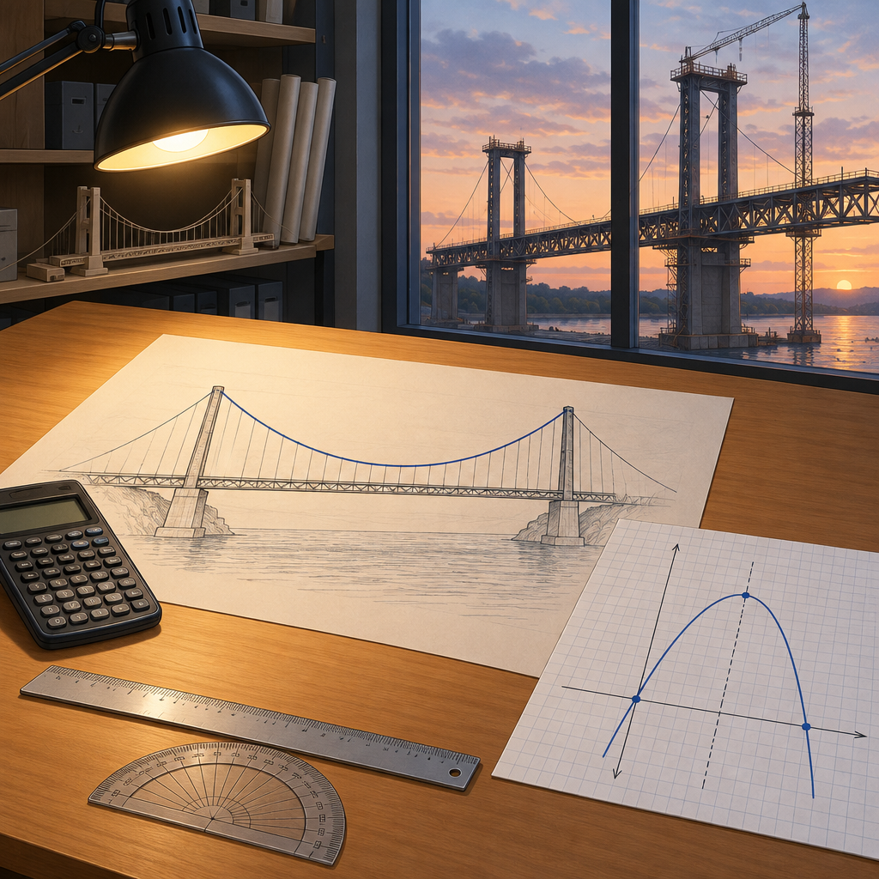
Students analyze quadratic functions to determine characteristics such as the vertex, domain and range, direction of opening, axis of symmetry, and x- and y-intercepts. "The footbridge cable sags like a parabola," she said. "If I model it, I can find the lowest point." Marcus leaned over. "Vertex form, then. y equals a times x minus p squared plus q. The vertex gives you the lowest cable height directly." She plugged numbers in, found the vertex, the axis of symmetry, the y-intercept where the deck is measured from, and the cable heights at the towers, which mark the ends of the domain she is modelling. "But the client wants the equation from measured points," Marcus added. "That's standard form, ax squared plus bx plus c. Expand yours and check they match." They did. Same parabola, opening upward, same domain and range. "Now solve for where the cable height reaches the railing height of 1.2 m," Priya said — a value the parabola actually attains. "Factor it,.

Words to know
- vertex form: A way to write a quadratic function as y = a(x − p)² + q, showing the vertex directly.
- standard form: A way to write a quadratic function as y = ax² + bx + c.
- axis of symmetry: The vertical line through the vertex that divides a parabola into two mirror-image halves.
- vertex: The maximum or minimum point on a parabola.
- quadratic formula: A formula used to find the roots of a quadratic equation of the form ax² + bx + c = 0.
Curriculum link: Outcome, Outcome, Outcome, Outcome, Outcome
Listen to the narration

AILI audio story · en · claude-sonnet-5 · 2026-09-17

