Comprehension of Texts
Grade 6 English Language Arts and Literature

Slide 1: Comprehension of Texts
Grade 6 English Language Arts and Literature: strategies for interpreting and responding to texts
Sources: Topic
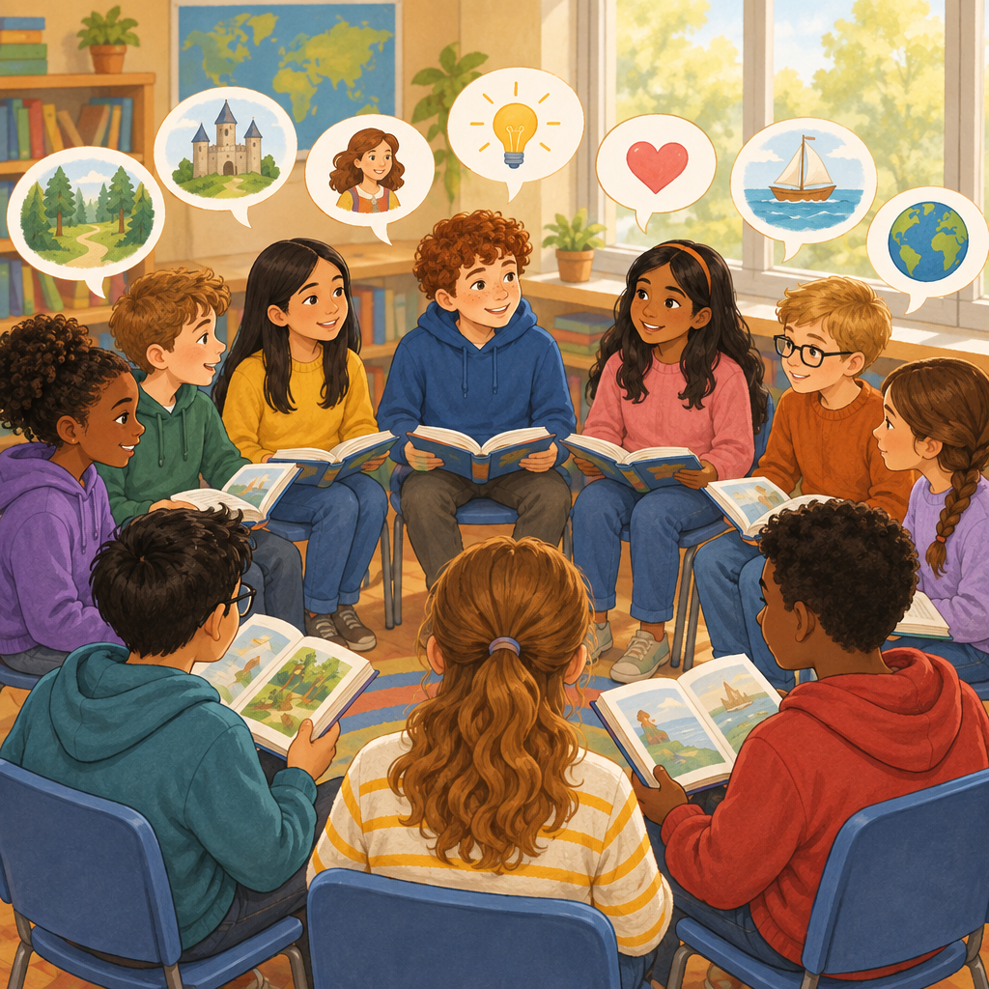
Notes: Introduce the lesson: today we build on comprehension strategies learned in earlier grades and focus on how Grade 6 readers interpret and respond to complex texts. Reference the organizing idea that runs from Grade 1 through Grade 6: comprehension is supported by varied strategies and by considering context and universal themes.

Slide 2: Our Learning Outcome and Guiding Question
- Guiding question: How do comprehension strategies enhance interpretations of texts? (Guiding question)
- Learning outcome: We interpret and respond to texts through applying comprehension strategies (Outcome)
- Strategies include predicting, inferring, making connections, summarizing, synthesizing, and evaluating (Details)
- Self-monitoring skills help us comprehend and interpret texts we read on our own (Details)
Sources: Guiding question, Outcome, Details
Notes: Success criteria: I can name at least four comprehension strategies. I can explain what self-monitoring means when reading. Checkpoint: cold-call a few students to name a strategy and give an example of when they might use it.

Slide 3: How Skilled Readers Work Through a Text
- Predict and connect: Use text to self, text to text, and text to world connections before and during reading (Details)
- Analyze closely: Examine ideas and information separately and in relationship to each other (Details)
- Notice context clues: Look at words, phrases, punctuation, dialogue, and images, diagrams, or charts (Details)
- Infer and draw conclusions: Use stated and implied ideas to reach judgements about the text (Details)
- Summarize and synthesize: Combine ideas to confirm or expand understanding (Details)
Sources: Details
Notes: Walk students through this sequence using a shared read-aloud text. Model thinking aloud at each step. Formative checkpoint: pause after step three and ask students to jot one context clue they noticed. Support: provide a simplified version of the flowchart with sentence starters. Extension: ask students to add their own step describing self-monitoring.

Slide 4: Explicit vs. Implicit: Reading Between the Lines
Stated in the text
Explicit information is written directly in the text. Context clues such as words, phrases, punctuation, and dialogue help us find it (Details). We distinguish between what is stated and what is inferred (Details).
Implied by the text
Implicit information is not written directly. We infer meanings from context clues and draw conclusions using both stated and implied ideas (Details). This is like reading between the lines to figure out what the author really means.
Sources: Details
Notes: Use a short mystery paragraph and ask students to sort clues into stated versus implied. Checkpoint: exit ticket with one explicit and one implicit example from a class novel. Support: colour-code stated details in one highlighter and inferred ideas in another.

Slide 5: Perspectives, Bias, and Context
Perspectives can change because of time, experience, context, or new information (Details). Making connections is a comprehension strategy that can support interpretation of increasingly complex texts (Details). Evaluating is a comprehension strategy that can be used to interpret and respond to increasingly complex texts(Details). Comprehension strategies can support interpretation of texts read independently(Details). Self-monitoring skills can support comprehension and interpretation of texts read independently(Details).
Whose story is being told?
Perspectives can change because of time, experience, context, or new information (Details). Making connections is a comprehension strategy that can support interpretation of increasingly complex texts (Details). Evaluating is a comprehension strategy that can be used to interpret and respond to increasingly complex texts(Details). Comprehension strategies can support interpretation of texts read independently(Details). Self-monitoring skills can support comprehension and interpretation of texts read independently(Details).
Sources: Details
Notes: Use a real example, such as two news headlines about the same event, or two characters in a class novel with different views. Ask: how might this text change if written in a different time or place? Extension: have students research the historical context of a text's setting. Support: give a sentence frame such as 'This author might be biased because...'.

Slide 6: Bringing It All Together
Summary: Readers use predicting, inferring, making connections, summarizing, synthesizing, and evaluating to interpret and respond to increasingly complex texts(Details). We use comprehension strategies such as predicting, inferring, making connections, summarizing, synthesizing, and evaluating to interpret and respond to increasingly complex texts(Details).
Question: The next time you read a story or article, which comprehension strategy will you try first, and why?
Sources: Details
Notes: Wrap up with a think-pair-share on the closing question. Collect answers on sticky notes as an exit ticket to check understanding before the next lesson. Support: offer a strategy word bank. Extension: ask students to explain how their chosen strategy would change if the text were biased or written long ago.

AILI presentation · en · claude-sonnet-5 · 2026-09-17

